**Lab21 – Understanding VNET Peering between Two VNET’s in same Region – Azure**

**Virtual network (VNET) peering:**

Virtual network peering enables you to seamlessly connect two Azure [virtual networks](https://docs.microsoft.com/en-us/azure/virtual-network/virtual-networks-overview). Once peered, the virtual networks appear as one, for connectivity purposes. The traffic between virtual machines in the peered virtual networks is routed through the Microsoft backbone infrastructure, much like traffic is routed between virtual machines in the same virtual network, through *private* IP addresses only. Azure supports:

* VNet peering - connecting VNets within the same Azure region
* Global VNet peering - connecting VNets across Azure regions

The benefits of using virtual network peering, whether local or global, include:

* Network traffic between peered virtual networks is private. Traffic between the virtual networks is kept on the Microsoft backbone network. No public Internet, gateways, or encryption is required in the communication between the virtual networks.
* A low-latency, high-bandwidth connection between resources in different virtual networks.
* The ability for resources in one virtual network to communicate with resources in a different virtual network, once the virtual networks are peered.
* The ability to transfer data across Azure subscriptions, deployment models, and across Azure regions.
* The ability to peer virtual networks created through the Azure Resource Manager or to peer one virtual network created through Resource Manager to a virtual network created through the classic deployment model. To learn more about Azure deployment models, see [Understand Azure deployment models](https://docs.microsoft.com/en-us/azure/azure-resource-manager/resource-manager-deployment-model?toc=%2fazure%2fvirtual-network%2ftoc.json).
* No downtime to resources in either virtual network when creating the peering, or after the peering is created.

**Connectivity**

After virtual networks are peered, resources in either virtual network can directly connect with resources in the peered virtual network.

The network latency between virtual machines in peered virtual networks in the same region is the same as the latency within a single virtual network. The network throughput is based on the bandwidth that's allowed for the virtual machine, proportionate to its size. There isn't any additional restriction on bandwidth within the peering.

The traffic between virtual machines in peered virtual networks is routed directly through the Microsoft backbone infrastructure, not through a gateway or over the public Internet.

Network security groups can be applied in either virtual network to block access to other virtual networks or subnets, if desired. When configuring virtual network peering, you can either open or close the network security group rules between the virtual networks. If you open full connectivity between peered virtual networks (which is the default option), you can apply network security groups to specific subnets or virtual machines to block or deny specific access.

**Topology:**

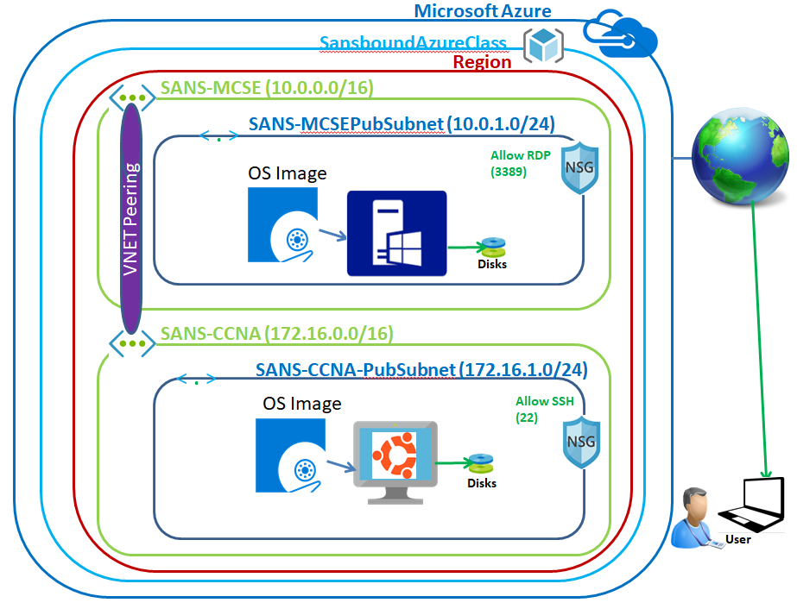

In Azure portal, click **“Resource group”**.

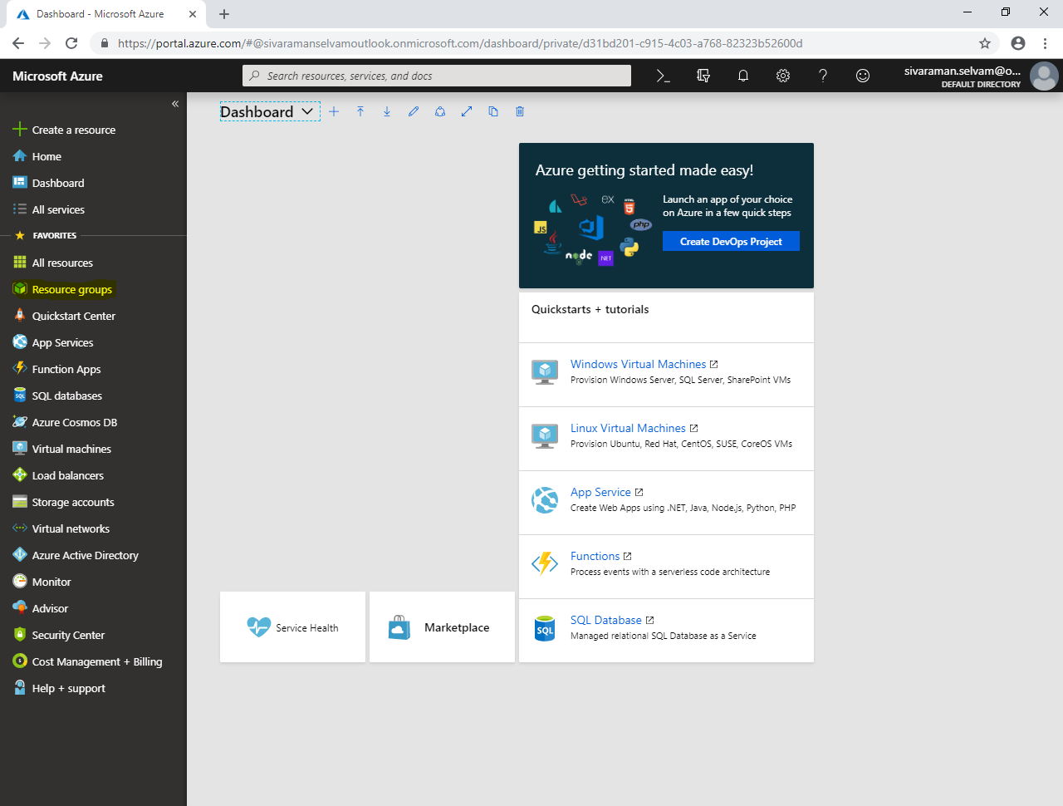

Click **“Add”**.

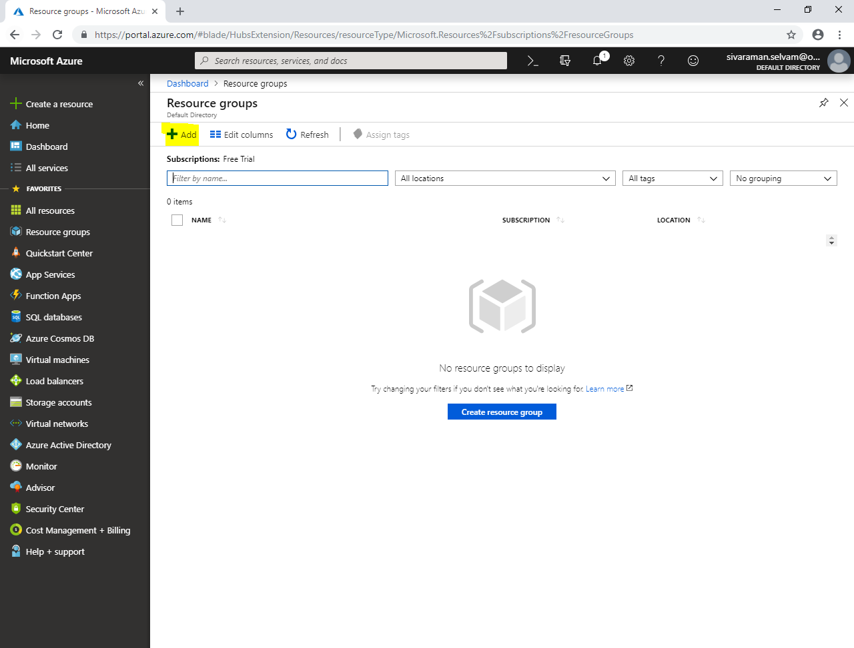

While create **“Resource group”**,

Type **“Resource group name”** as **“SansboundAzureClass”**.

Select **“Subscription”** as **“Free Trial”**.

Select **“Resource group location”** as **“Central US”**.

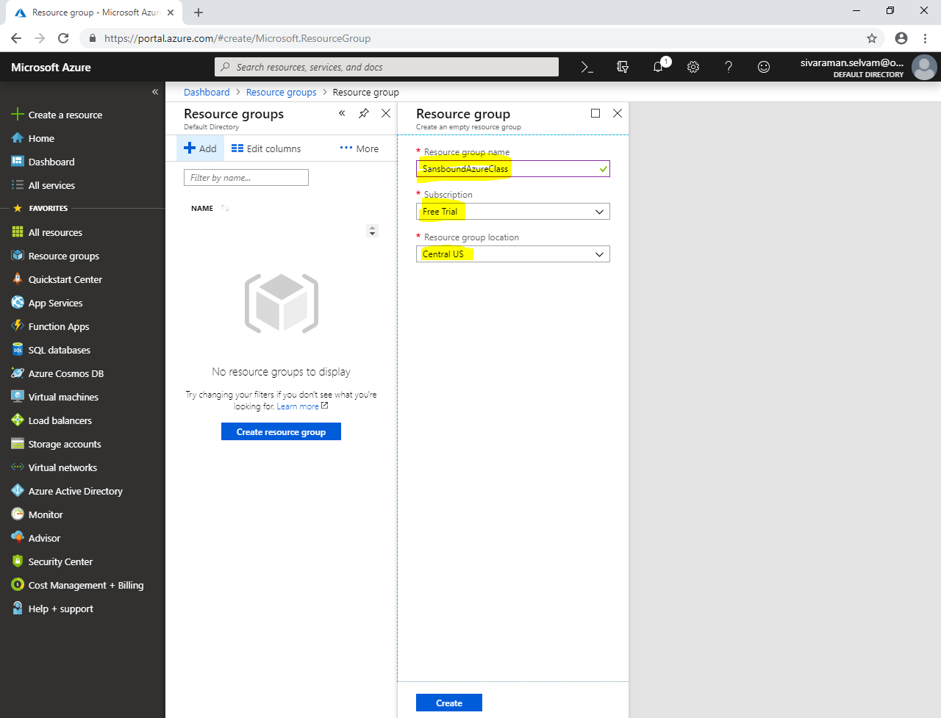

Click **“Create”**.

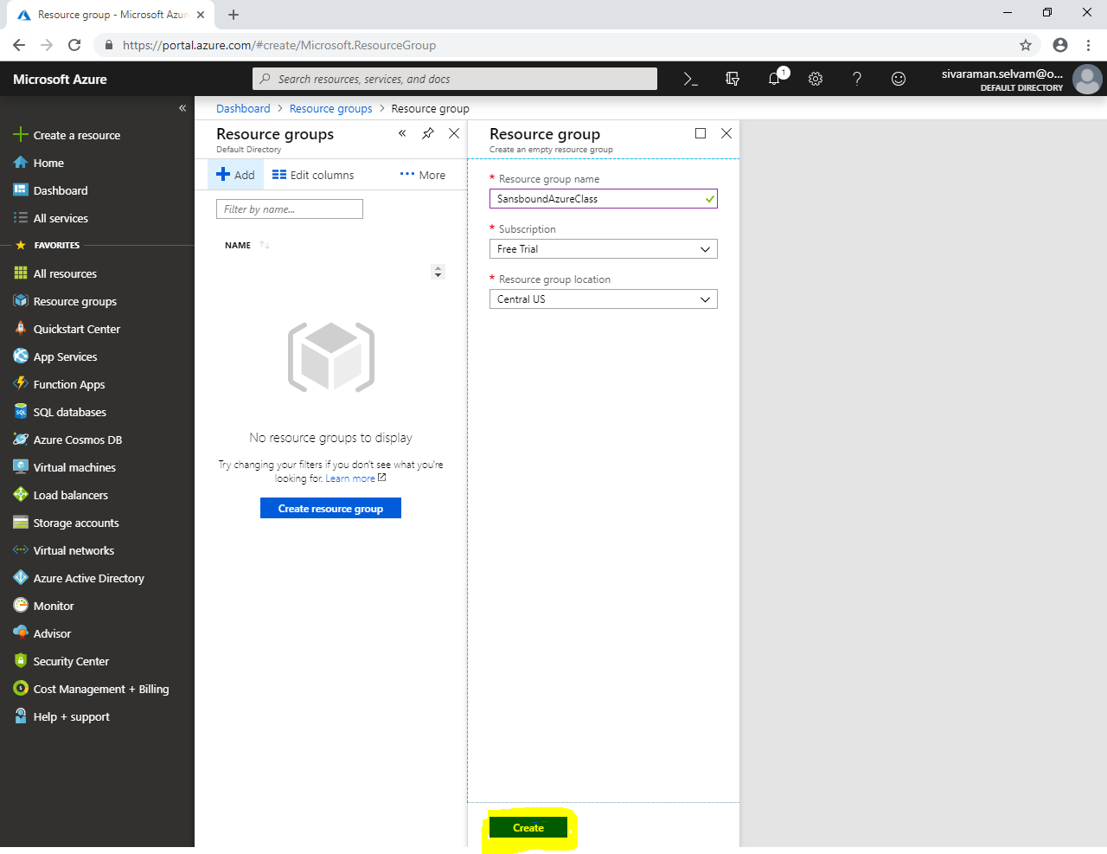

Click **“Virtual Networks”**.

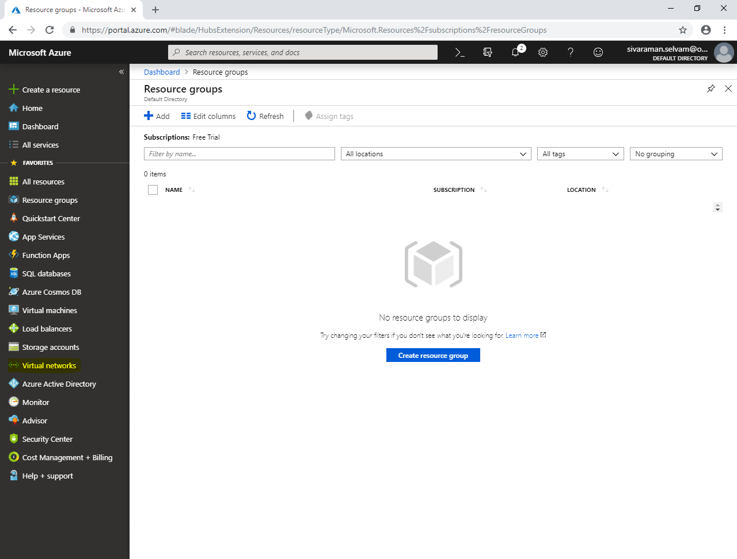

Click **“Add”**.

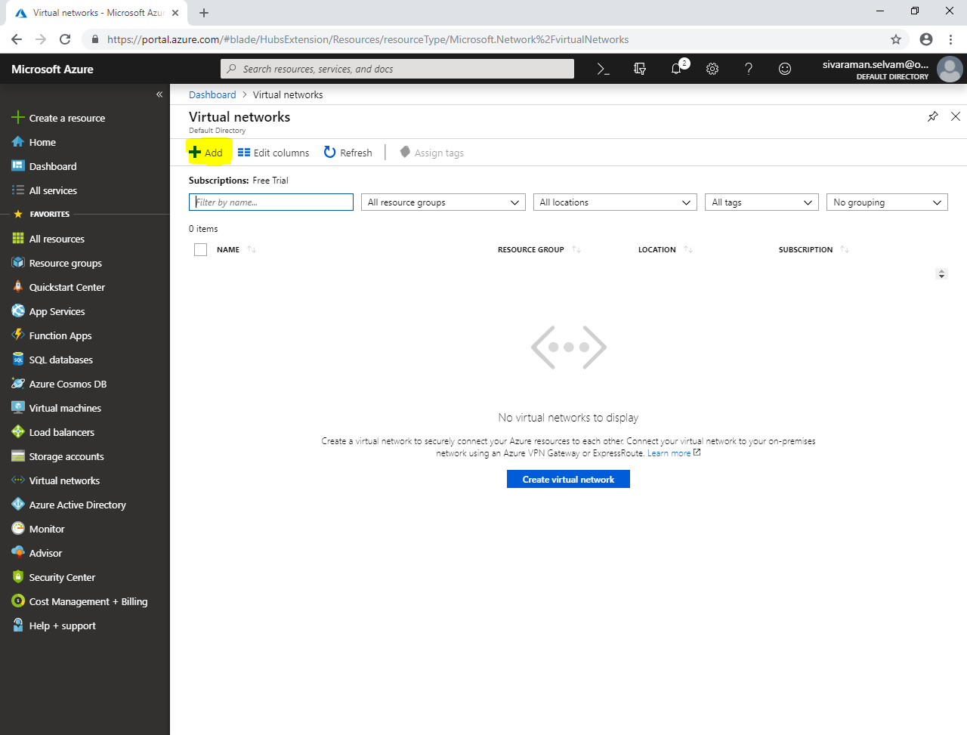

While create **“Virtual network”.**

Type **“Name”** as **“SANS-MCSE”**.

Type **“Address space”** as **“10.0.0.0/16”**.

Select **“Subscription”** as **“SansboundAzureClass”**.

Select **“Location”** as **“Central US”**.

Type **“Subnet”** name as “**SANS-MCSEPubSubnet”.**

Type **“Address range”** as **“10.0.1.0/24”**.

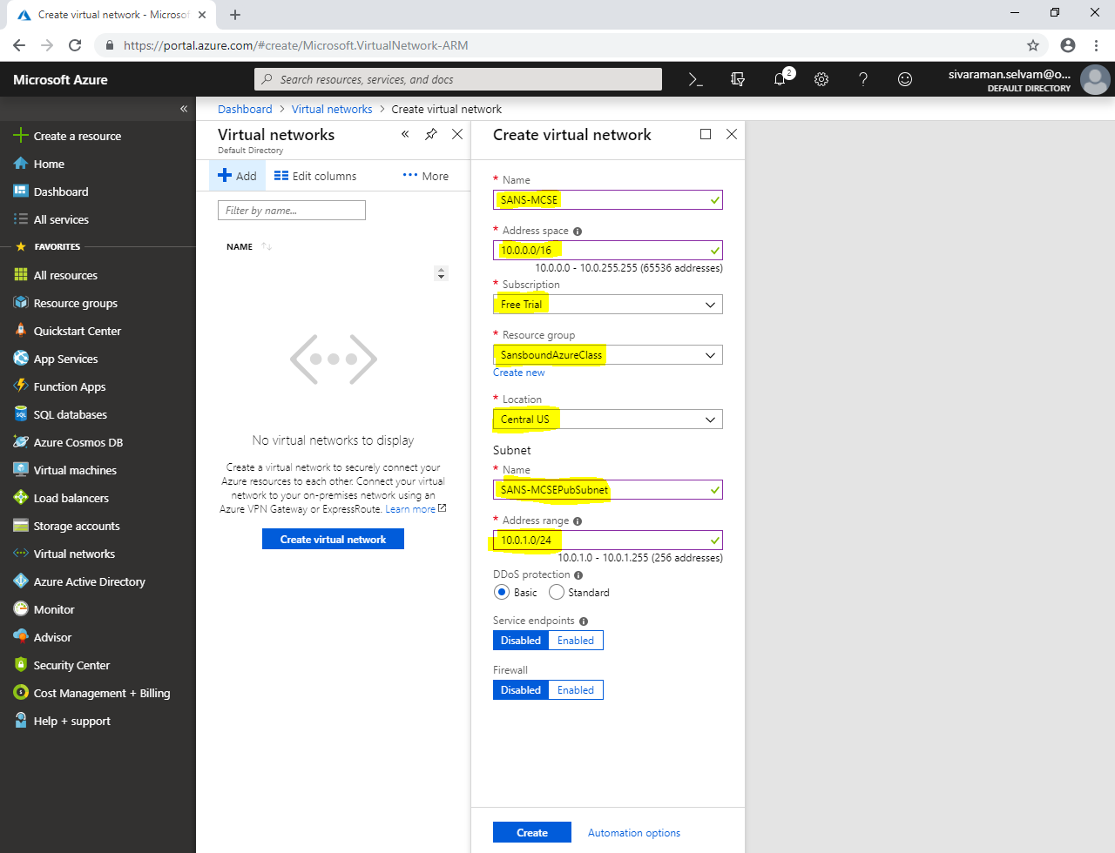

Click **“Create”**.

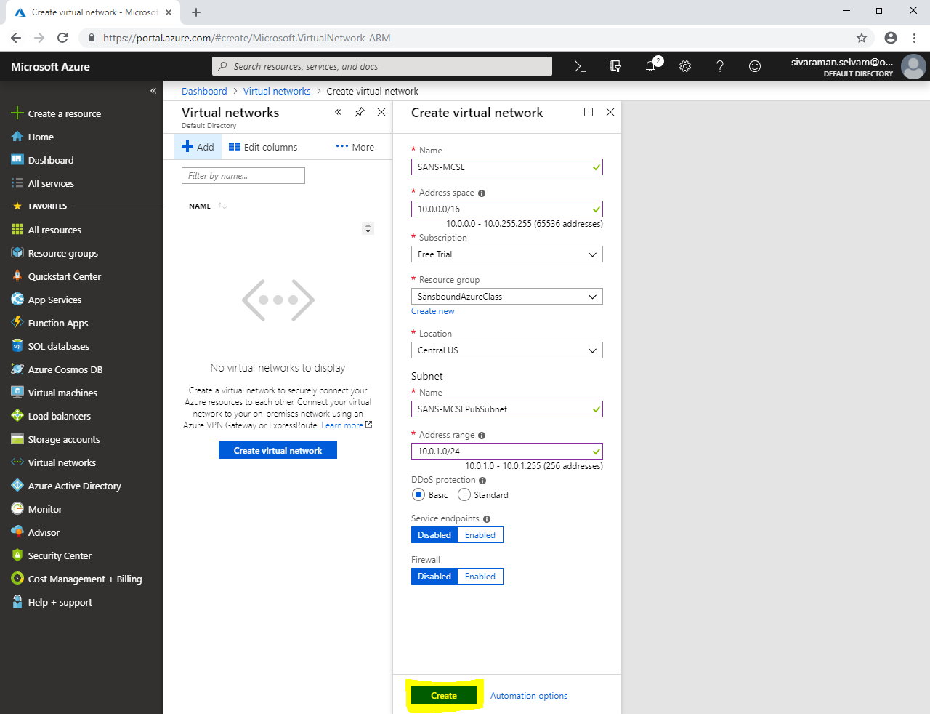

Click **“Add”.**

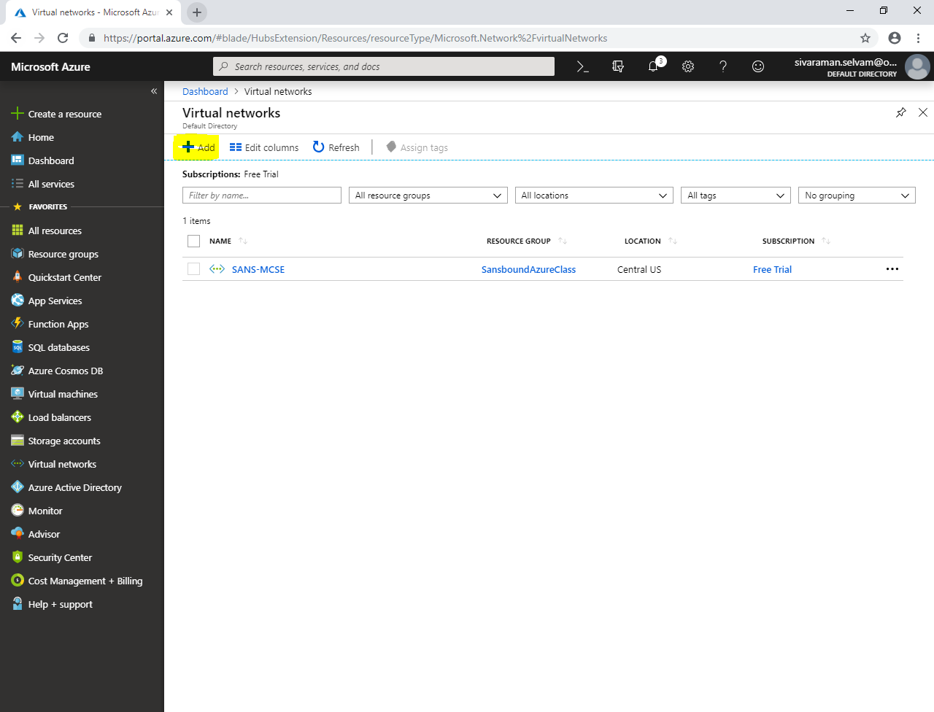

While create **“Virtual network”,**

Type **“Name”** as **“172.16.0.0/16”**.

Select **“Subscription”** as **“Free Trial”.**

Select **“Resource group”** as **“SansboundAzureClass”**.

Select **“Location”** as **“Central US”**.

Type **“Subnet”** name as “**SANS-CCNA-PubSubnet”.**

Type **“Address range”** as **“172.16.1.0/24”**.

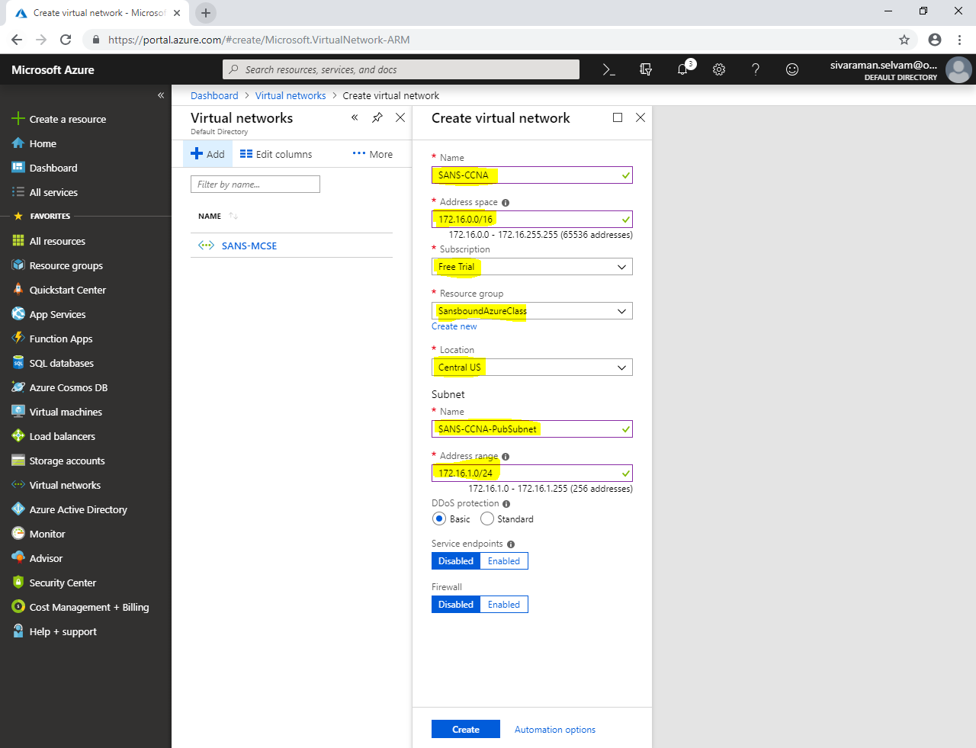

Click **“Create”**.

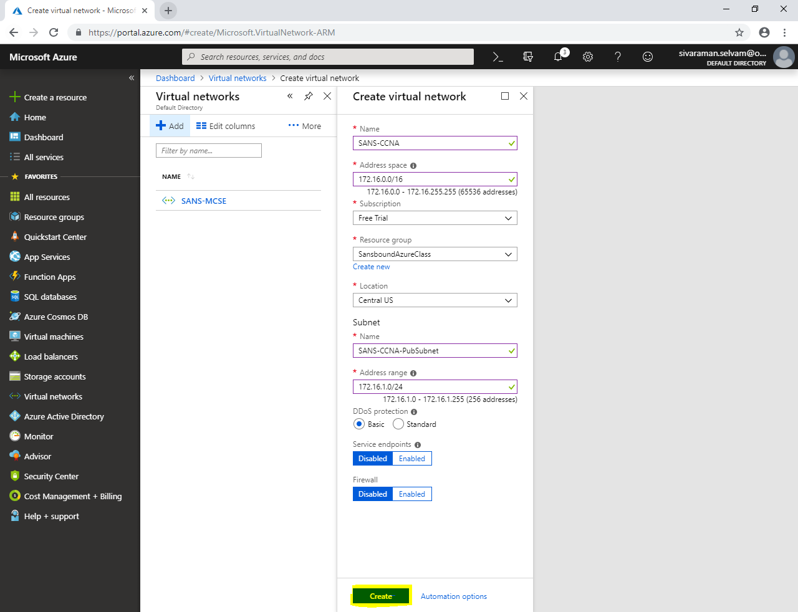

Click **“Refresh”** to view the newly created Virtual network.

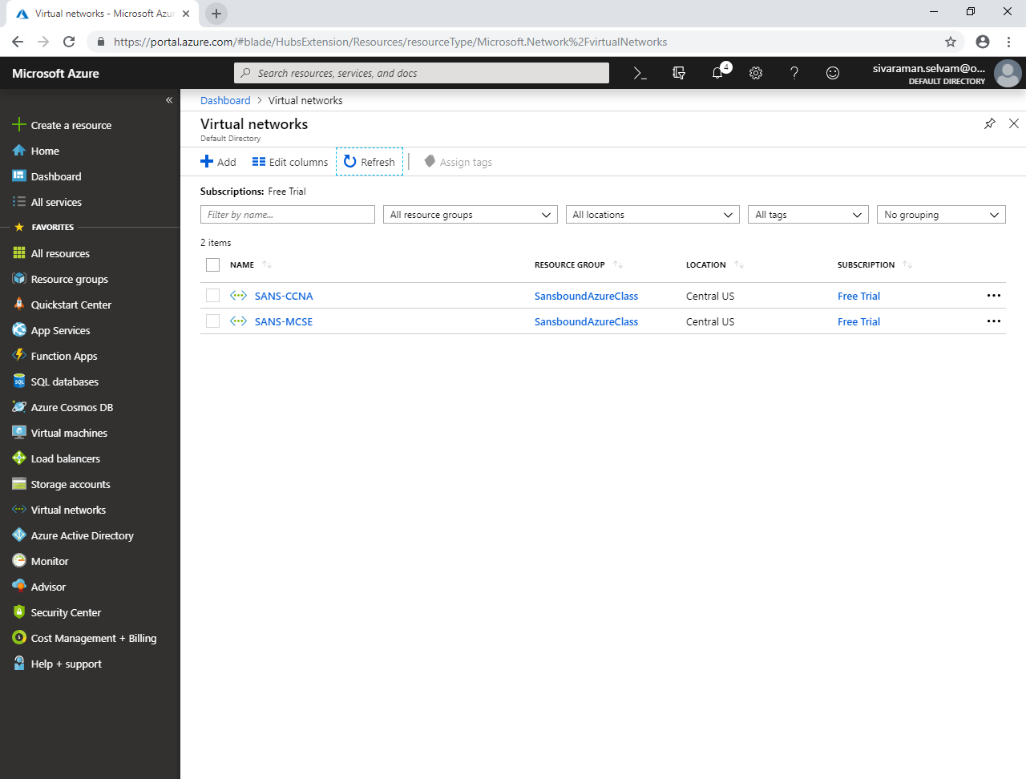

Click **“Virtual machines”**.

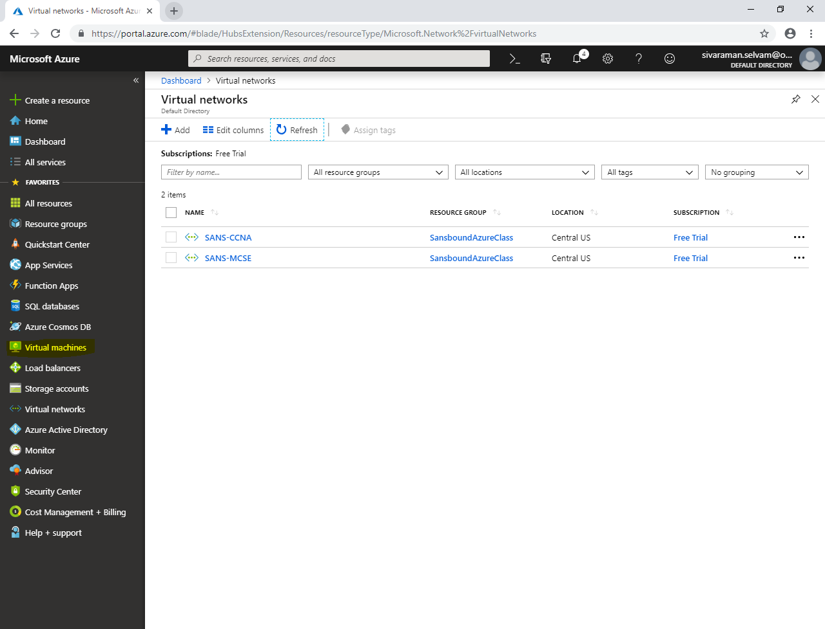

In **“Virtual machines”**,

Click **“Add”**.

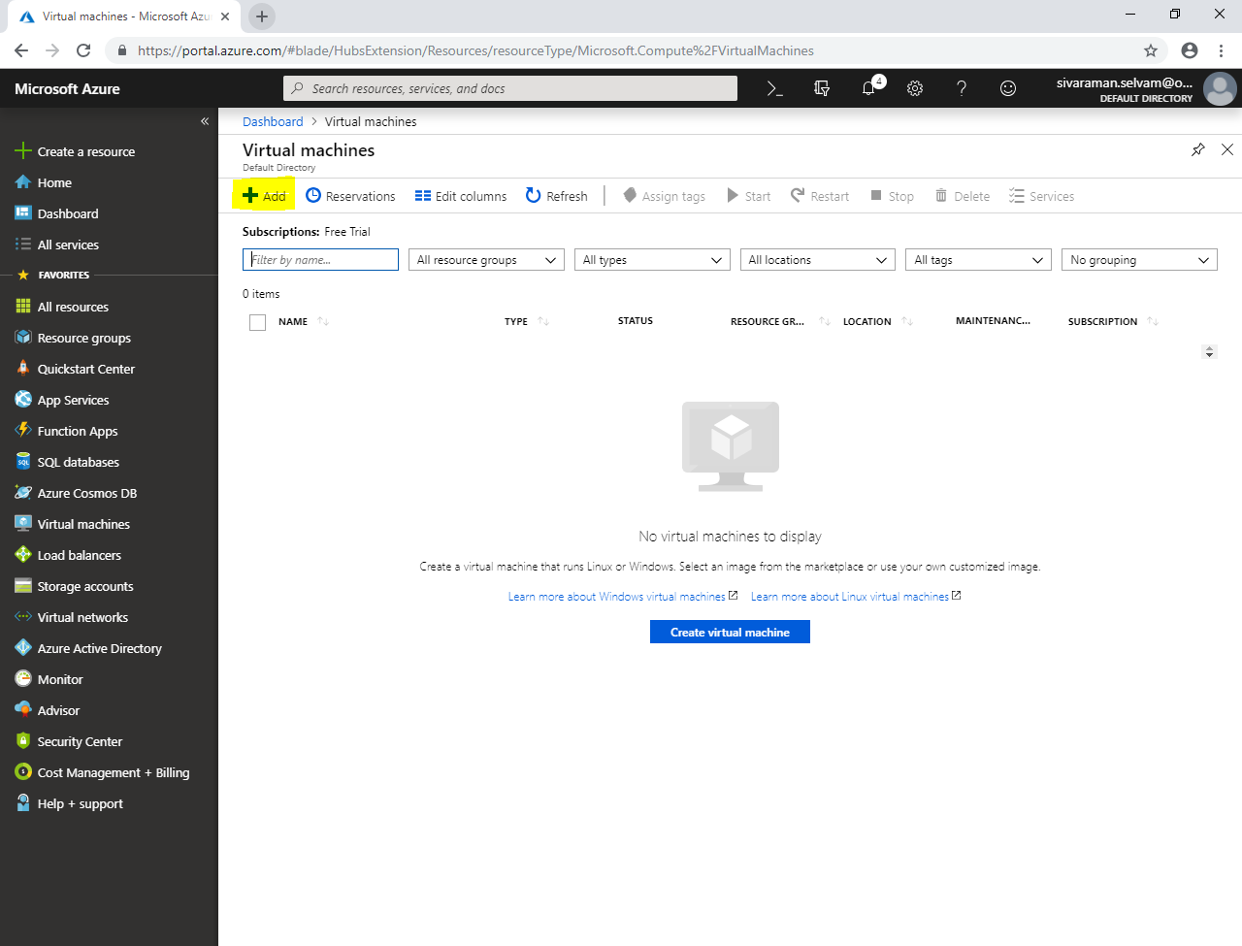

While create virtual machine,

Select **“Subscription”** as **“Free Trial”.**

Select **“Resource group”** as **“SansboundAzureClass”**.

Type **“Virtual machine name”** as **“MCSEVM-Azure”**.

Select **“Region”** as **“Central US”**.

Select **“Image”** as **“Windows Server 2008 R2 SP1”**.

Change **“Virtual machine size”** as **“Standard B1s”**.

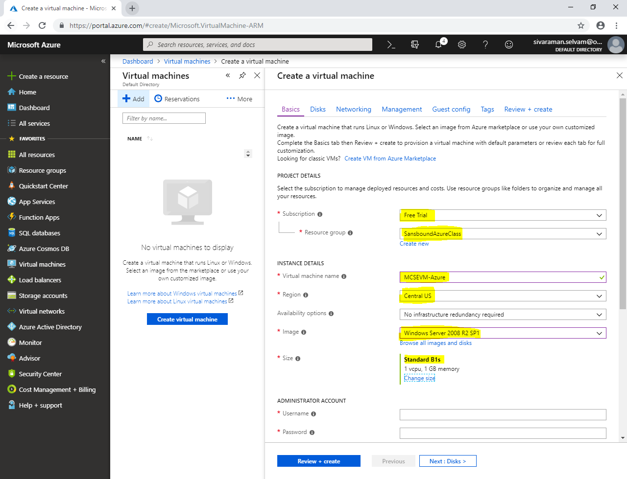

In **“Administrator Account”**,

In **“Username”** type as **“sansbound”**.

In **“Password”** of virtual machine.

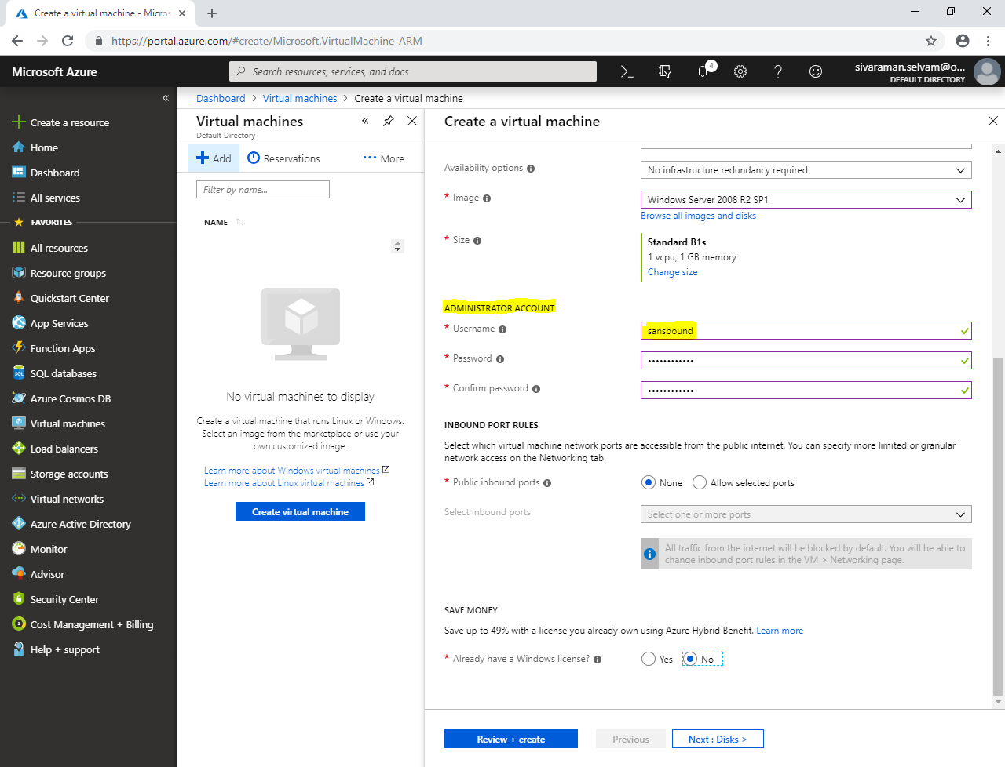

In **“Save Money”**,

Click **“Yes”** to **“Already have a windows license”**.

Need to check **“Confirmation”** box.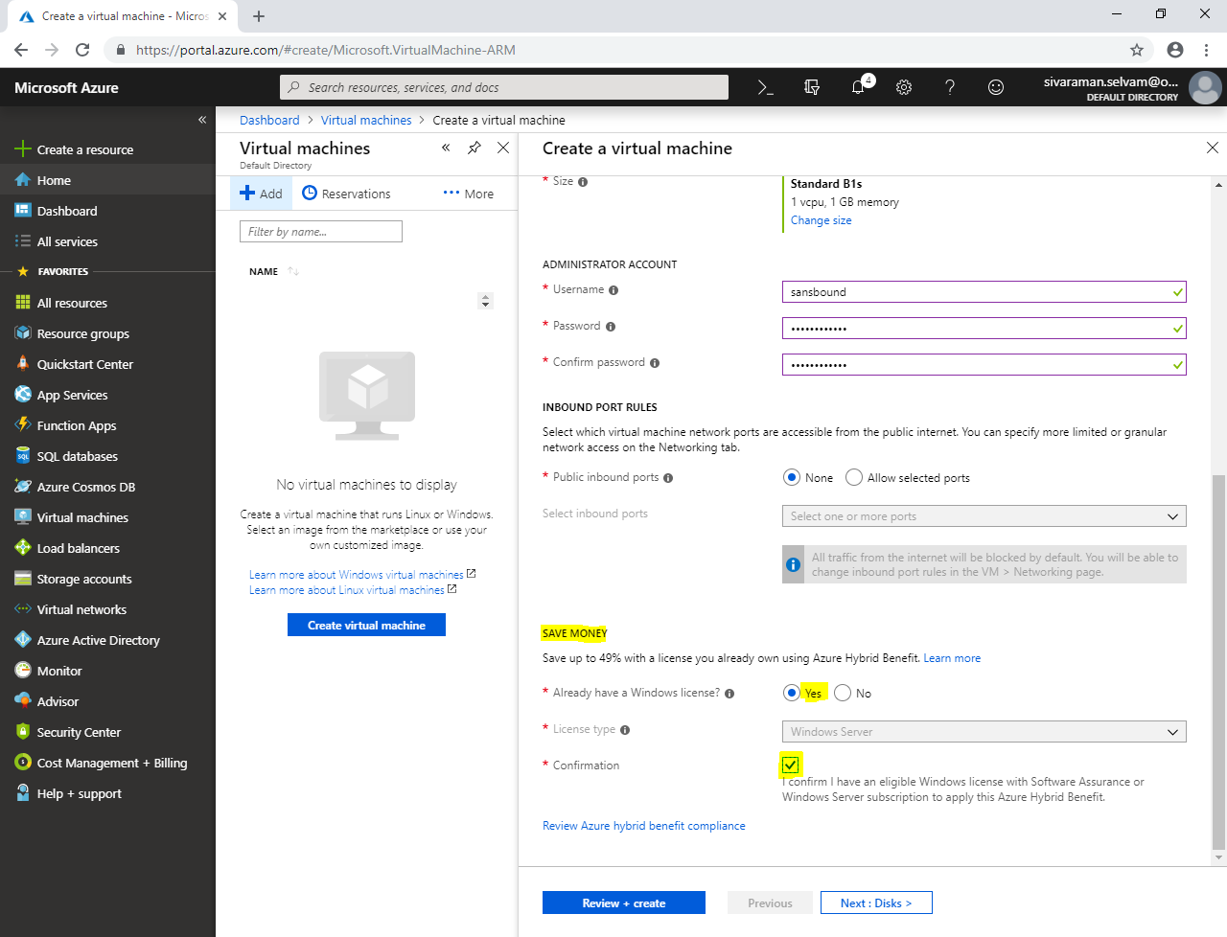

In **“Disks”**,

Click **“Next : Networking >”**.

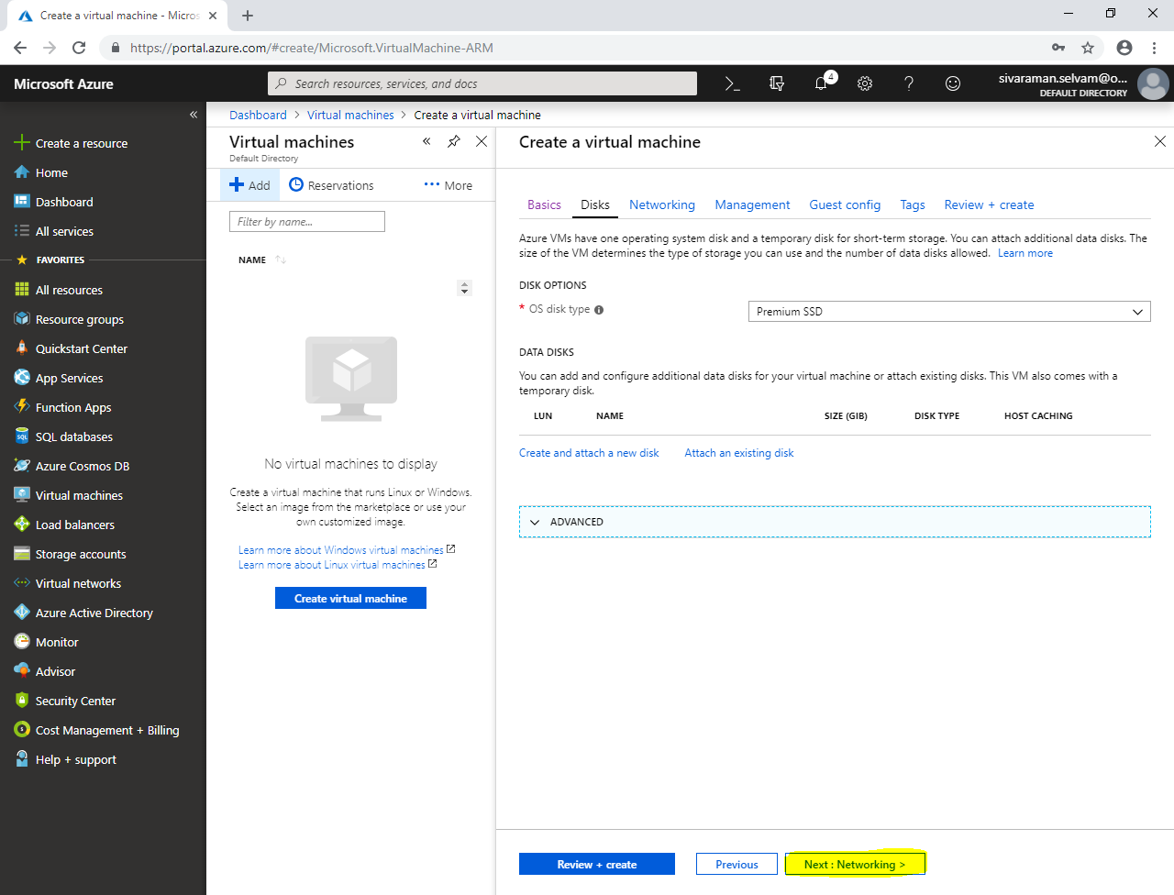

In **“Networking”**,

Create **“Virtual machine”**

Select **“Virtual network”** as **“SANS-MCSE”**.

Select **“Subnet”** as **“SANS-MCSEPubSubet”**.

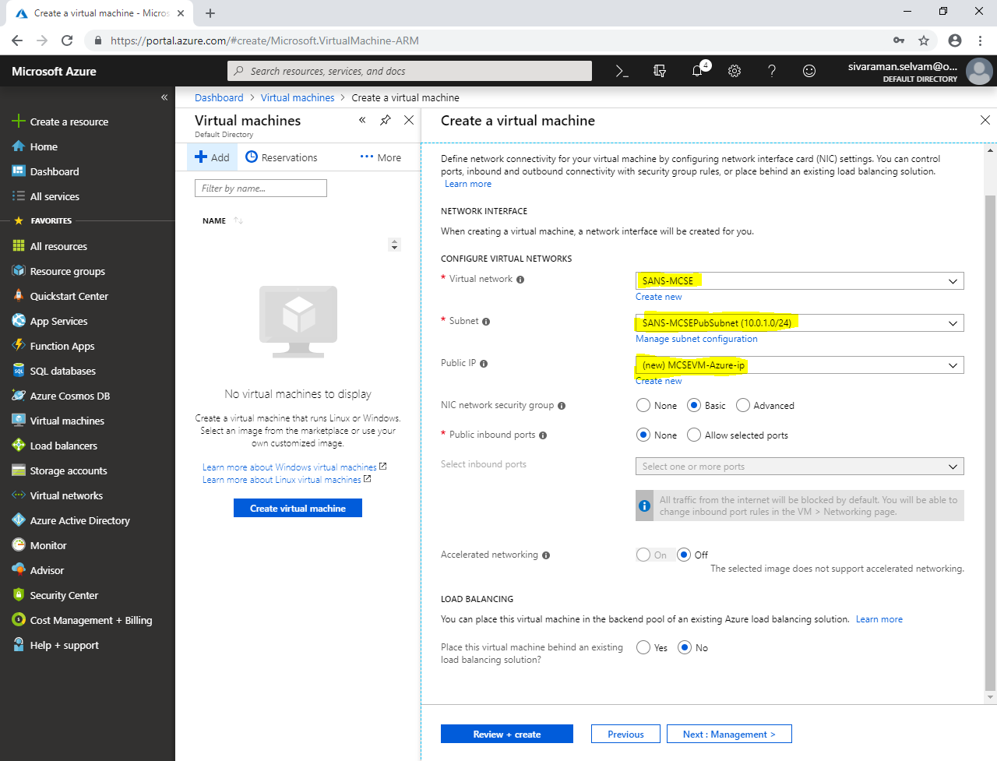

Click **“Next : Management”**.

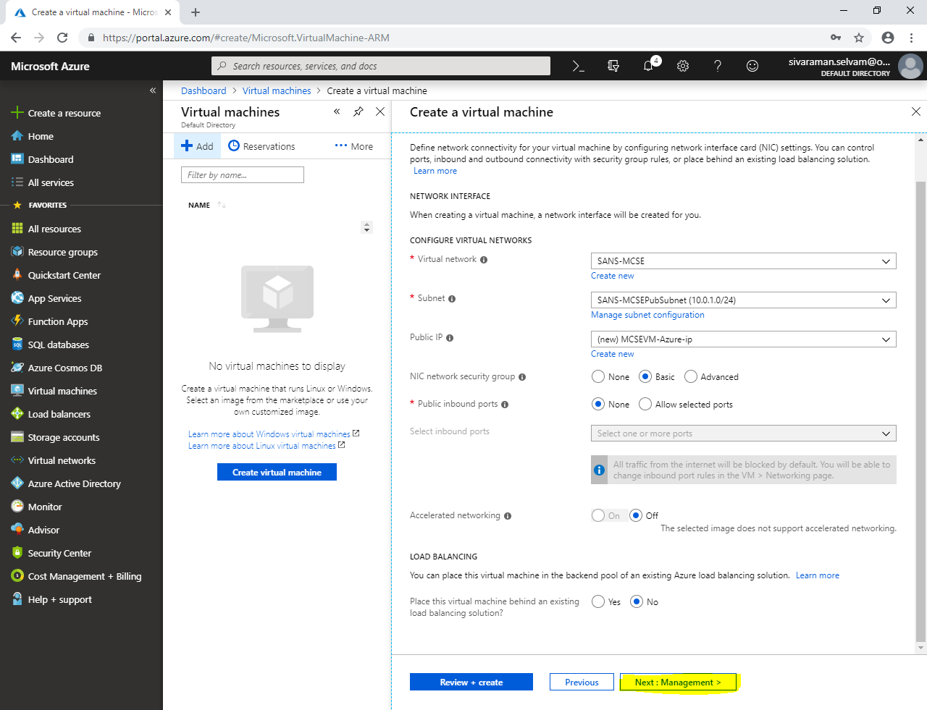

In **“Management”**,

Click **“Next : Guest config”**.

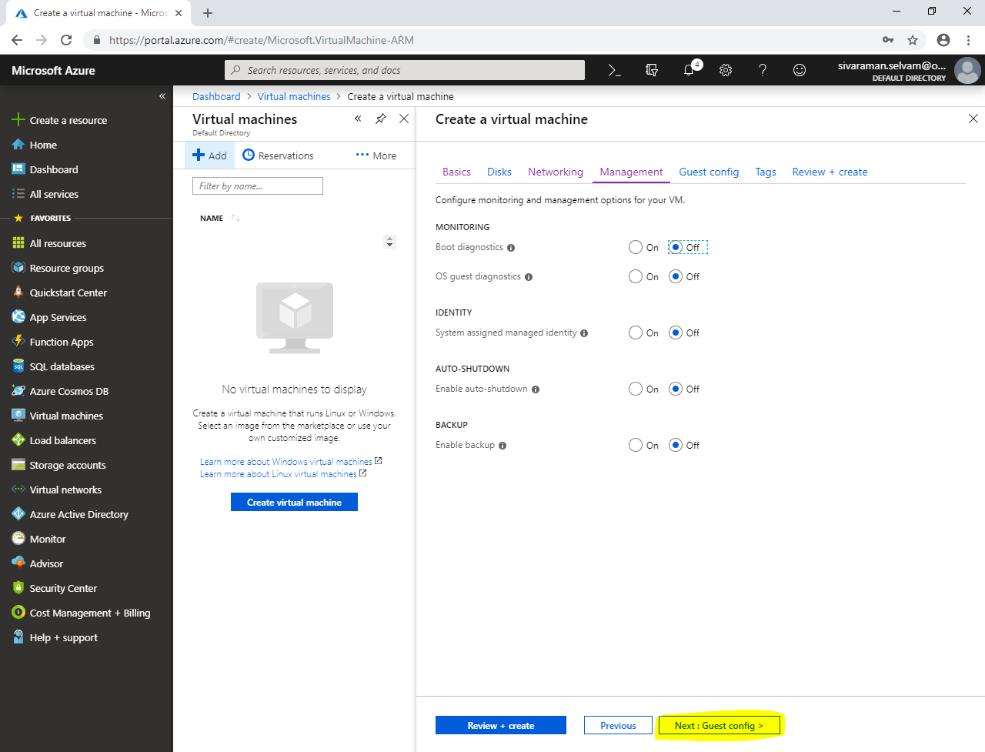

In **“Guest config”**,

Click **“Next : Tags >”**.

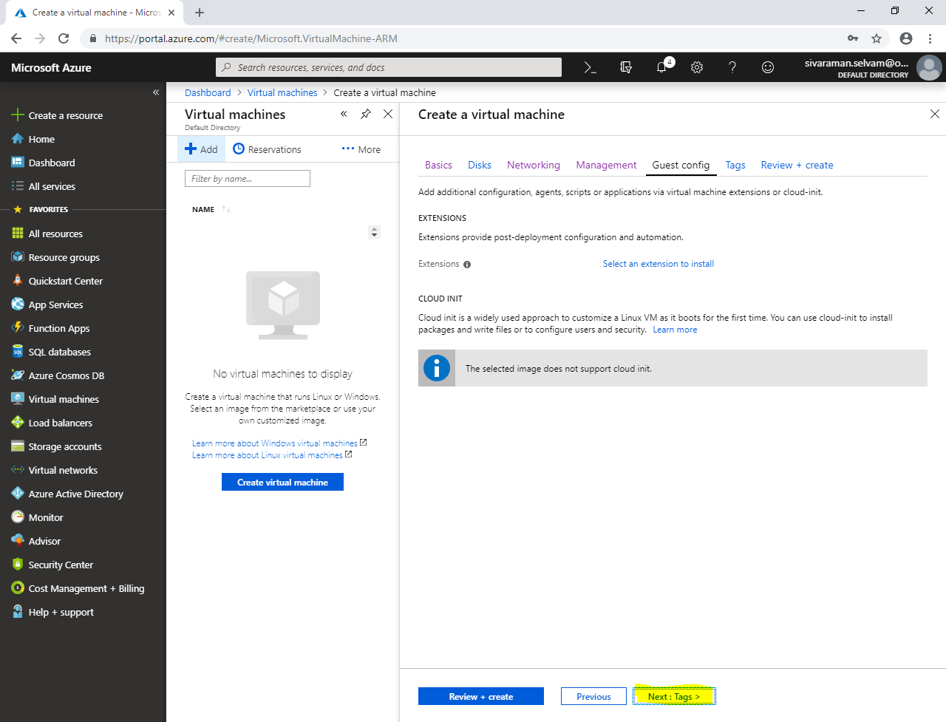

In **“Tags”**,

Click **“Next : Review + create >”**.

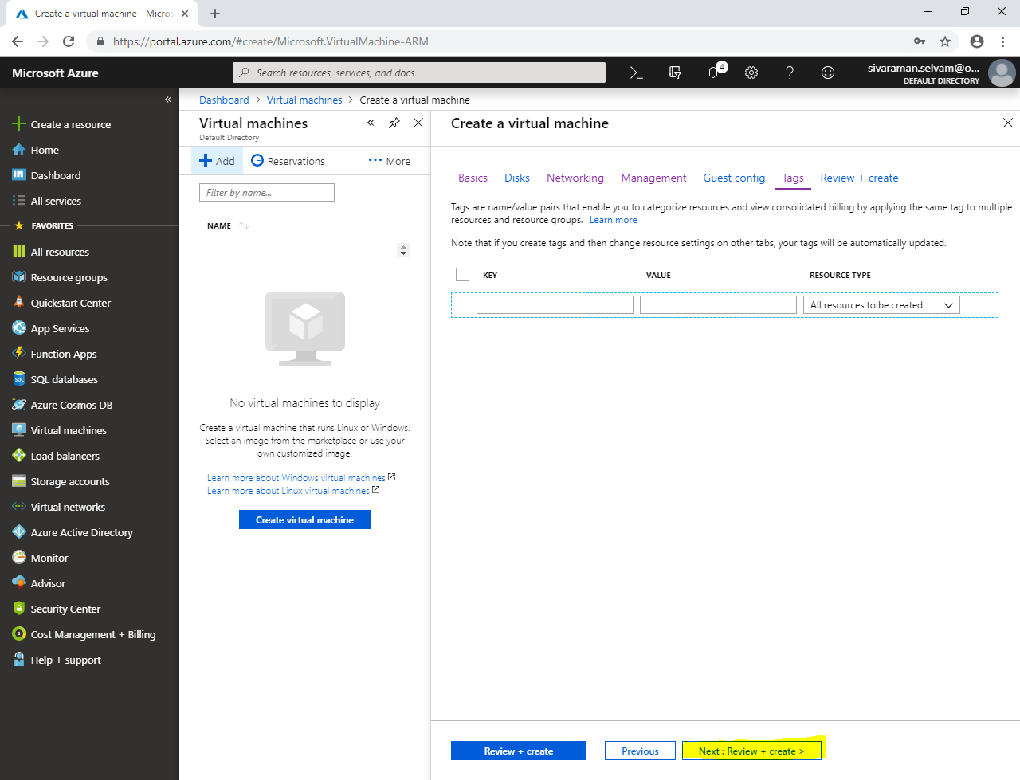

Click **“Create”**.

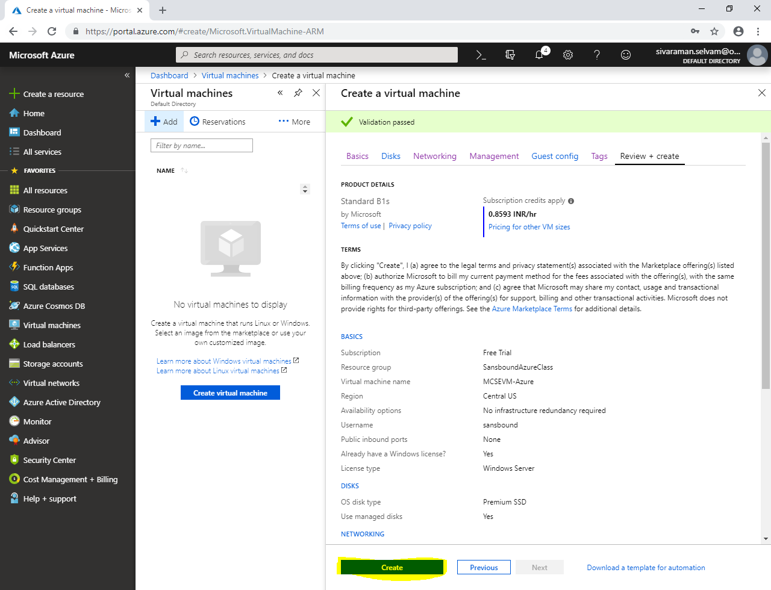

Click **“Virtual machines”** in left side panel.

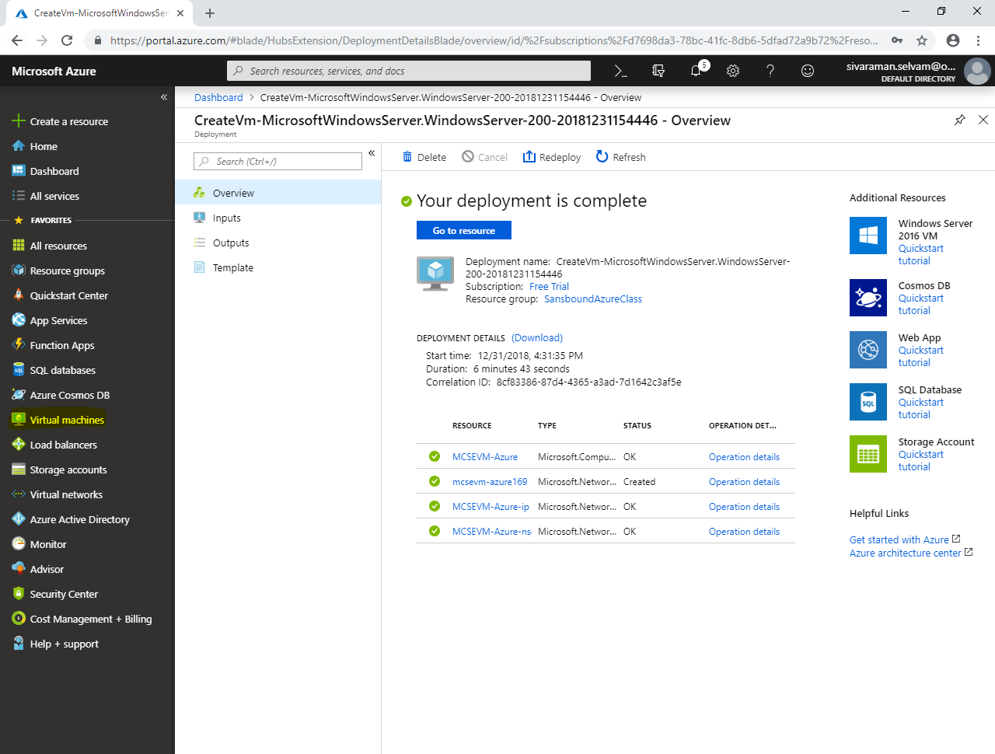

In **“Virtual machines”**, click **“Add”.**

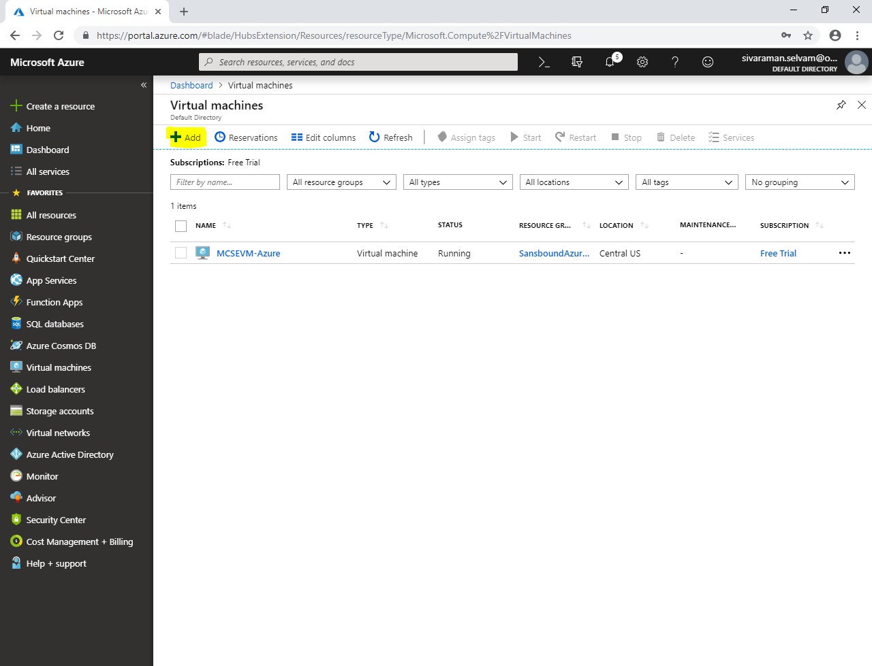

While create virtual machine,

Select **“Subscription”** as **“Free Trial”**.

Select **“Resource group”** as **“SansboundAzureClass”**.

In **“Virtual machine name”** as **“CCNAVM-Azure”**.

Select **“Region”** as **“Central US”**.

Select **“Image”** as **“Ubuntu Server 18.04 LTS”**.

Change **“Virtual machine Size”** as **“Standard B1s”**.

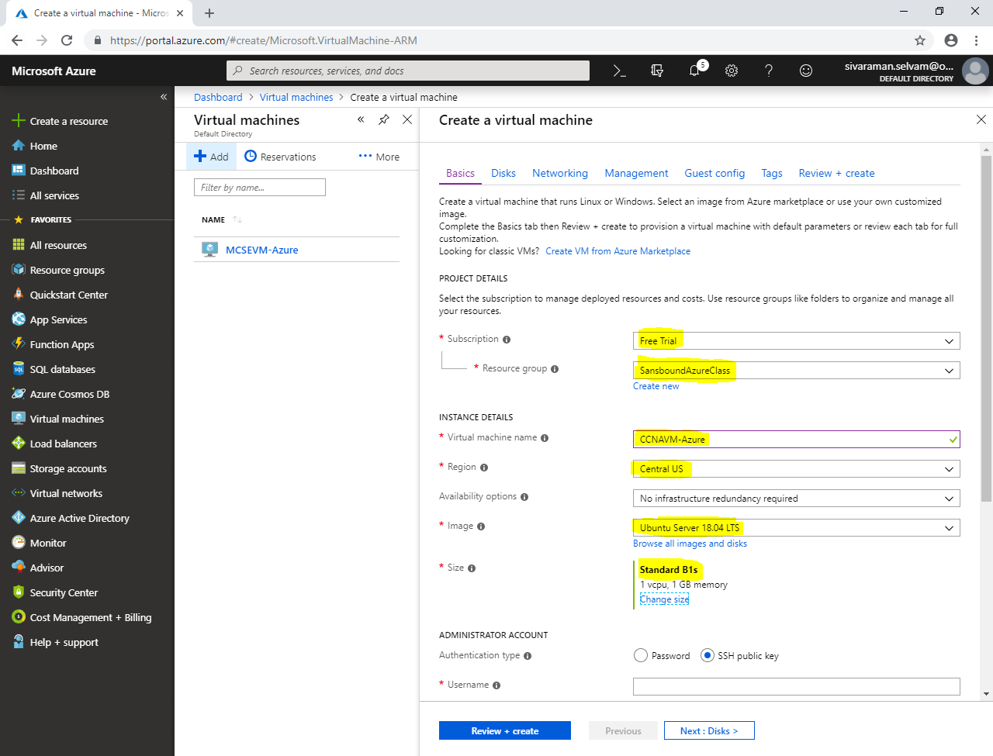

In **“Administrator Account”**,

Click **“Authentication type”** as **“Password”**.

Type **“Username”** as **“sansbound”**.

Type **“Password”** for virtual machine.

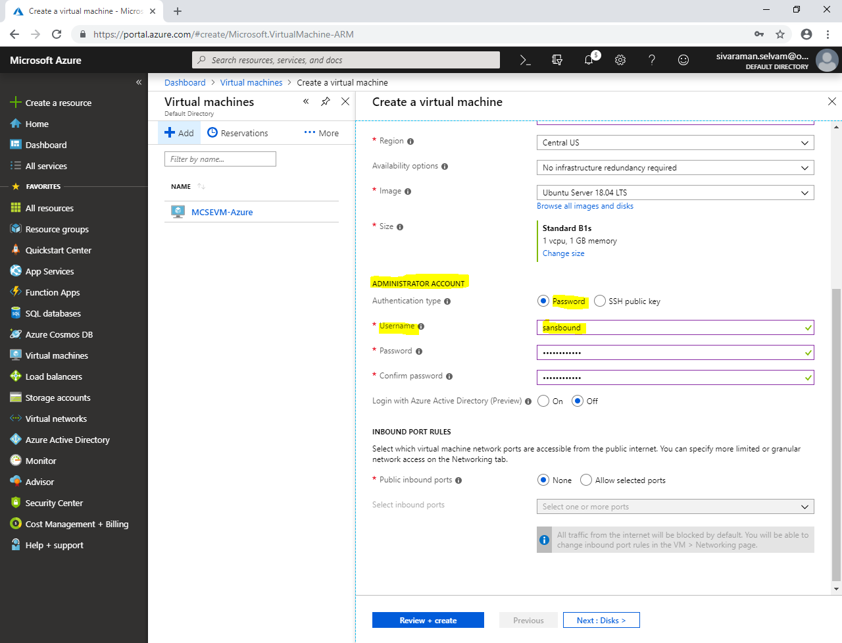

Click **“Next : Disks >”**.

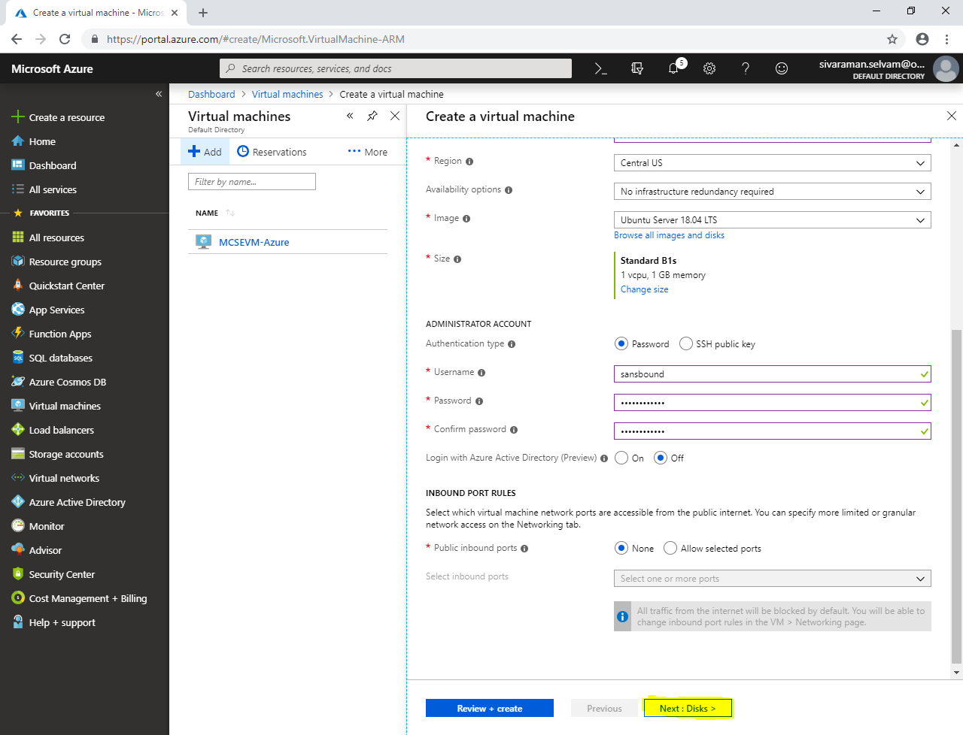

In “Disks”

Click **“Next : Networking >”**.

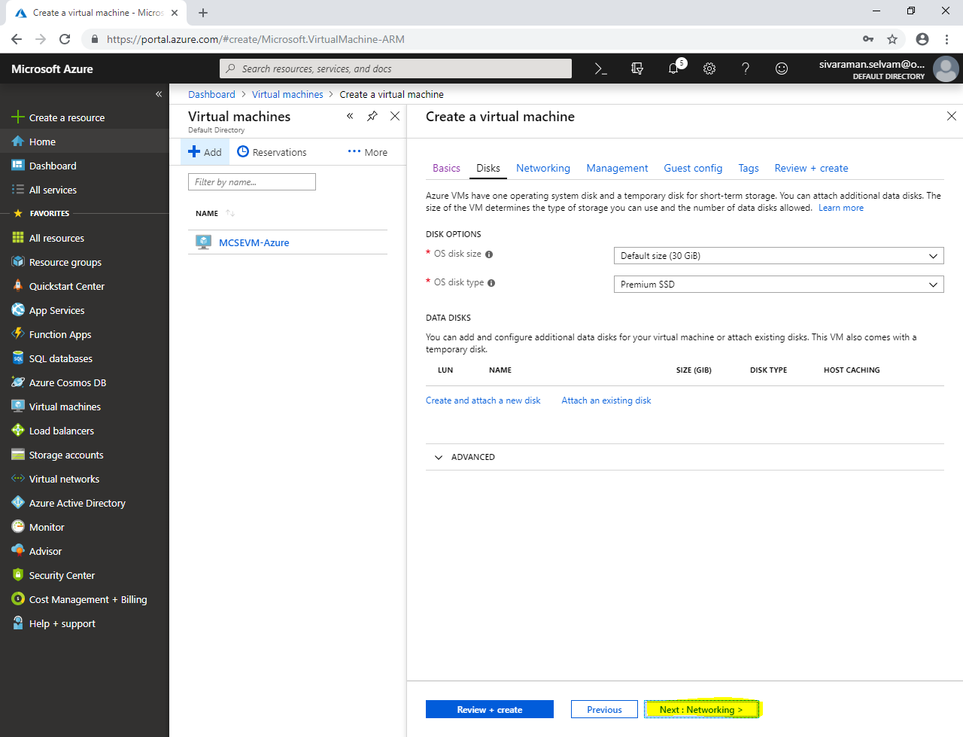

In **“Networking”**,

Select **“Virtual network”** as **“SANS-CCNA”**.

Click **“Subnet”** as **“SANS-CCNA-PubSubnet”**.

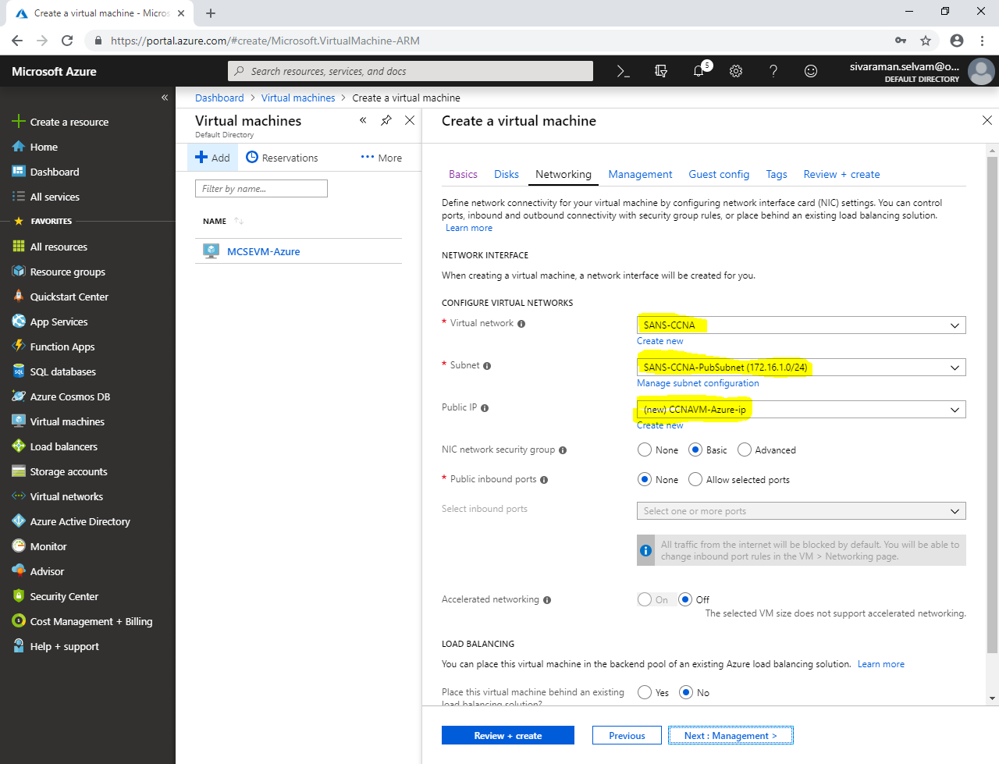

Click **“Next : Management”**.

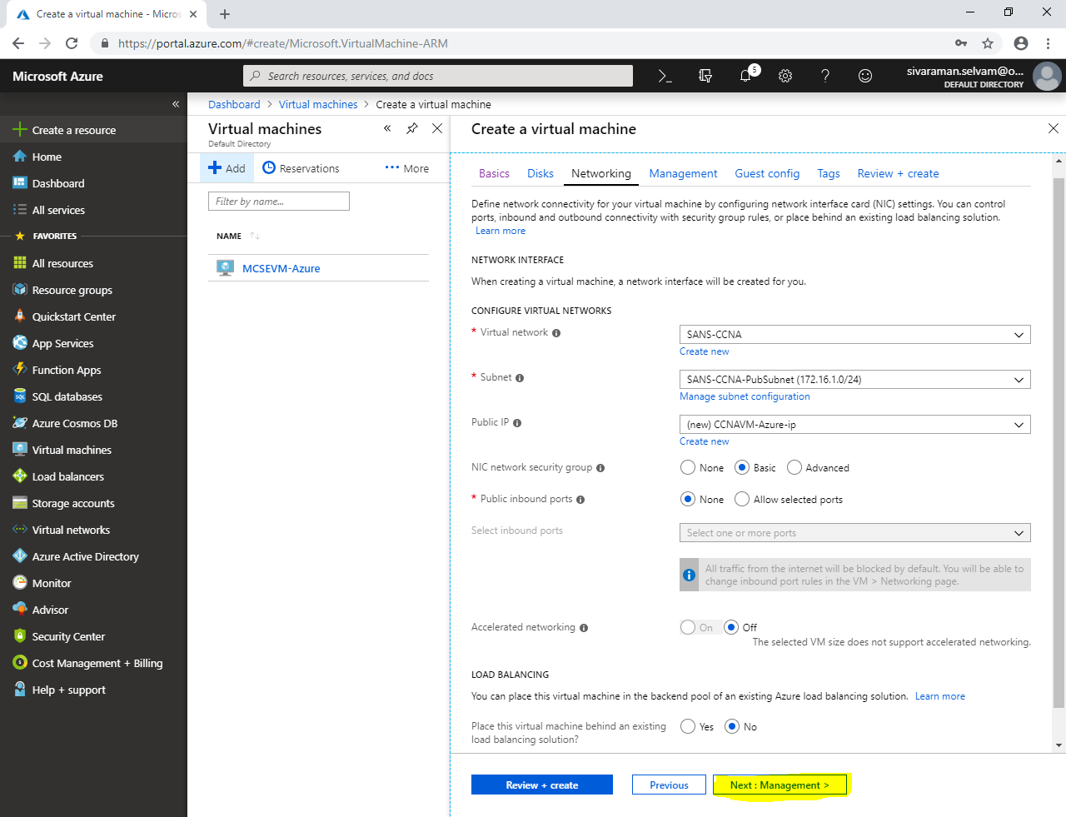

In **“Management”**,

Click **“Next : Guest config”**.

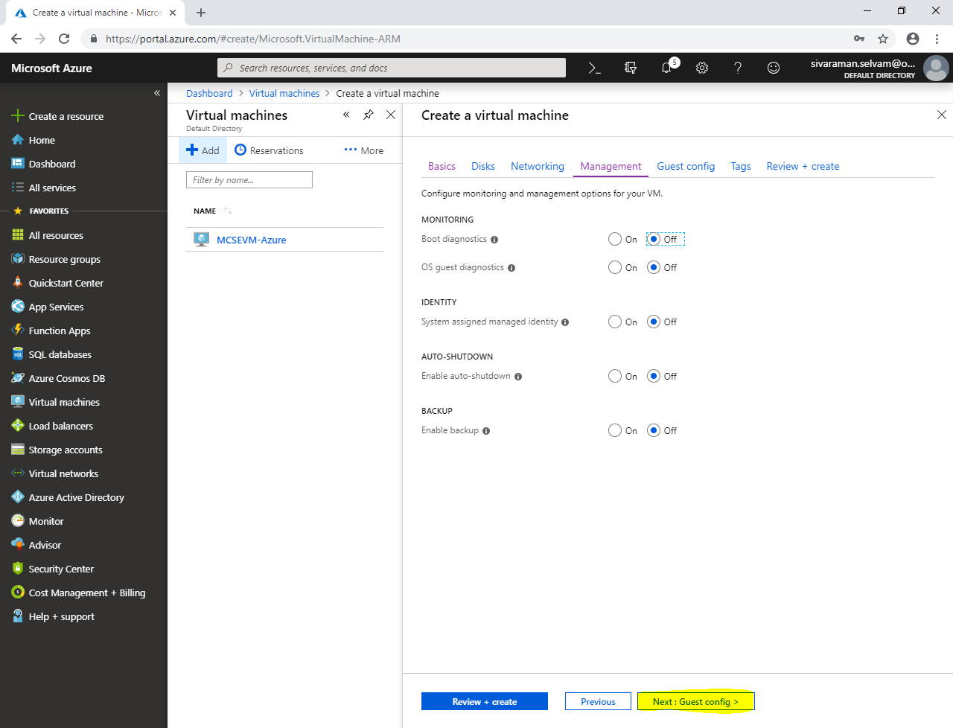

In **“Guest config”**,

Click **“Next : Tags >”**.

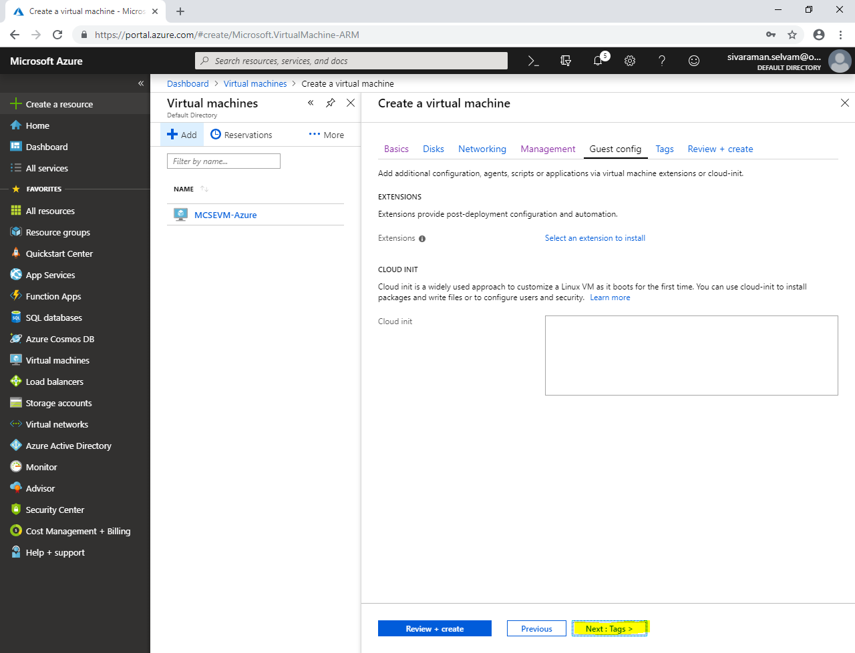

In **“Tags”**,

Click **“Next : Review + create”**.

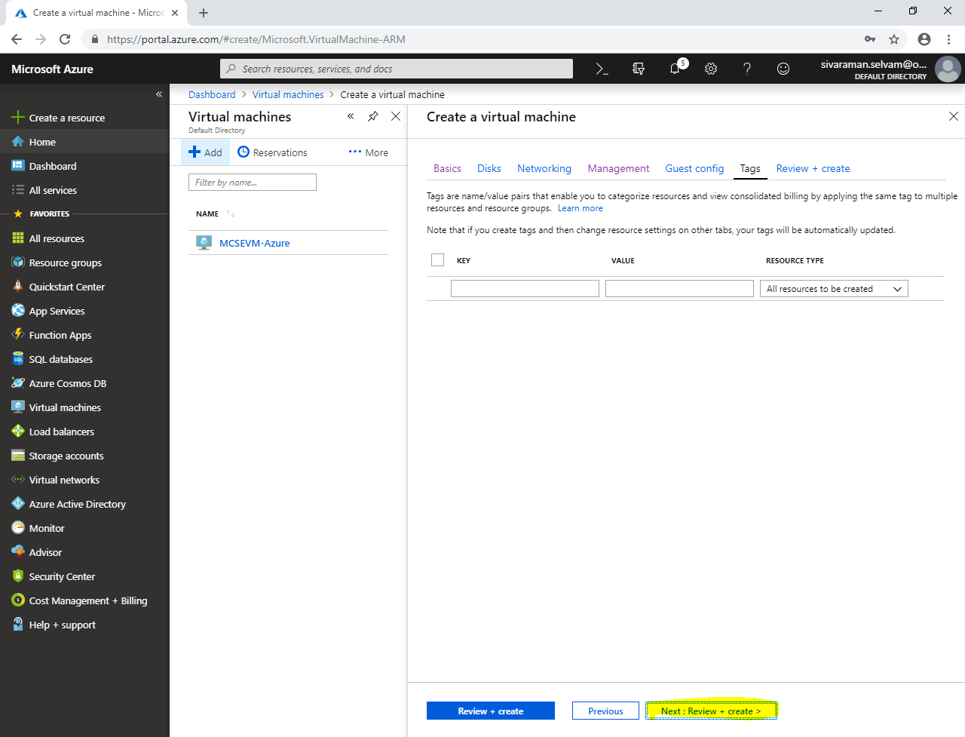

Click **“Create”**.

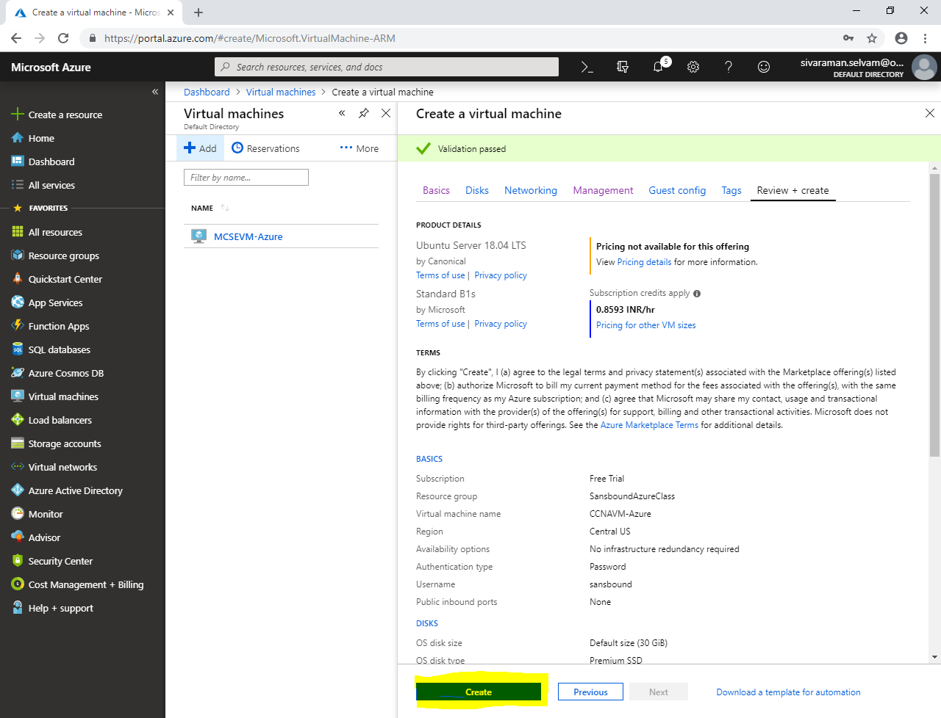

Click **“All resources”**.

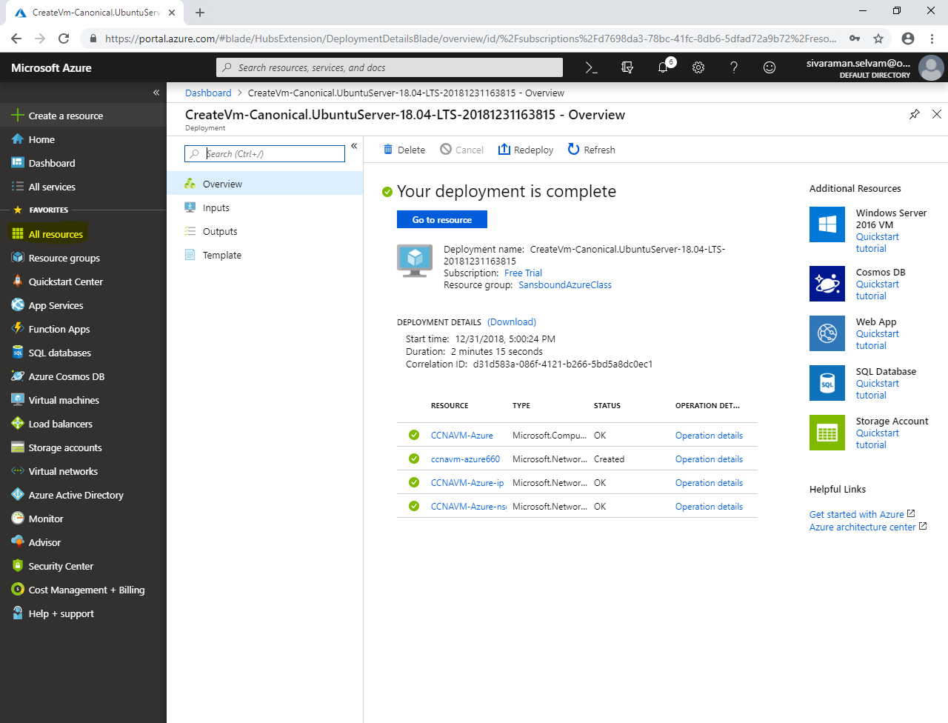

In “All resources”,

Click “Network security group” named as **“MCSEVM-Azure-nsg”**.

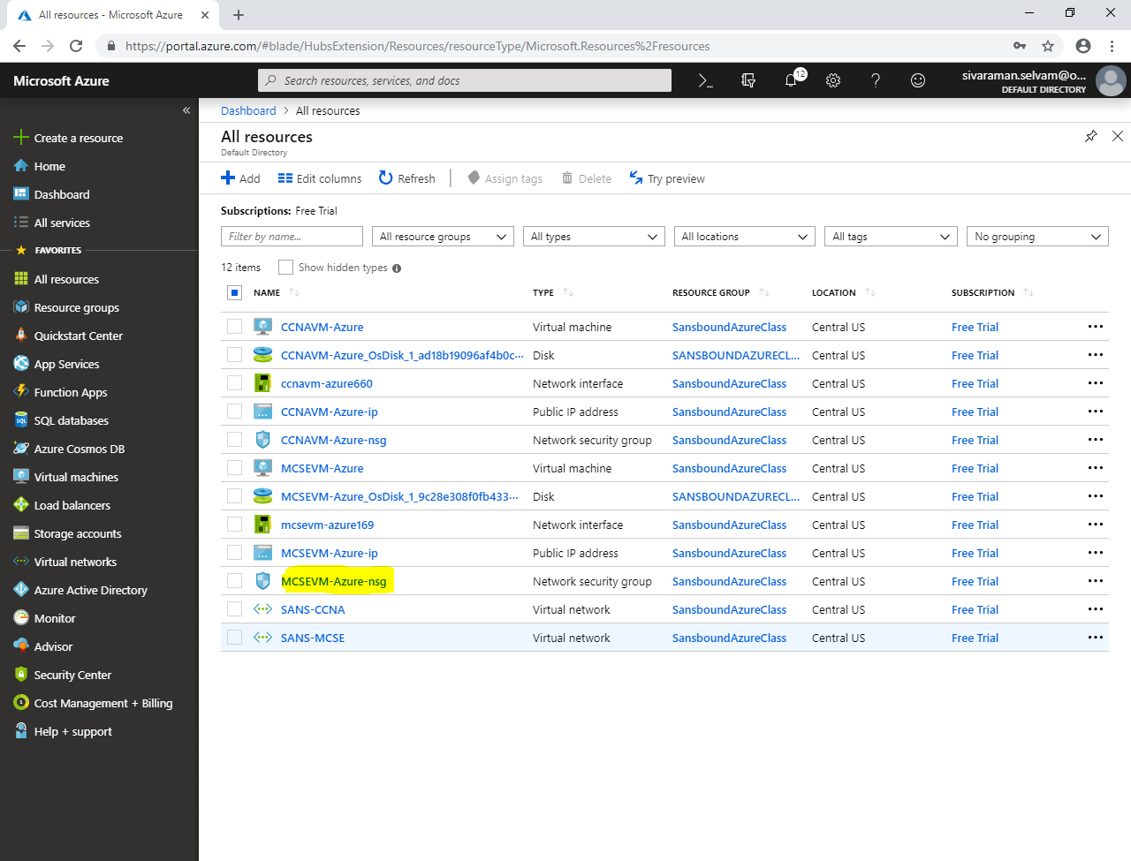

In **“MCSEVM-Azure-nsg”** network security group,

Click **“Subnets”**.

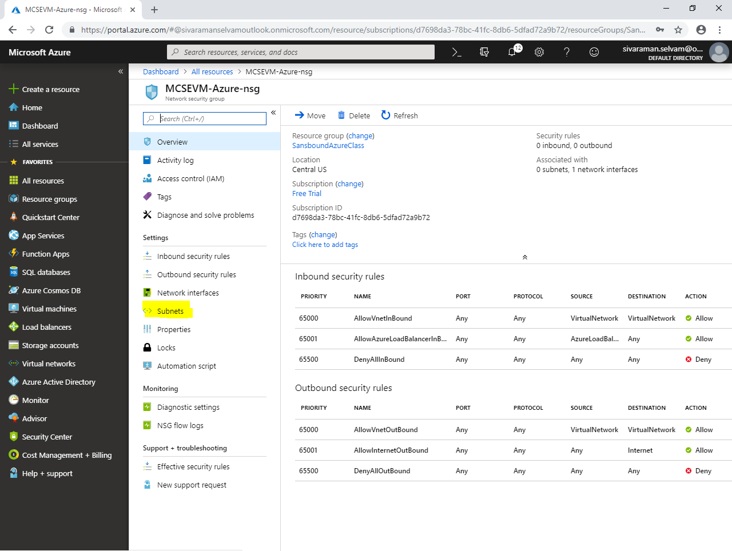

We have required to associate the “SANS-MCSEPubSubnet” to “MCSEVM-Azure-nsg” network security group.

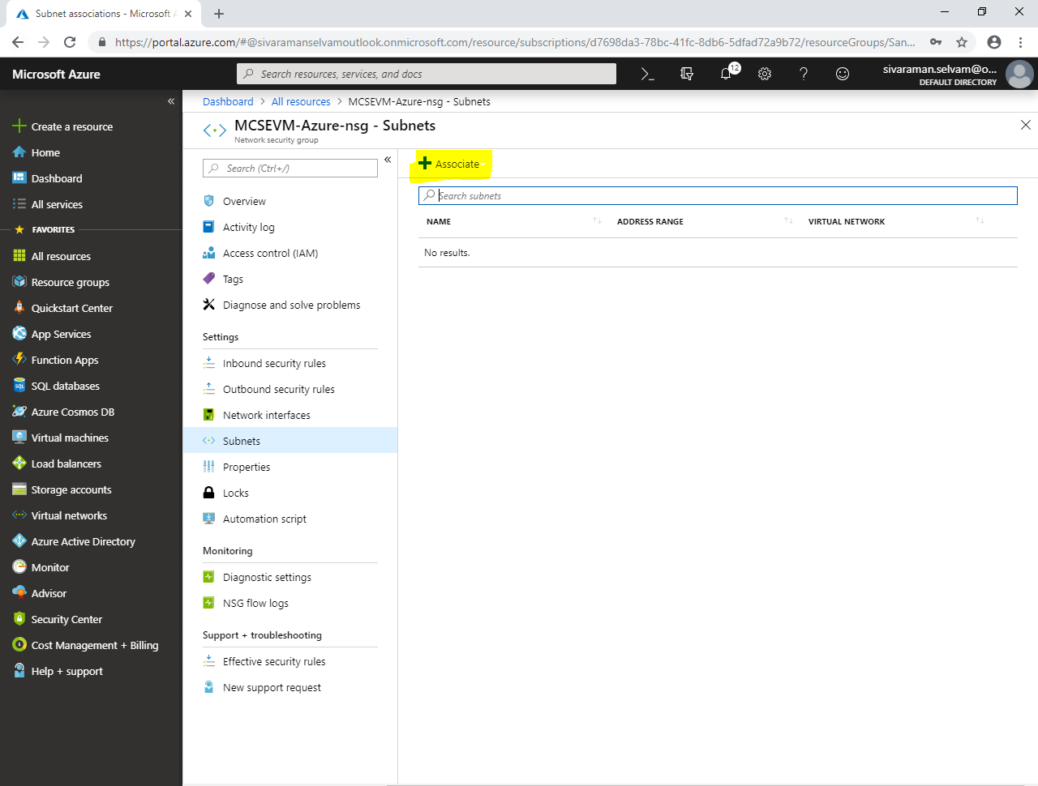

While **“Associate subnet”**,

Click **“Choose a virtual network”.**

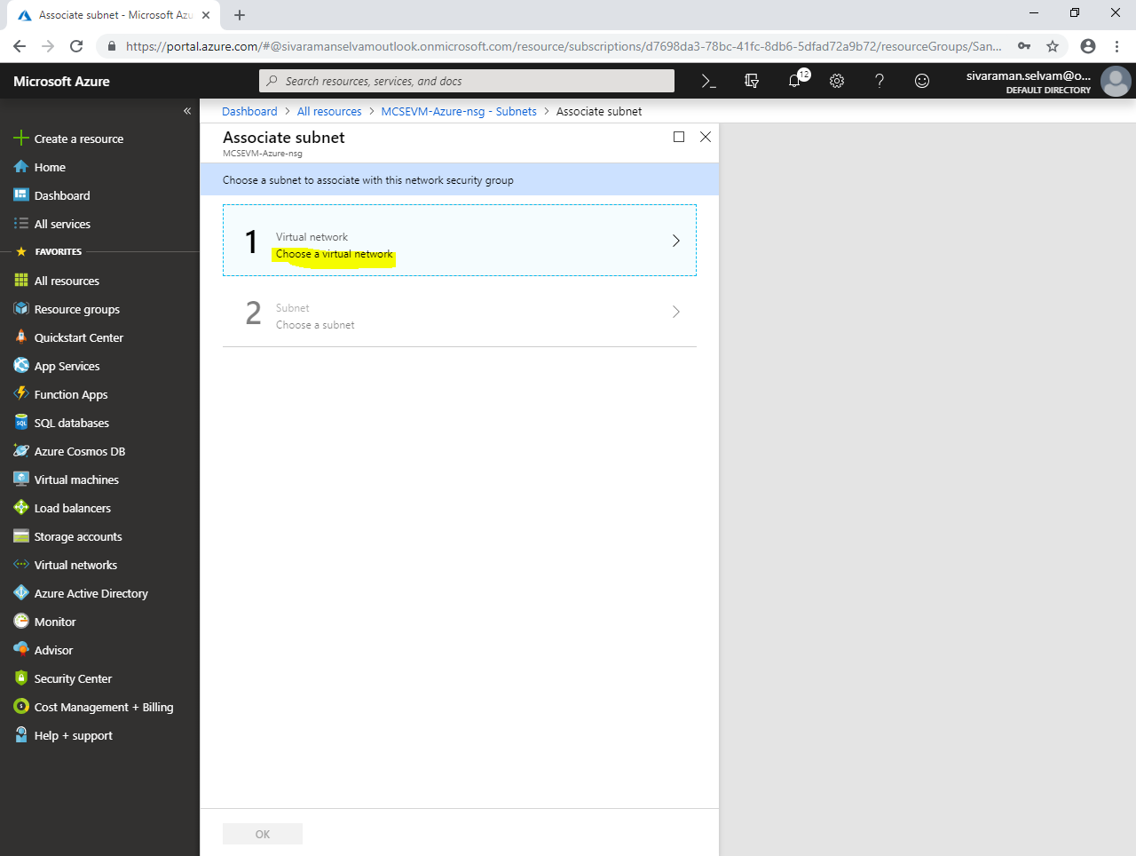

Click **“SANS-MCSE”** to select the Virtual network.

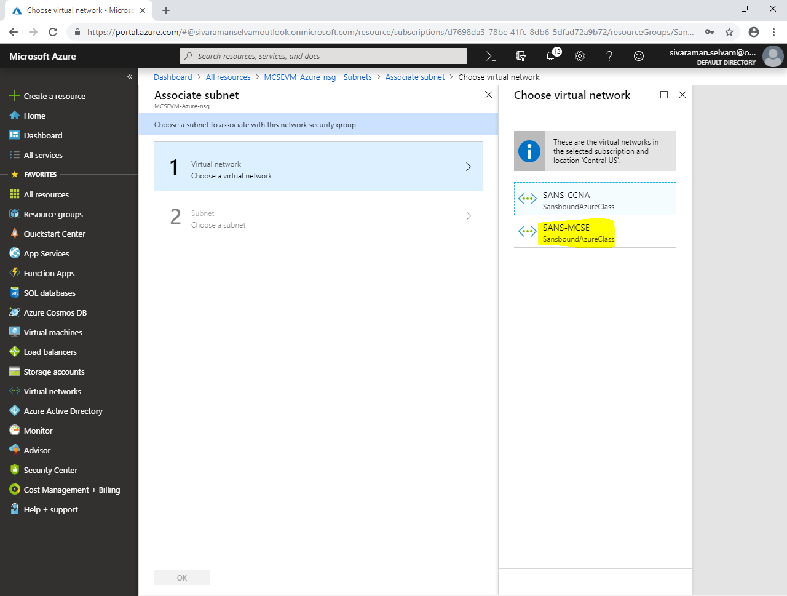

In **“Choose a subnet”** click on **“SANS-MCSEPubSubnet”**.

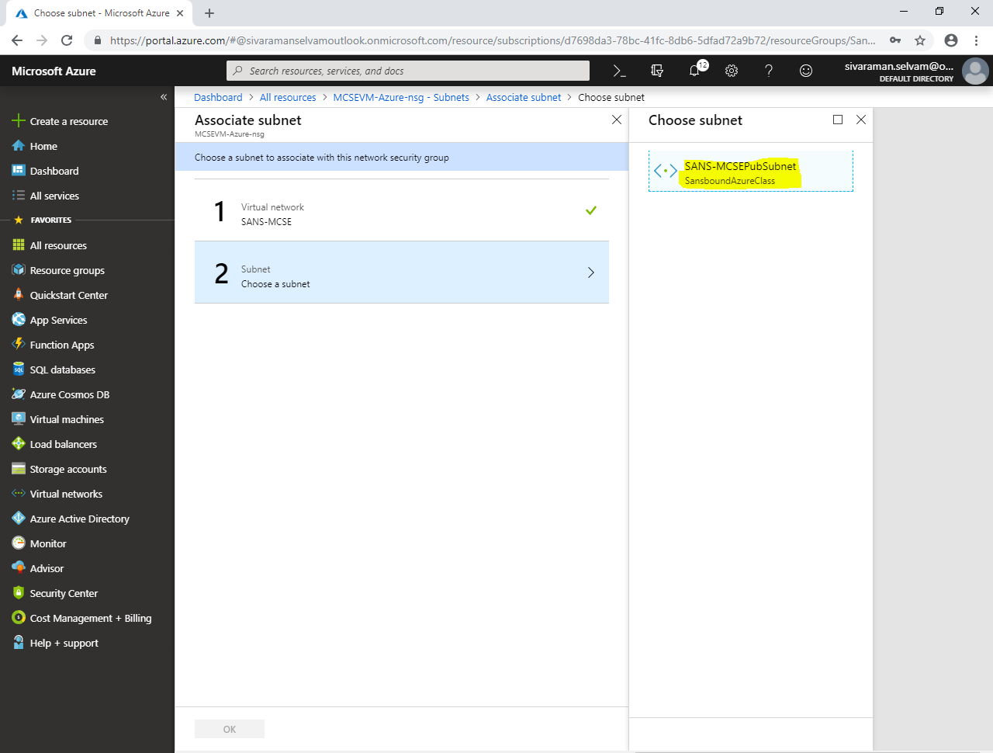

Click **“Ok”**.

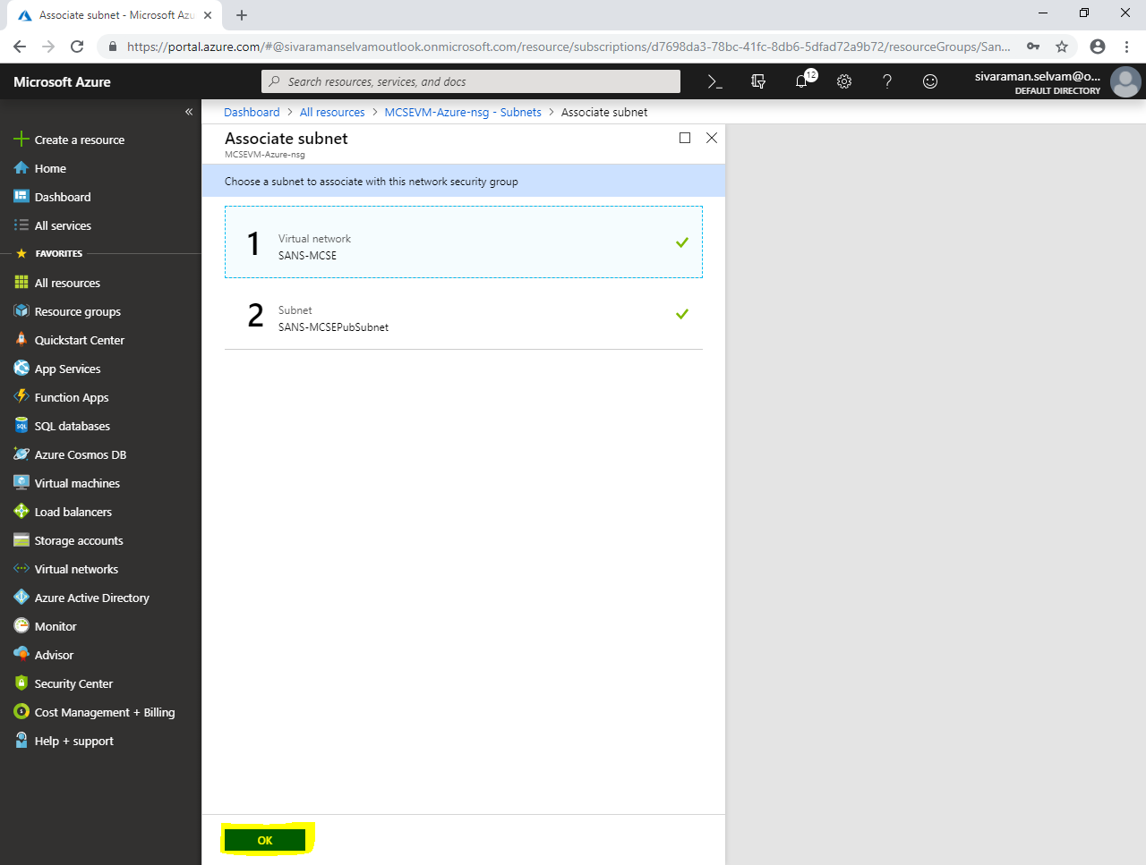

You have successfully associated the **“SANS-MCSEPubSubnet”** subnet with **“MCSEVM-Azure-nsg”** network security group.

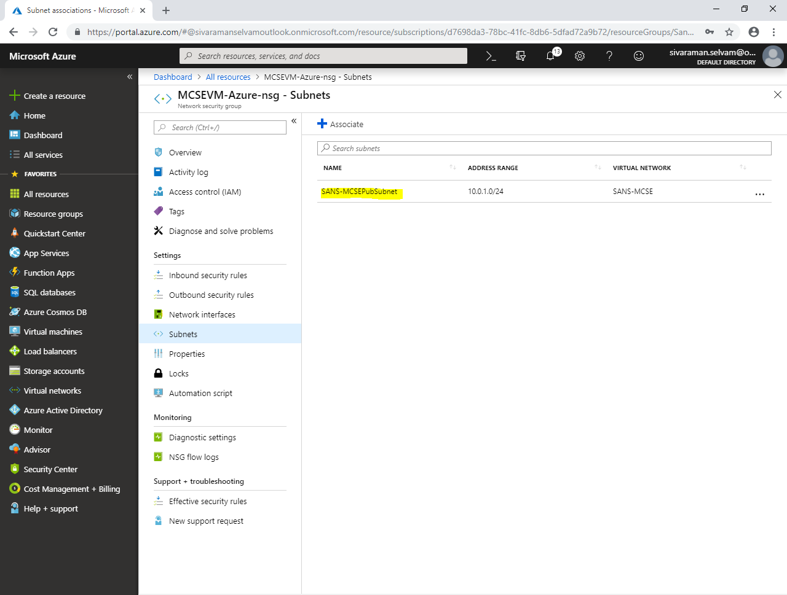

Click **“All resources”**.

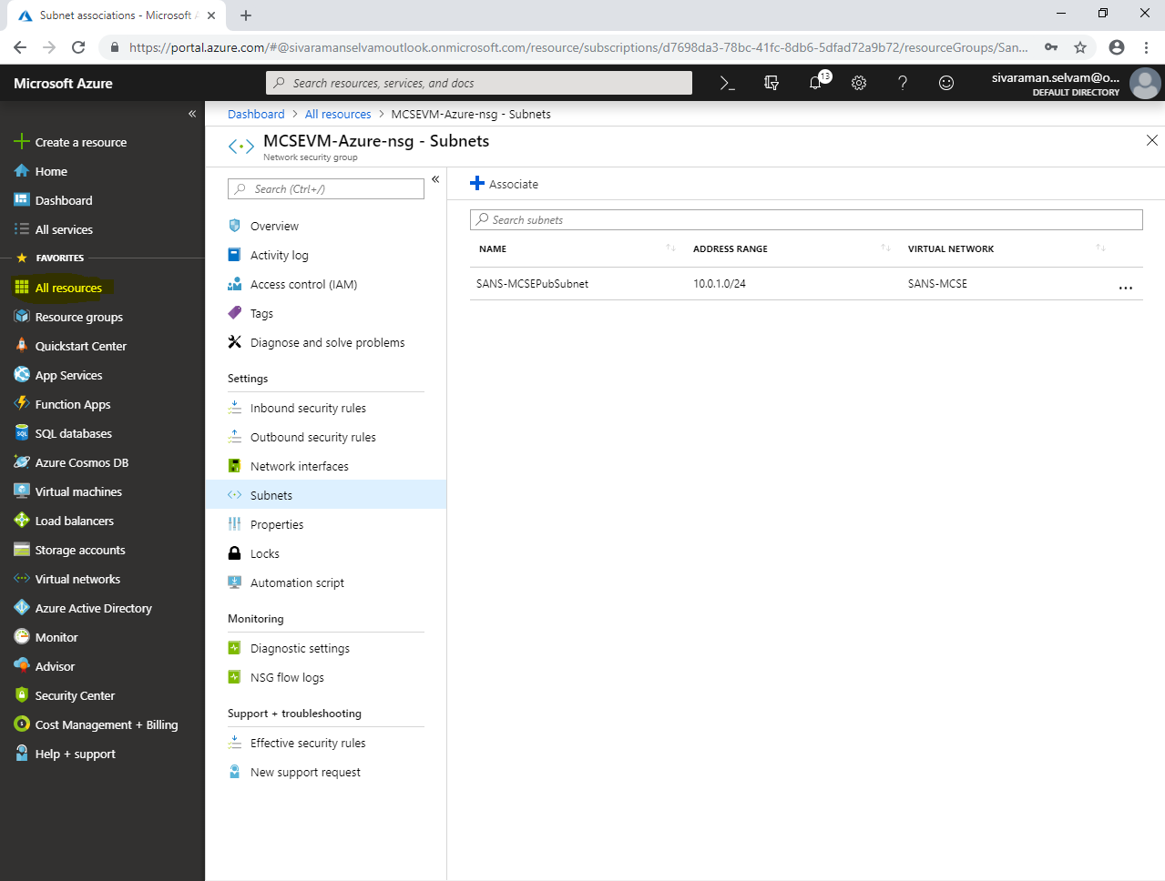

Click **“Inbound security rules”**

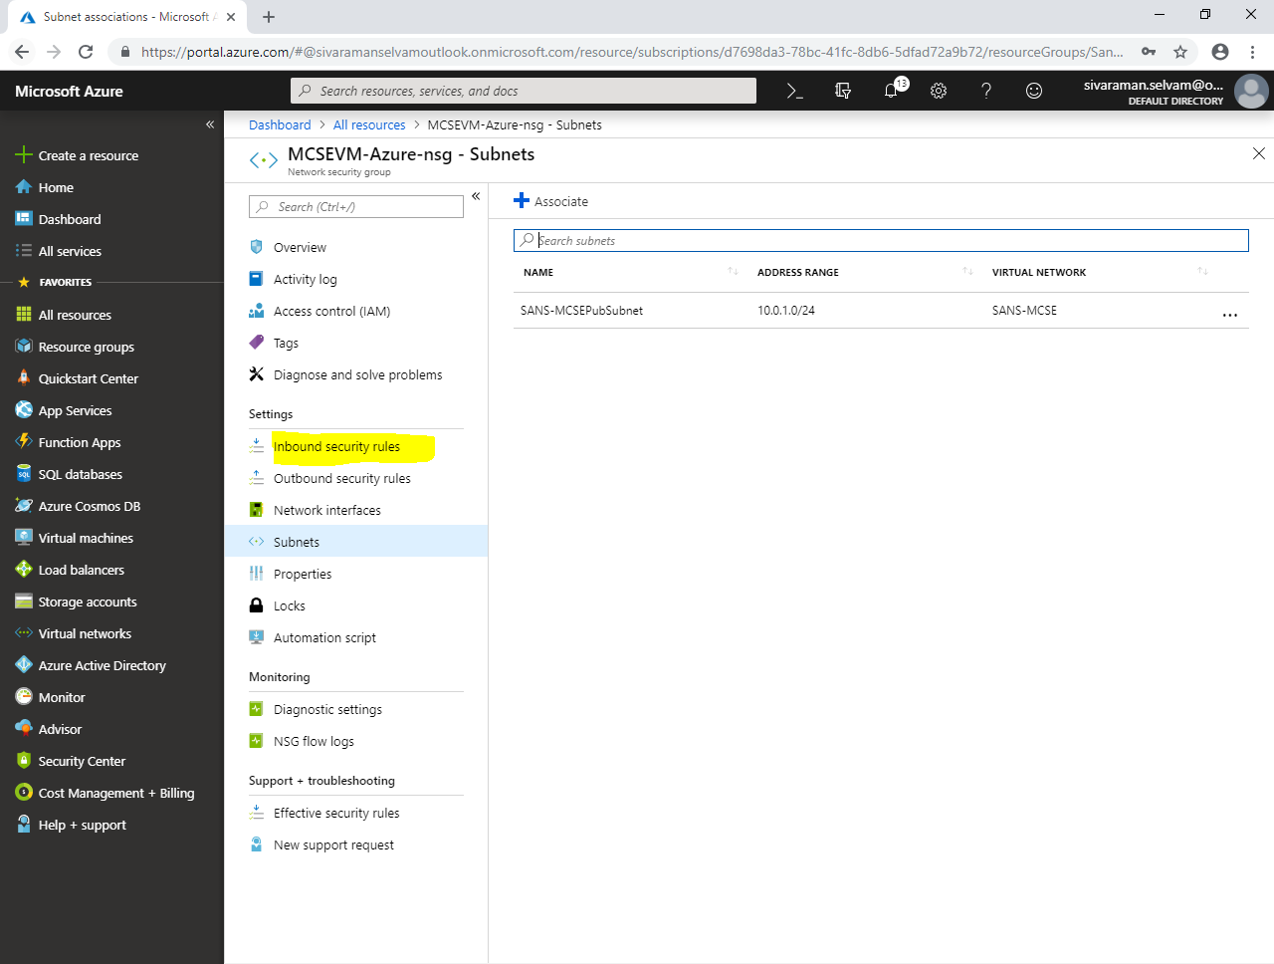

Click **“Add”.**

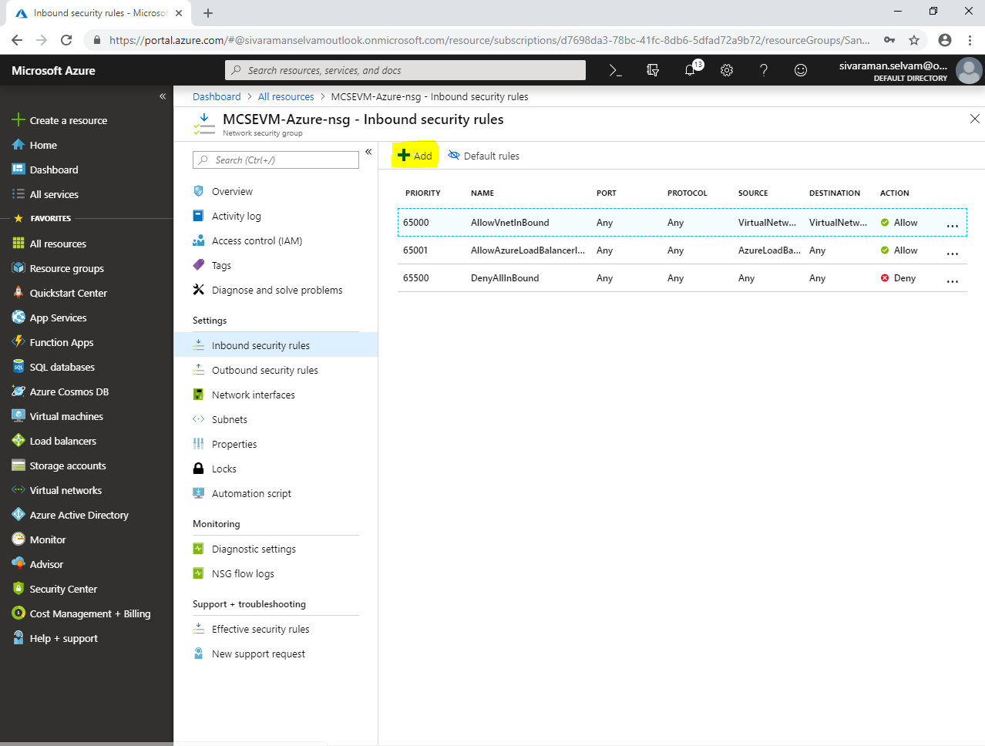

While **“Add inbound security rule”**,

Select **“Protocol”** as **“TCP”.**

Type Rule **“Name”** as **“AllowRDP”**.

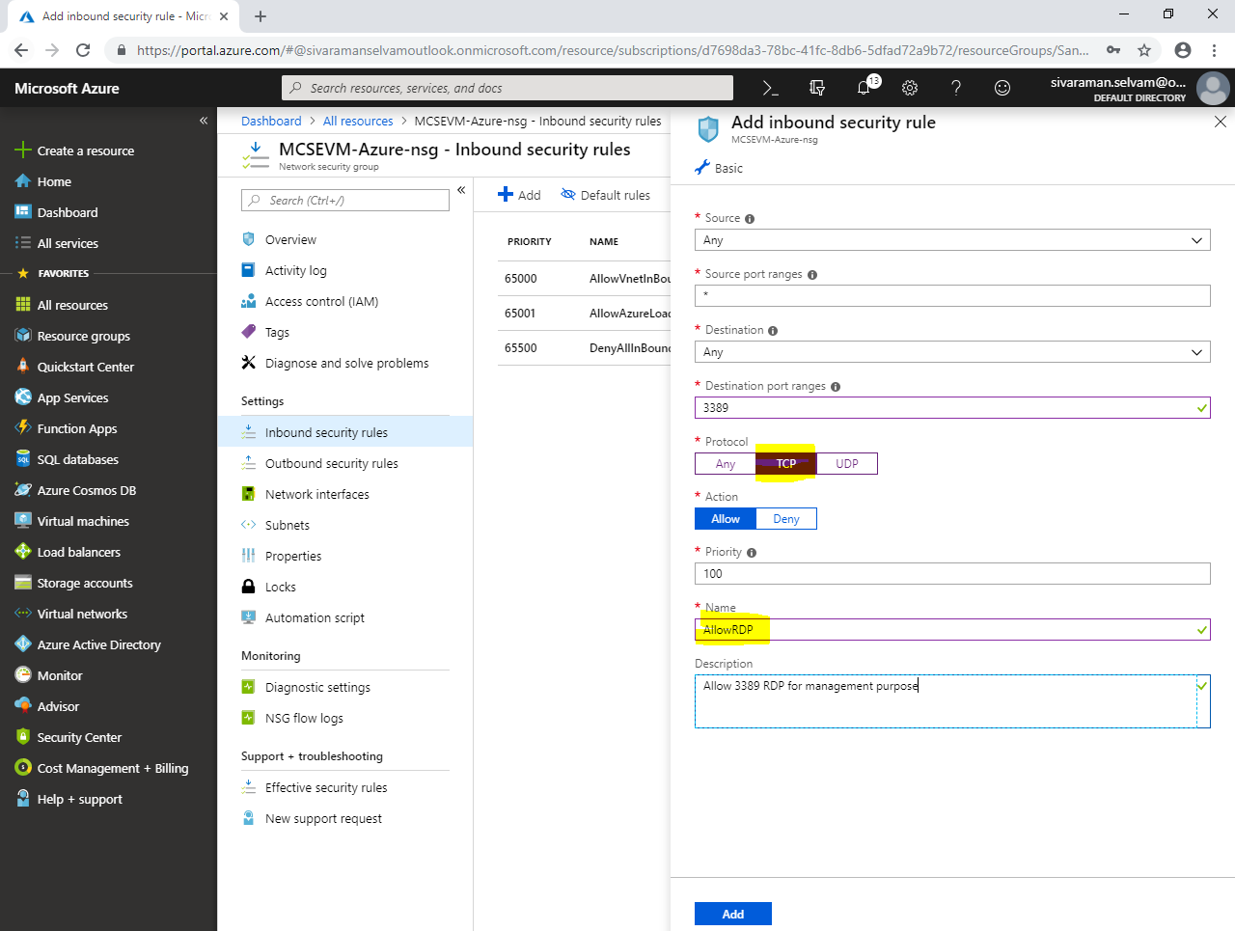

Click **“Add”**.

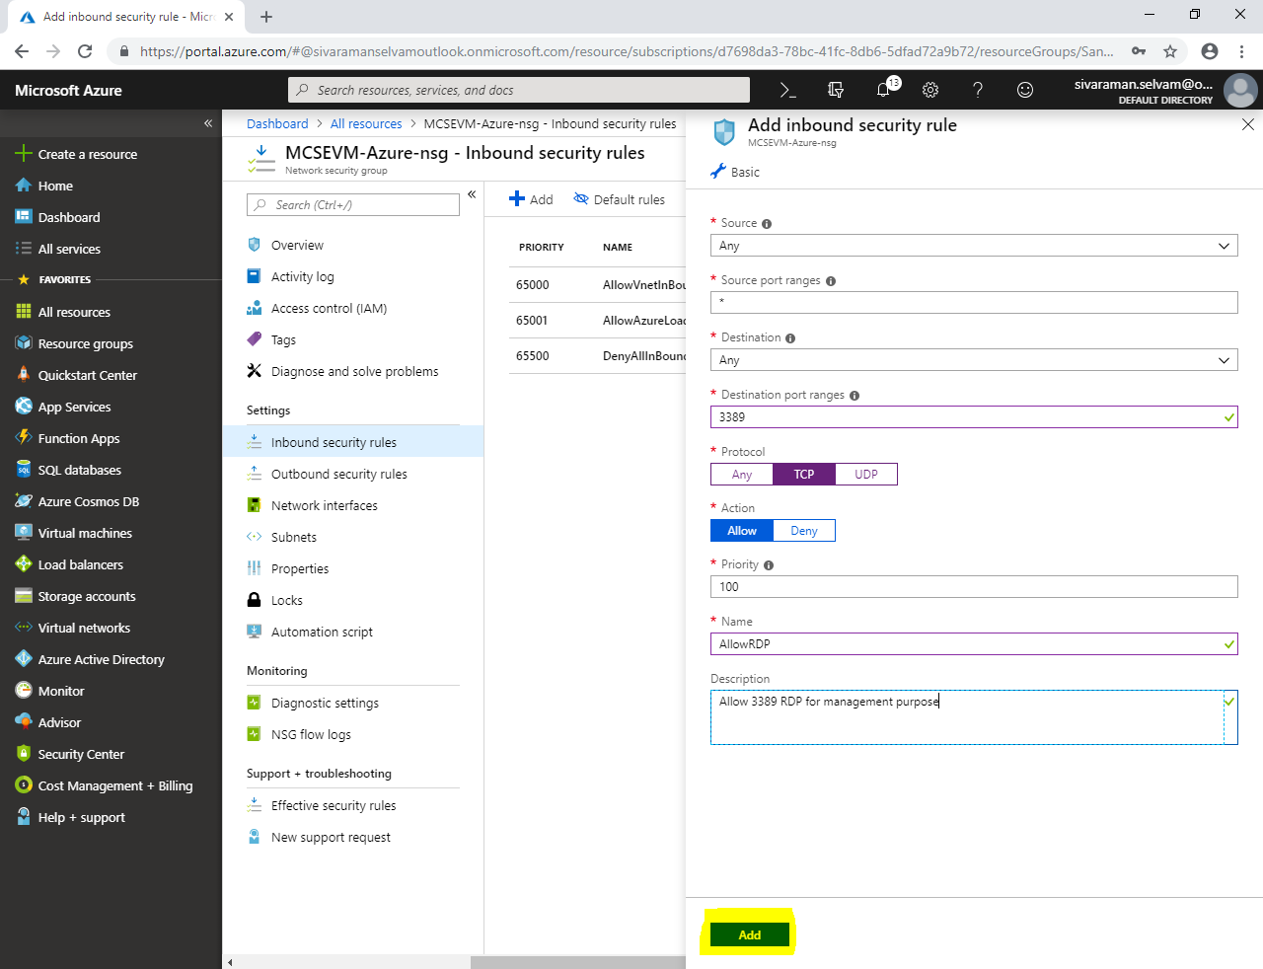

We have allowed **“RDP”** port to manage the Windows Servers remotely.

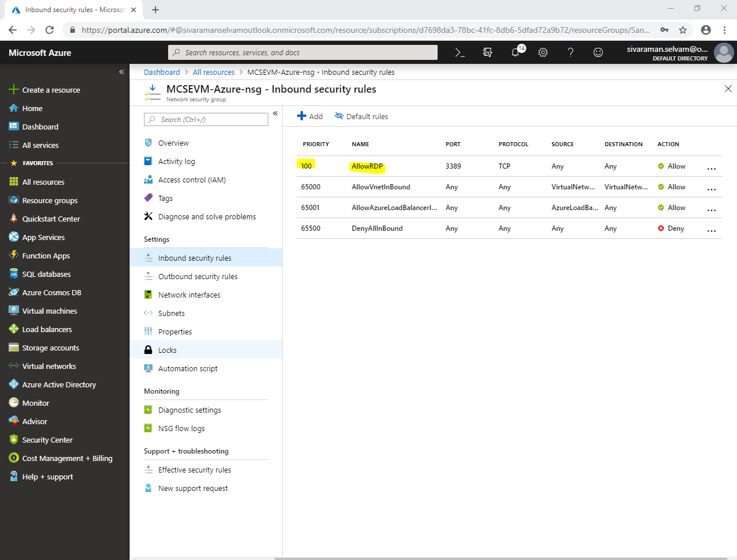

Click **“All resources”**.

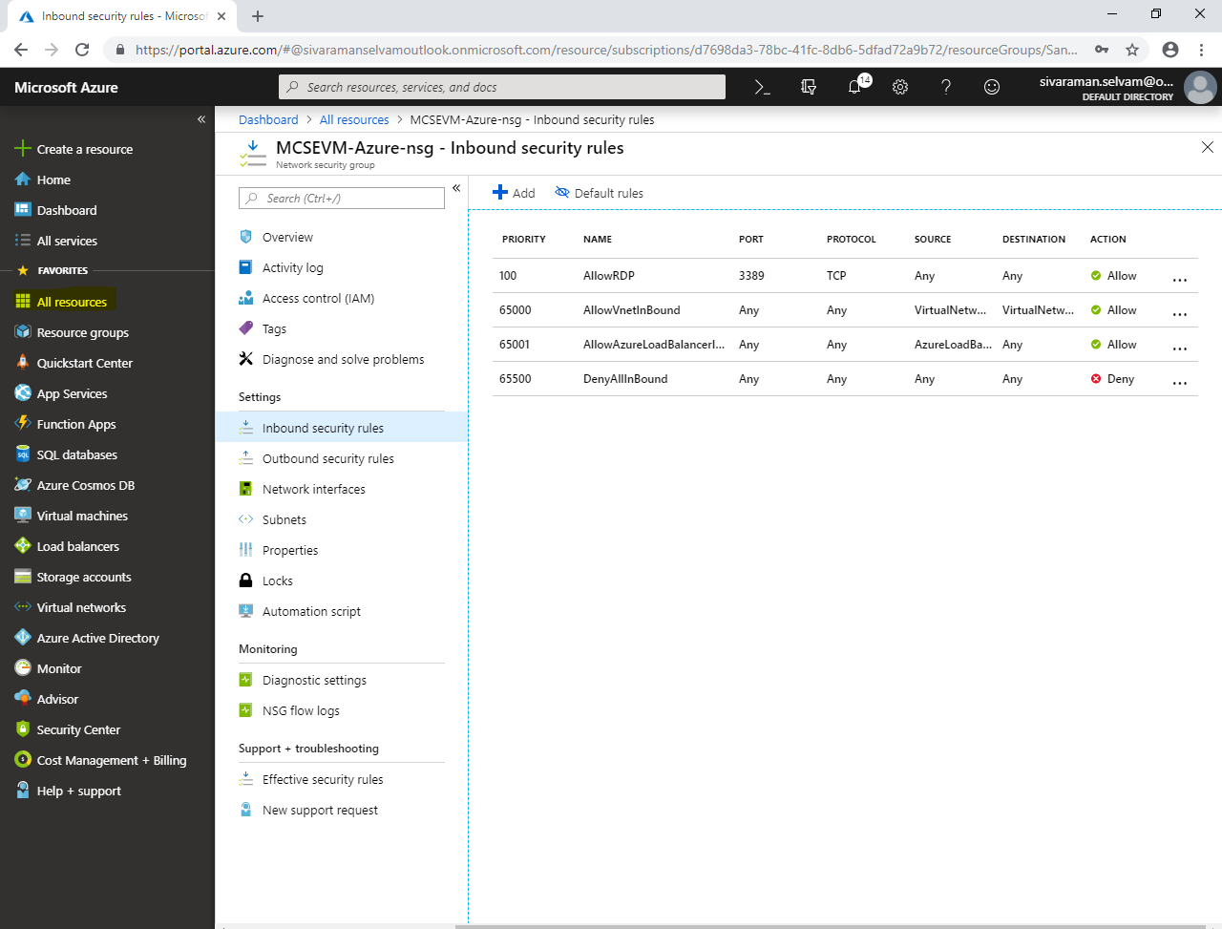

Click **“CCNAVM-Azure-nsg”** Network security group.

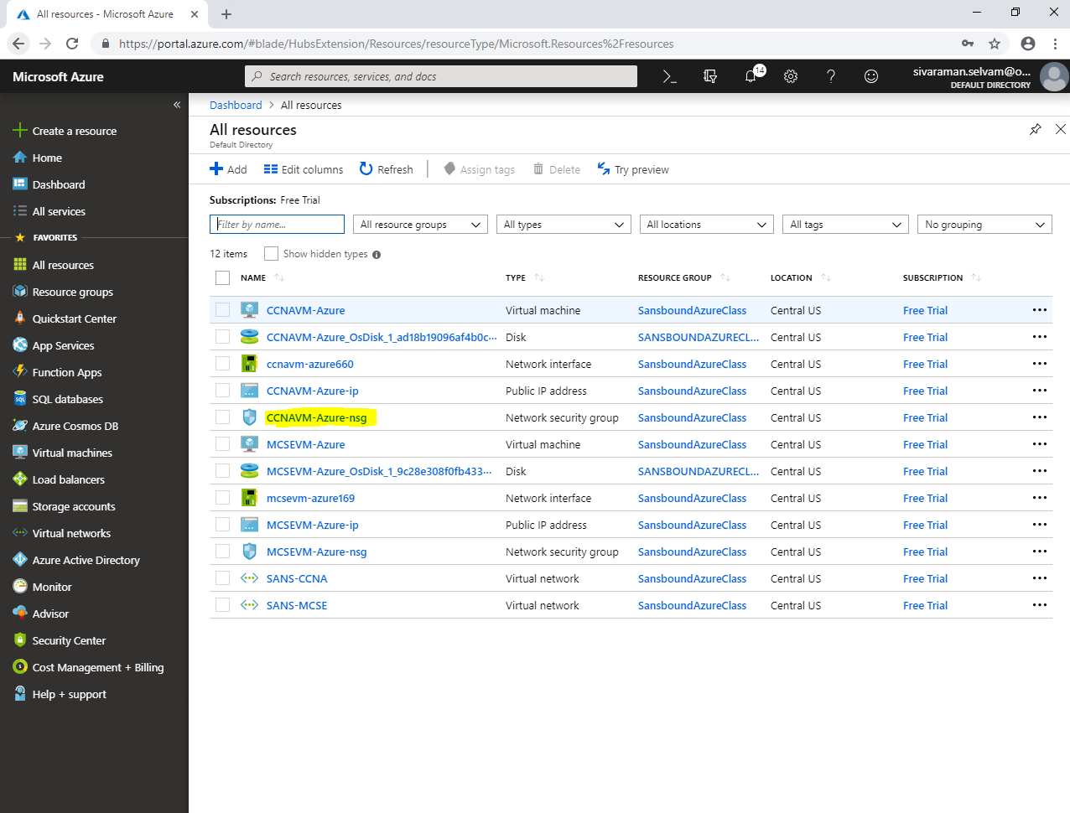

In **“CCNAVM-Azure-nsg”** network security group,

Click **“Subnets”**.

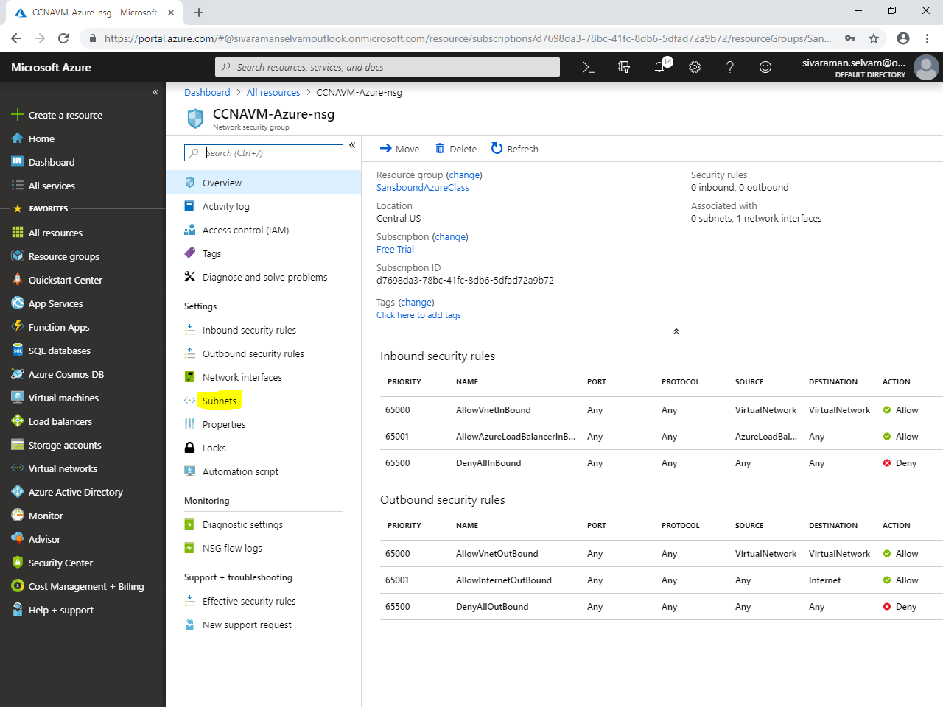

In **“Subnets”** click **“Associate”** to associate the subnet to network security group.

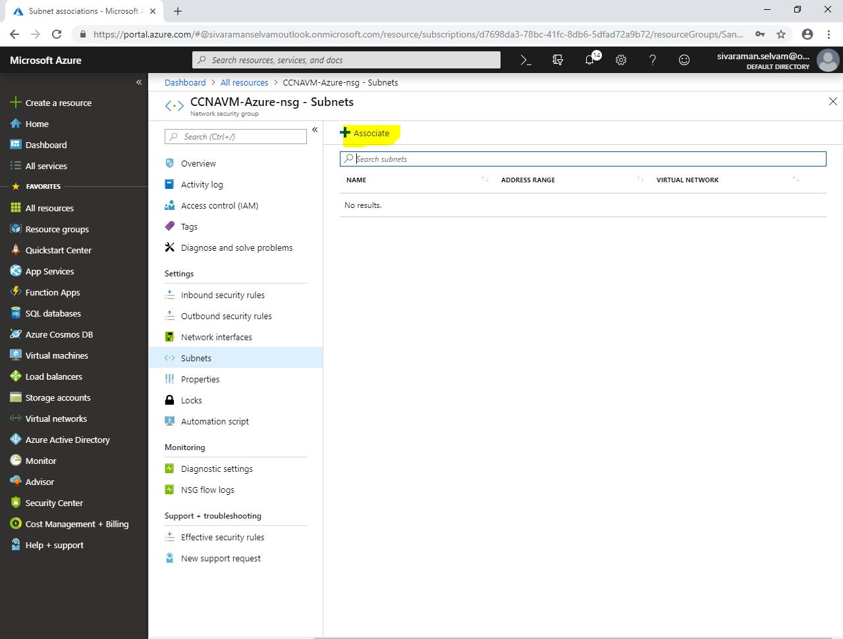

While associate subnet,

Click **“Choose a virtual network”**

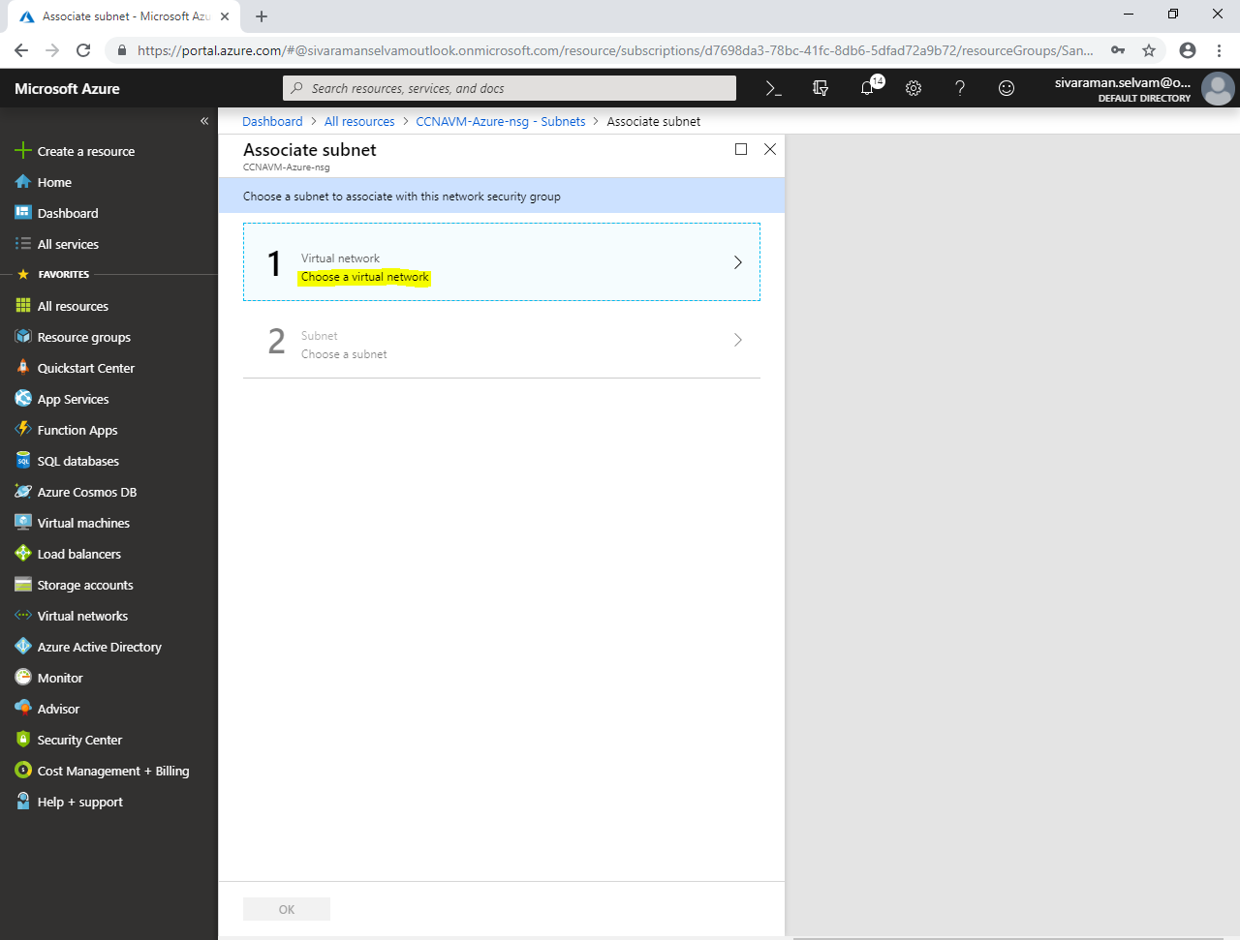

Click on **“SANS-CCNA”** to select Virtual network.

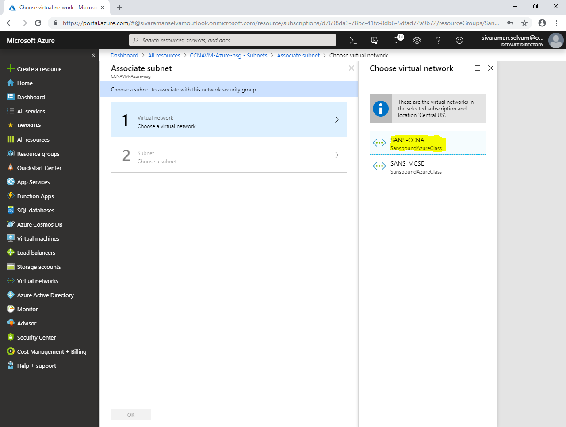

In **“Choose a subnet”** click on **“SANS-CCNA-PubSubnet”**.

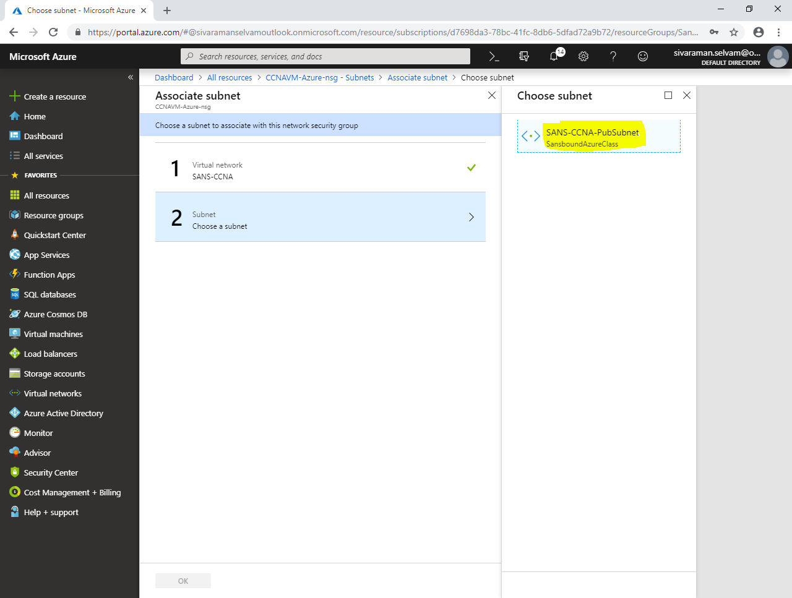

Click **“Ok”**.

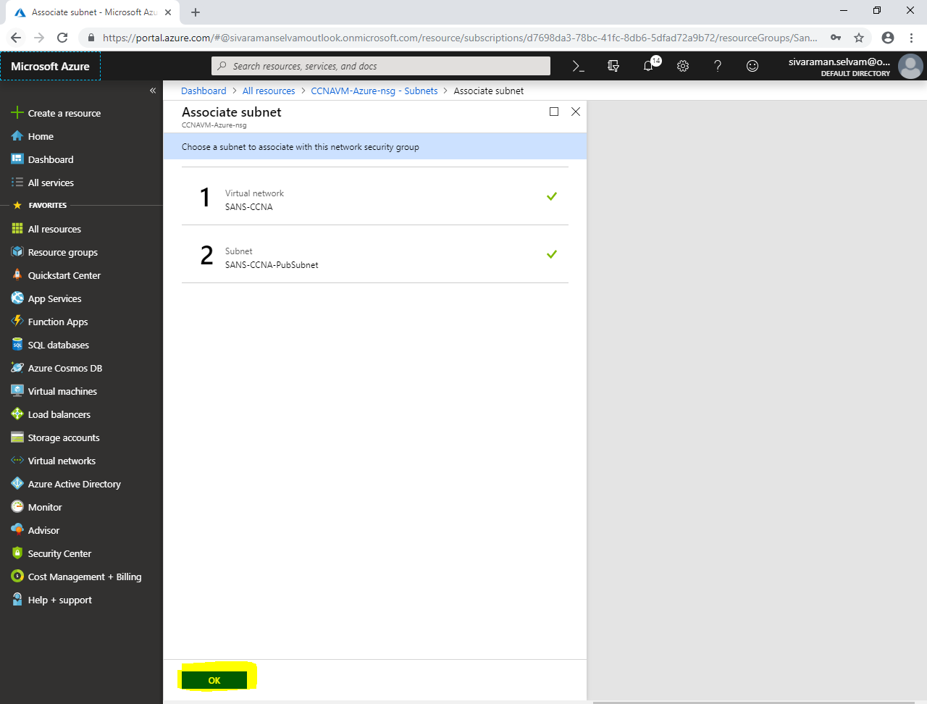

In Network security group **“Subnets”**,

We are able see that **“SANS-CCNA-PubSubnet”** has been successfully associated with **“CCNAVM-Azure-nsg”** network security group.

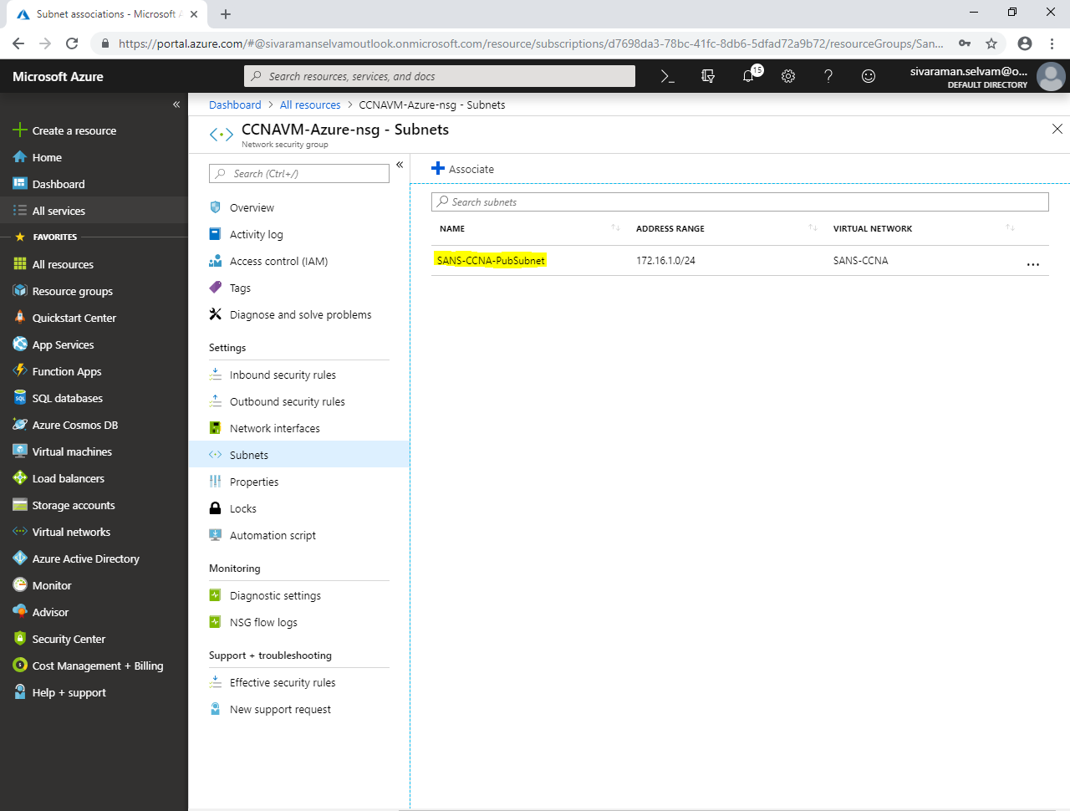

Click **“Inbound security rules”**,

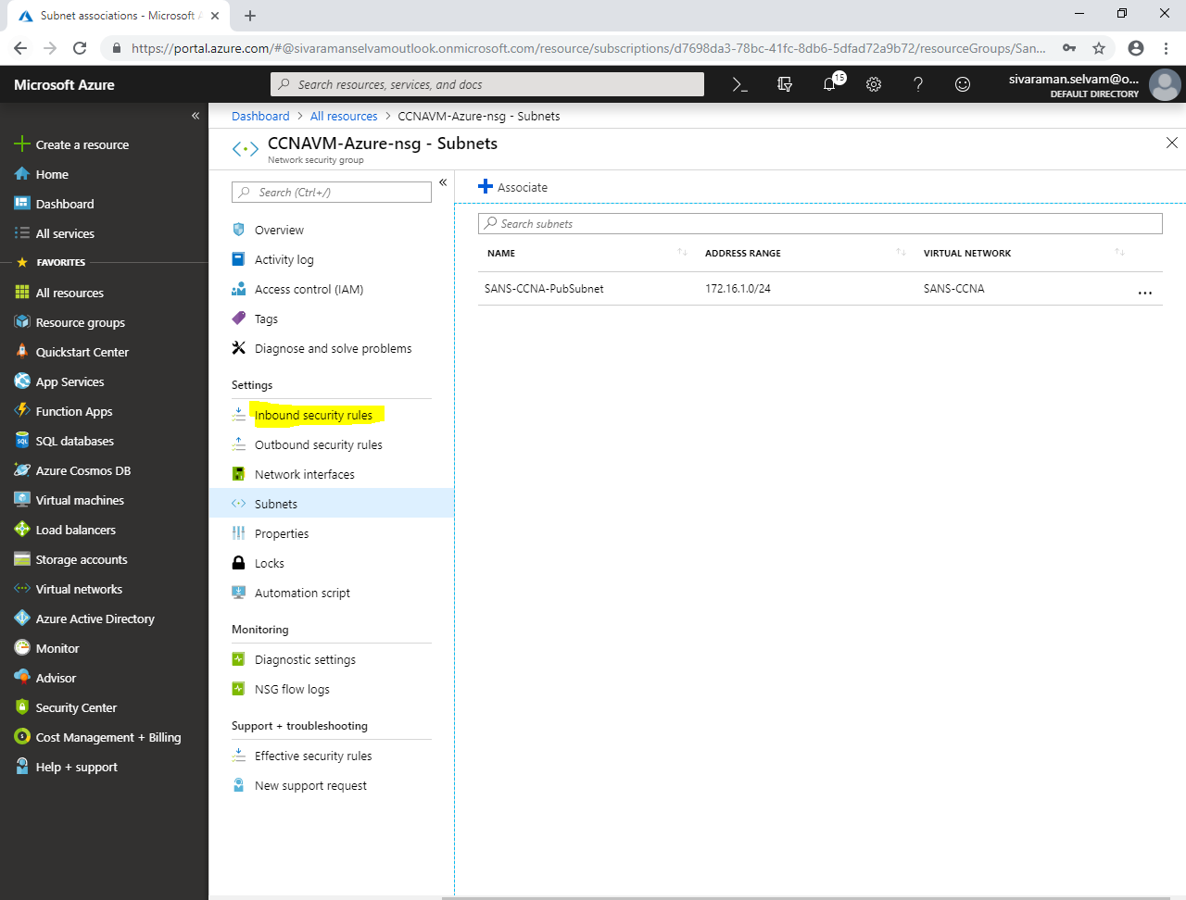

In **“Inbound security rules”**,

Click **“Add”**.

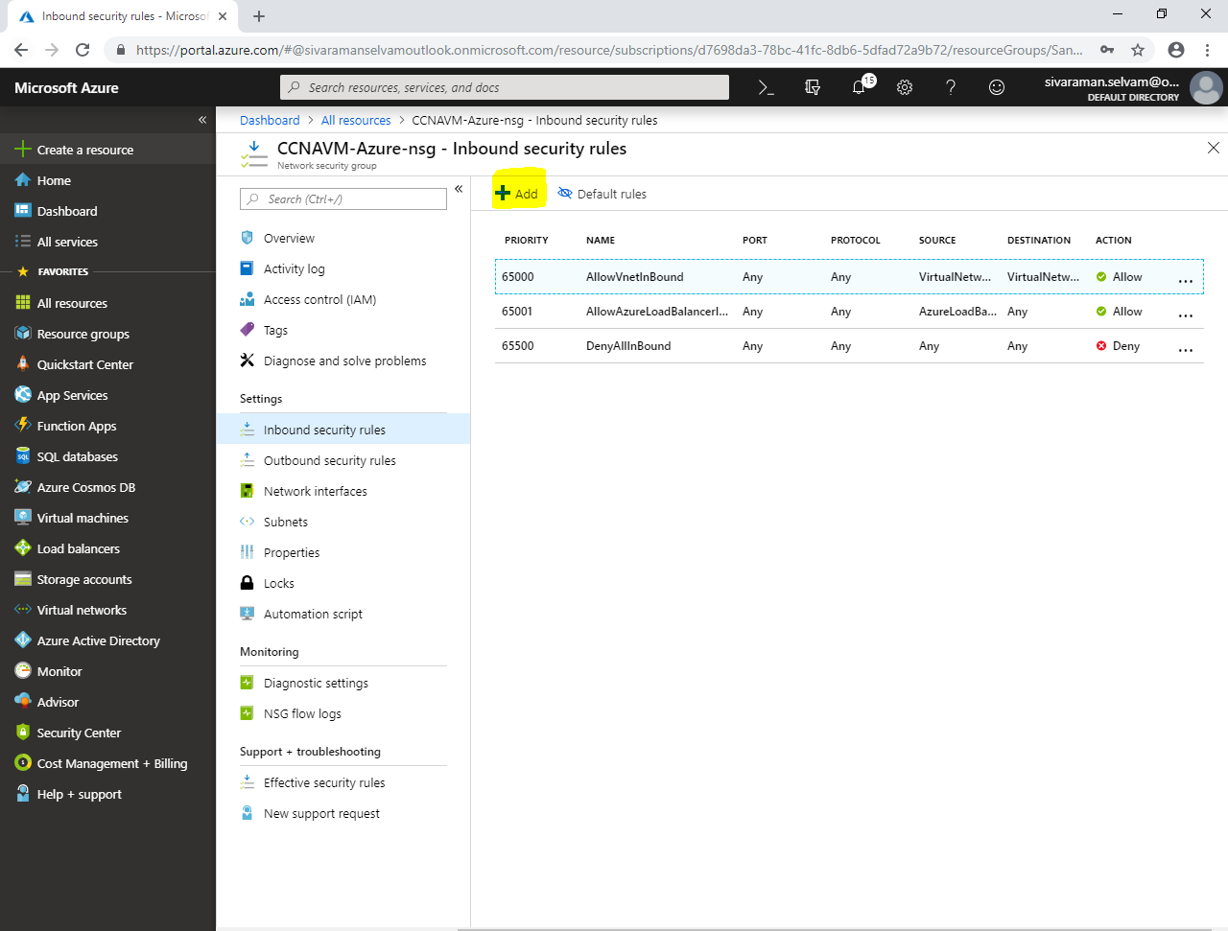

While **“Add inbound security rule”**,

Type “**Destination port ranges”** as **“22”**.

In **“Protocol”** select **“TCP”**.

Set **“Priority”** as **“100”**.

Type **“Name”** as **“AllowSSH”**.

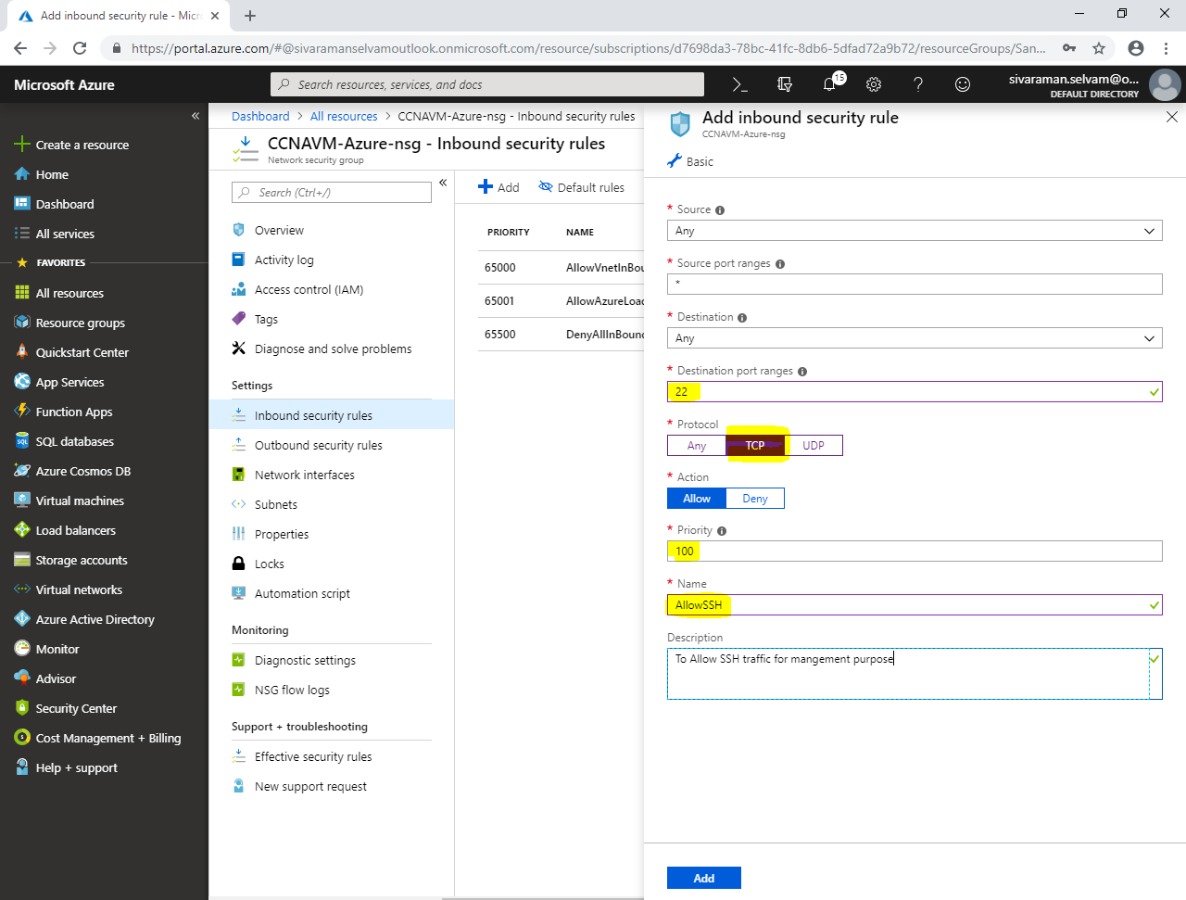

Click **“Add”**.

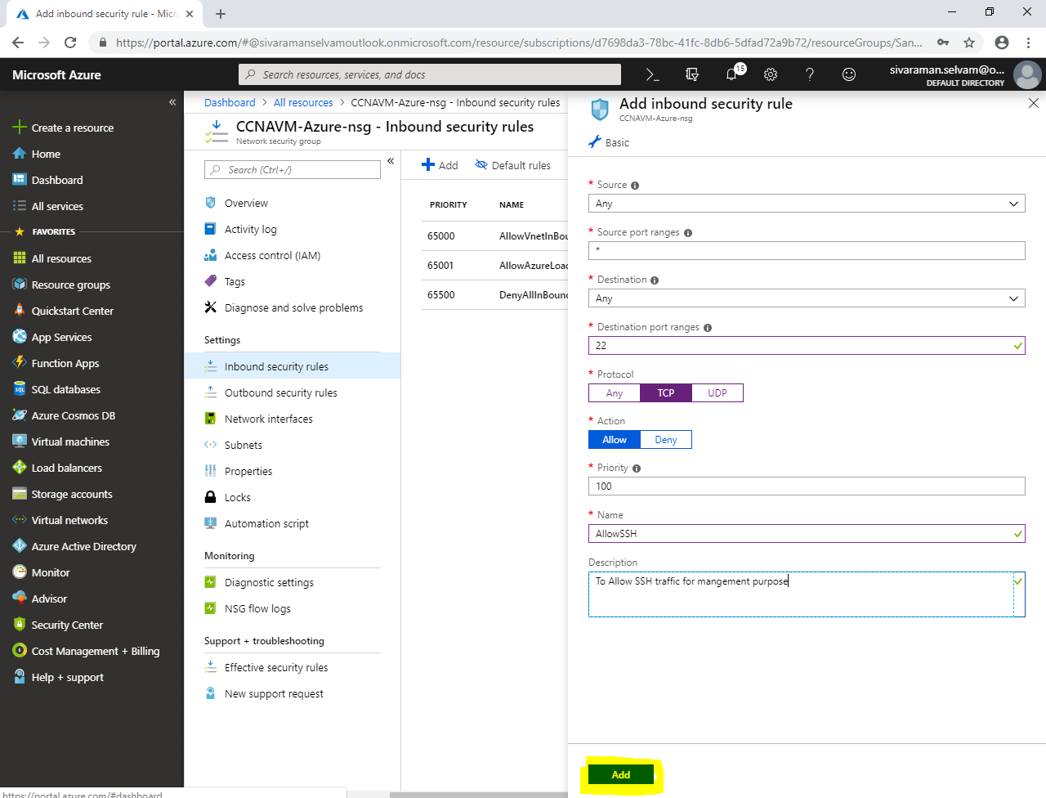

You are able to see that inbound rule has been created for **“CCNAVM-Azure-nsg”** successfully.

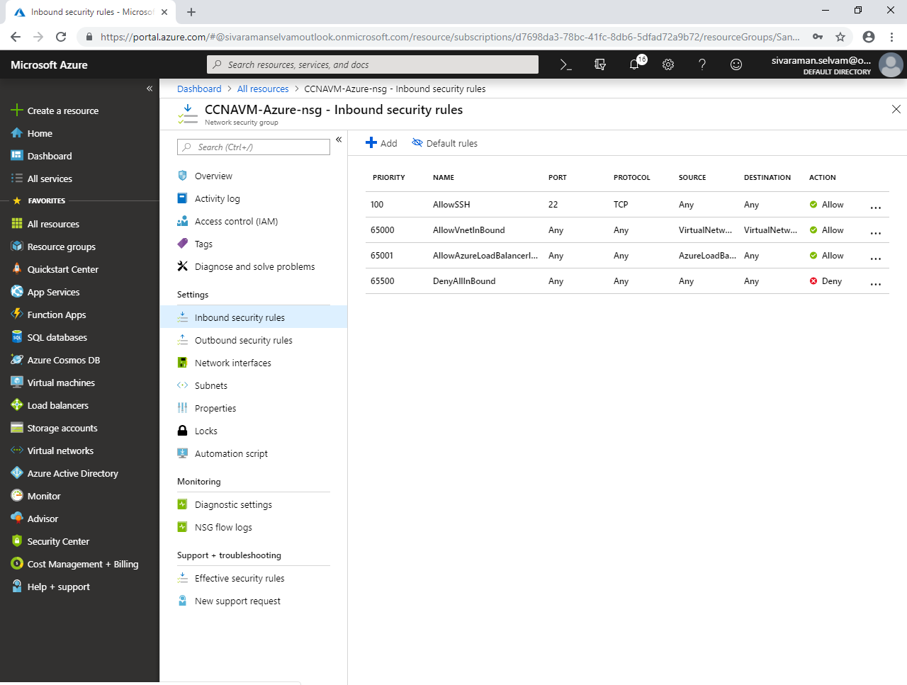

Click Virtual machine named **“MCSEVM-Azure”** which belongs to **“SANS-MCSE”** Virtual network as well as **“SANS-MCSE-PubSubnet”**.

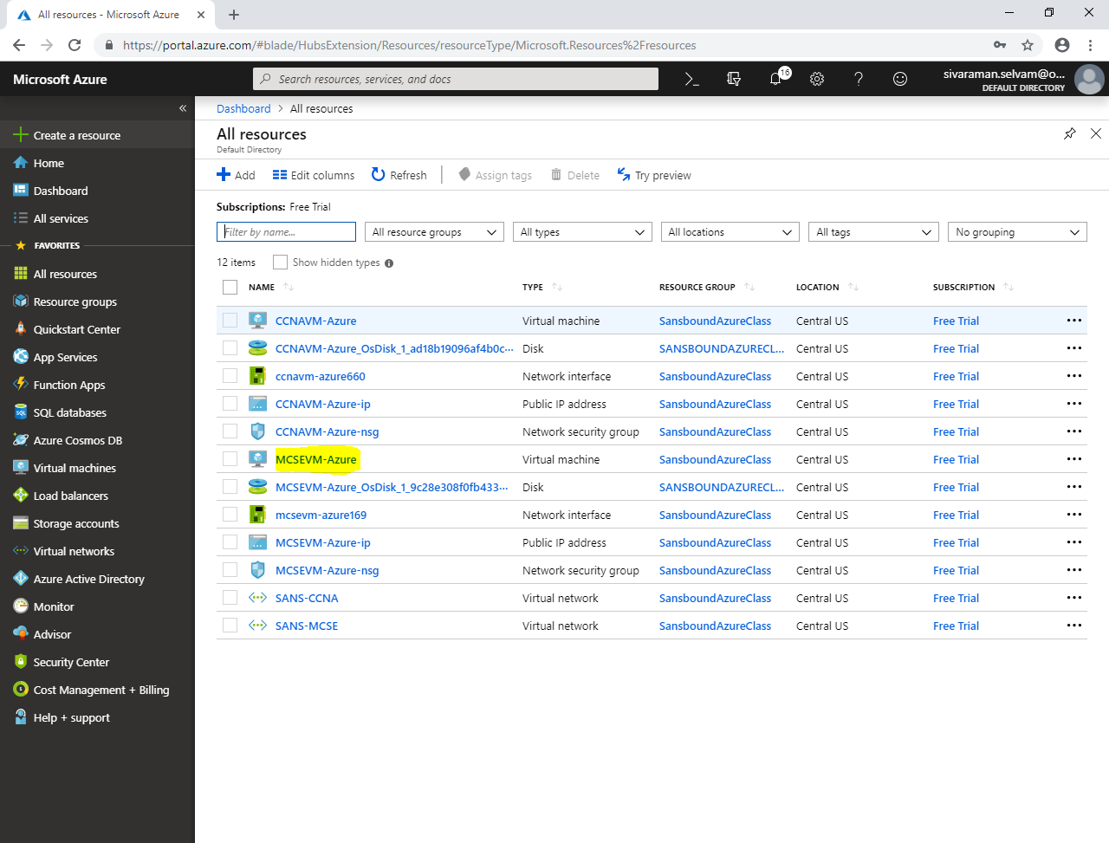

In **“MCSEVM-Azure”**

Click on **“Networking”**,

Kindly note the Public and Private IP address of the Virtual machine.

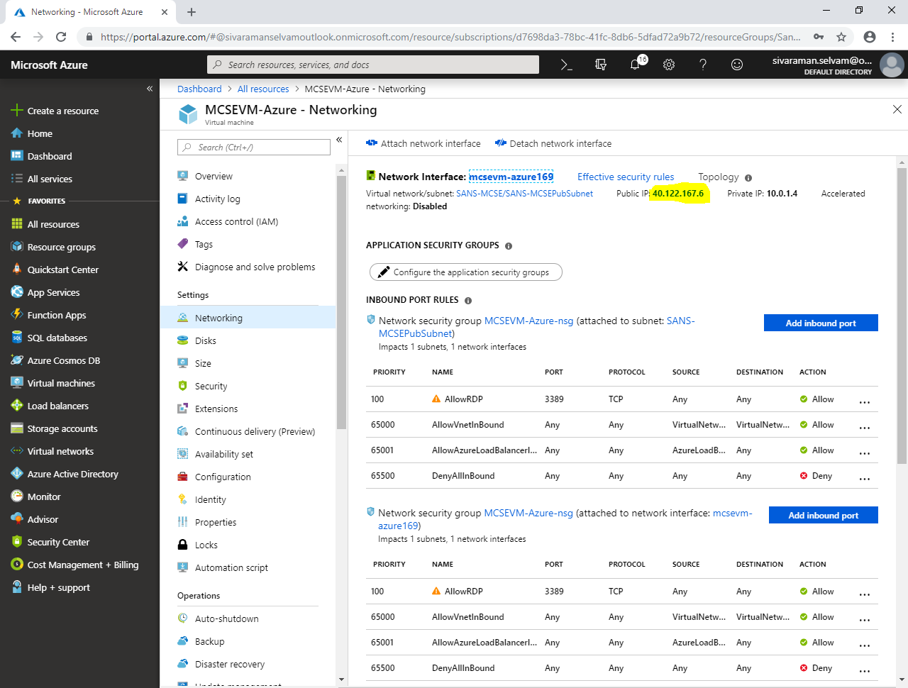

From your local machine, type **“mstsc”** in run box, and press **“Enter”**.

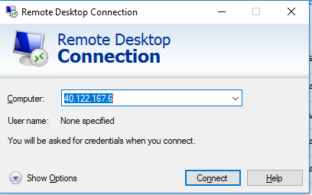

Click **“Connect”**.

Type username as sansbound

Type password for the Windows 2008 R2 server.

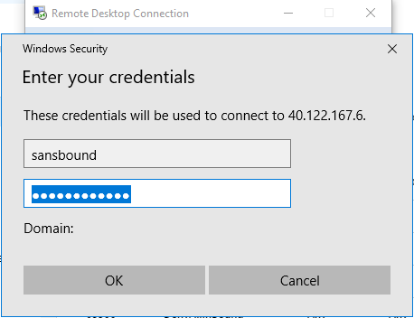

Click **“Ok”**.

Click **“Yes”.**

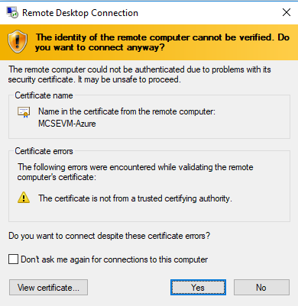

You have successfully logged into the **“Windows 2008 R2 Server”.**

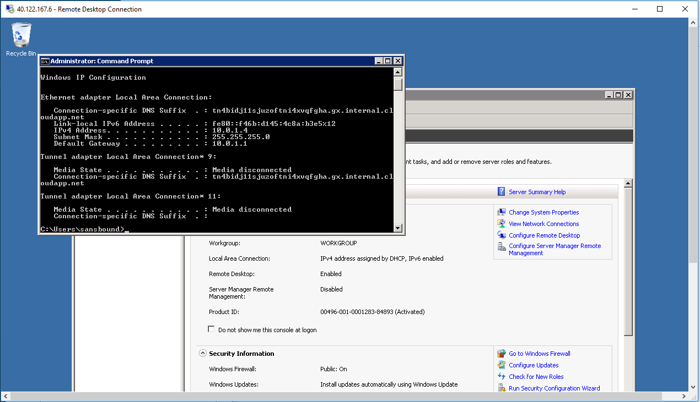

In **“Windows 2008 R2 server”,**

Type **“firewall.cpl”** in Run box and press **“Enter”**.

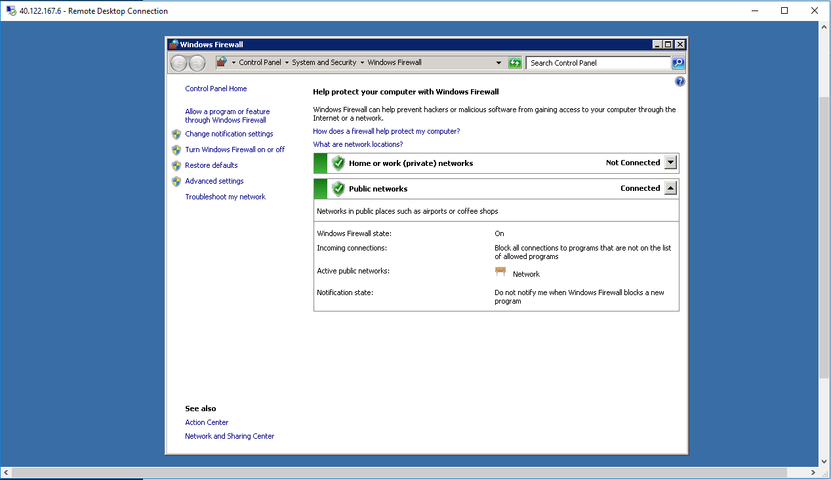

Click **“Turn Windows Firewall on or off”**.

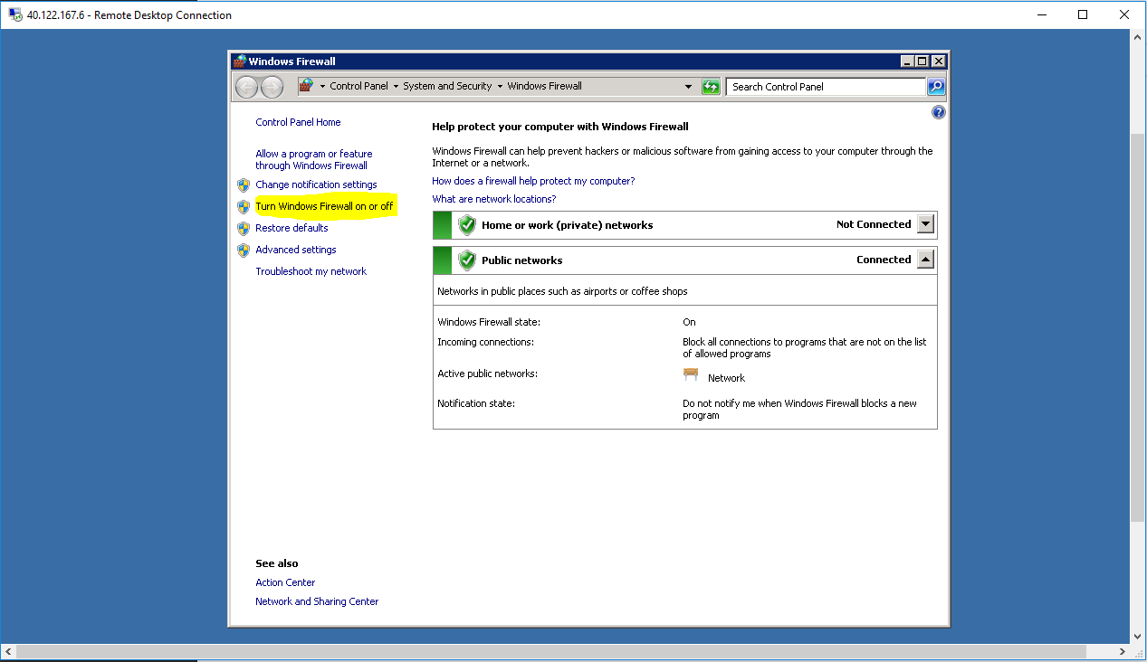

Click **“Turn off”** on both.

Click “Ok”.

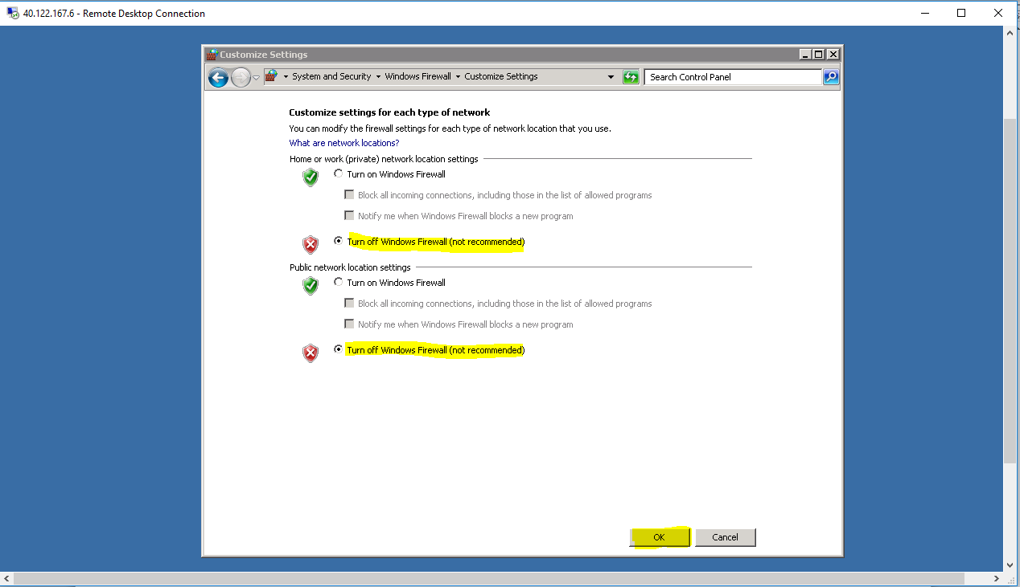

In **“All resources”**.

Click virtual machine named **“CCNAVM-Azure”**.

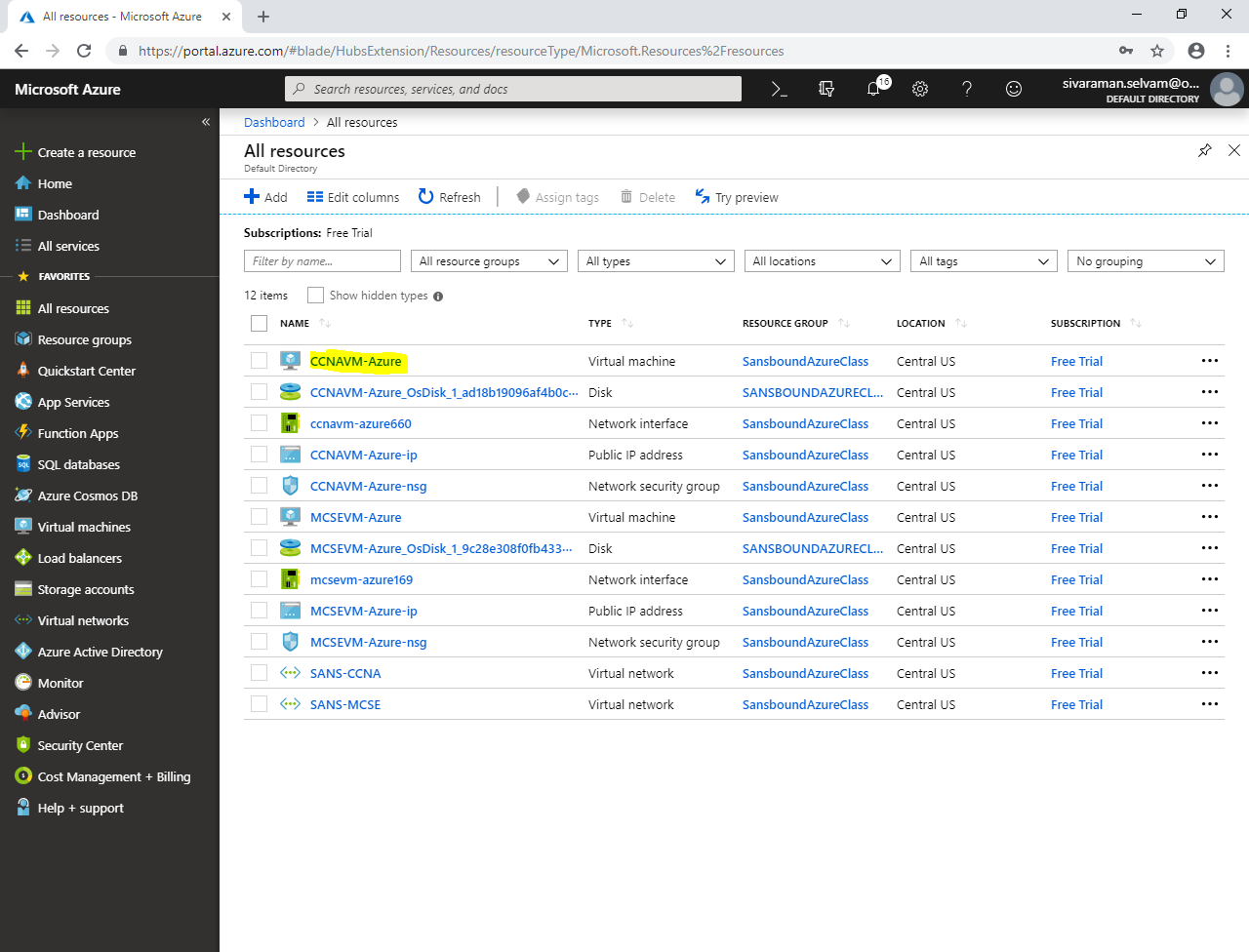

In virtual machine named **“CCNAVM-Azure”**,

Click **“Networking”**.

Kindly note the Public and Private IP address of the Virtual machine of Ubuntu.

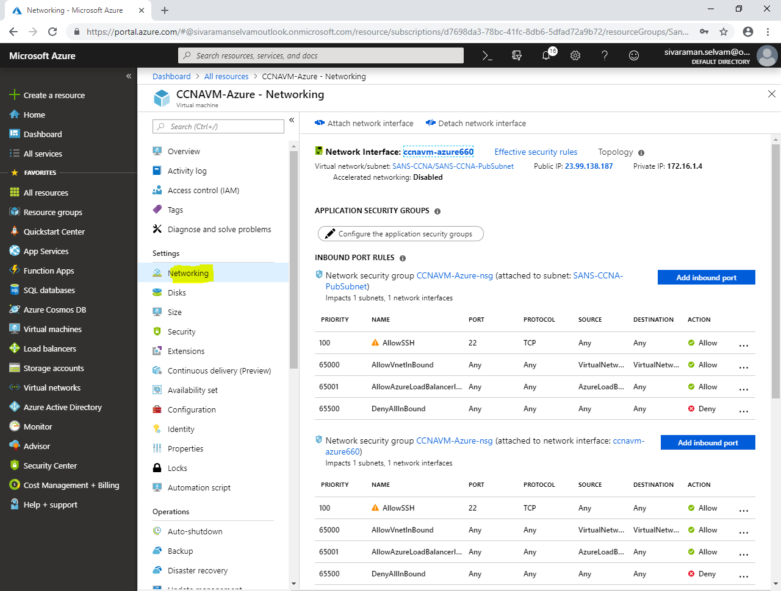

In **“Windows server 2008 R2”**machine,

Try to ping IP address of the Ubuntu (172.16.1.4)

But, we have got **request timed out**.

What is the reason?

Windows 2008 R2 server is belongs to **“SANS-MCSEPubSubnet”** of **“SANS-MCSE”** virtual network.

But Ubuntu machine which you are trying to connect is belongs to **“SANS-CCNA-PubSubnet”** of **“SANS-CCNA”** virtual network.

**That is the reason, two different virtual networks are will not communicate with each other by default.**

So that, we have required to configure Vnet peering on both Virtual networks.

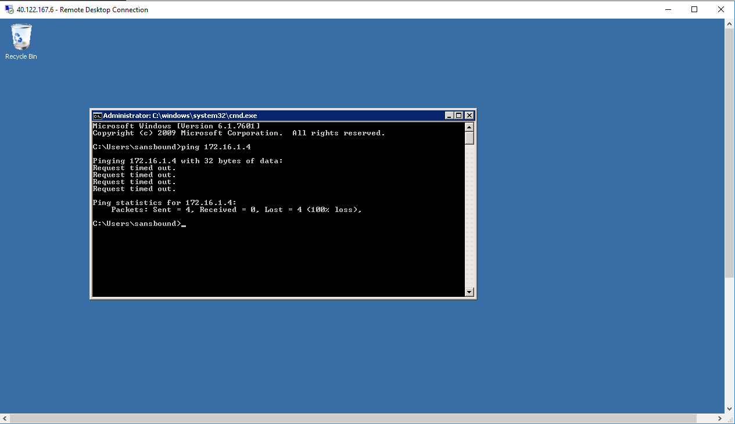

Click **“Virtual networks”** in left side panel.

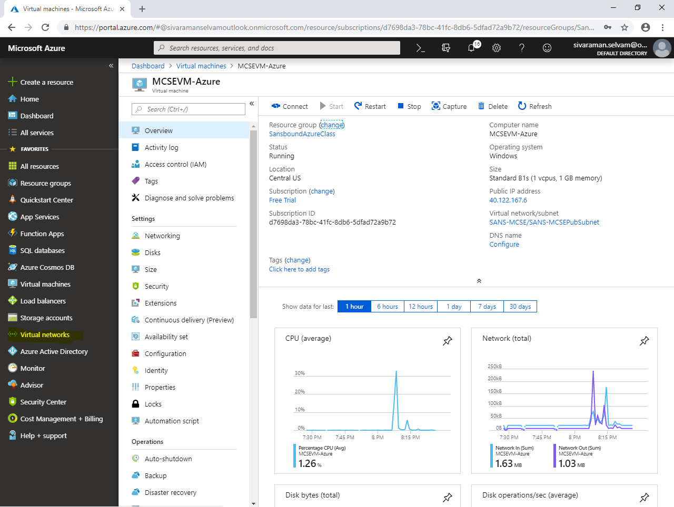

Click **“SANS-MCSE”** virtual network.

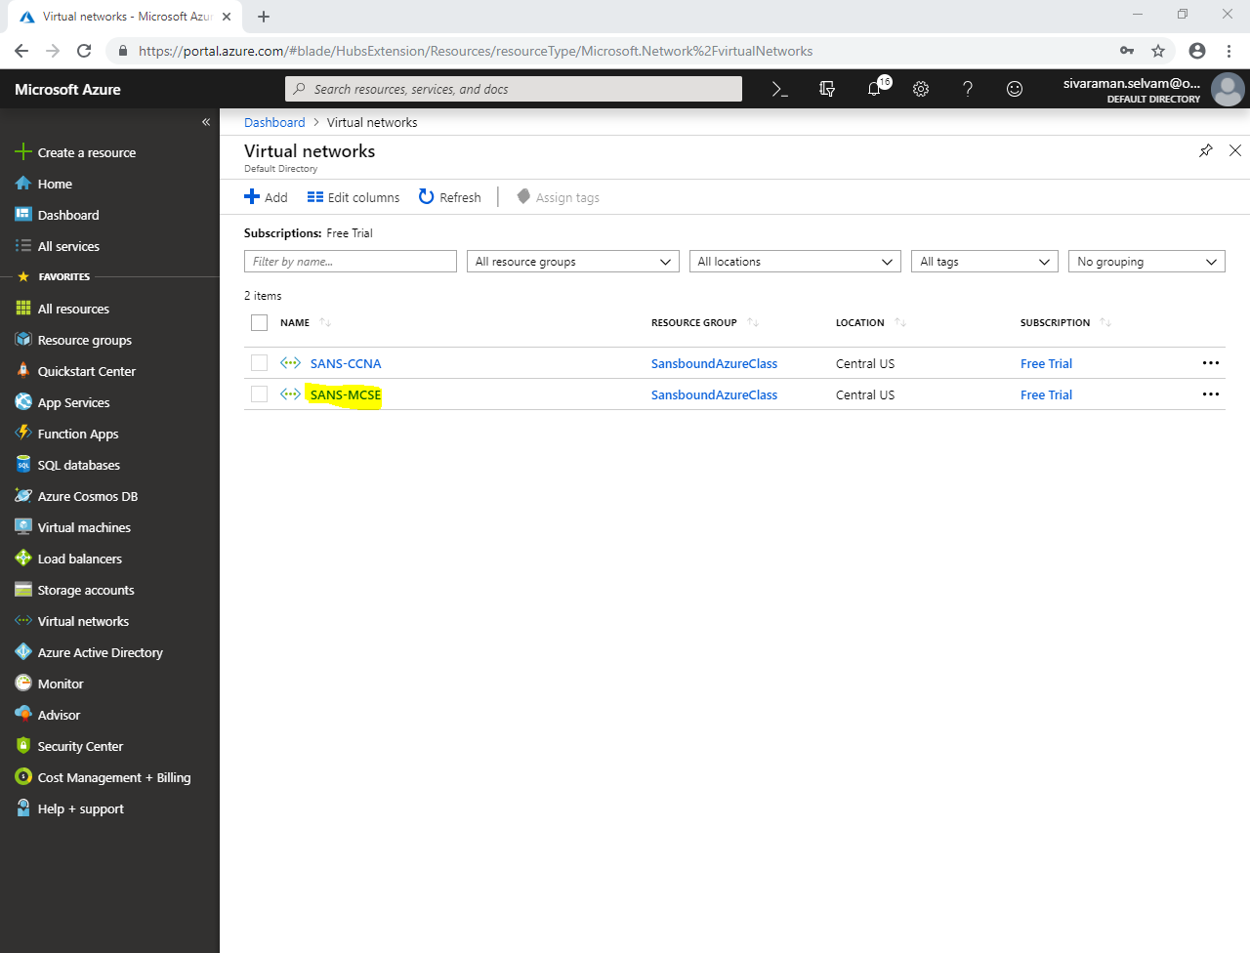

In **“SANS-MCSE”** virtual network,

Click on **“Peerings”**.

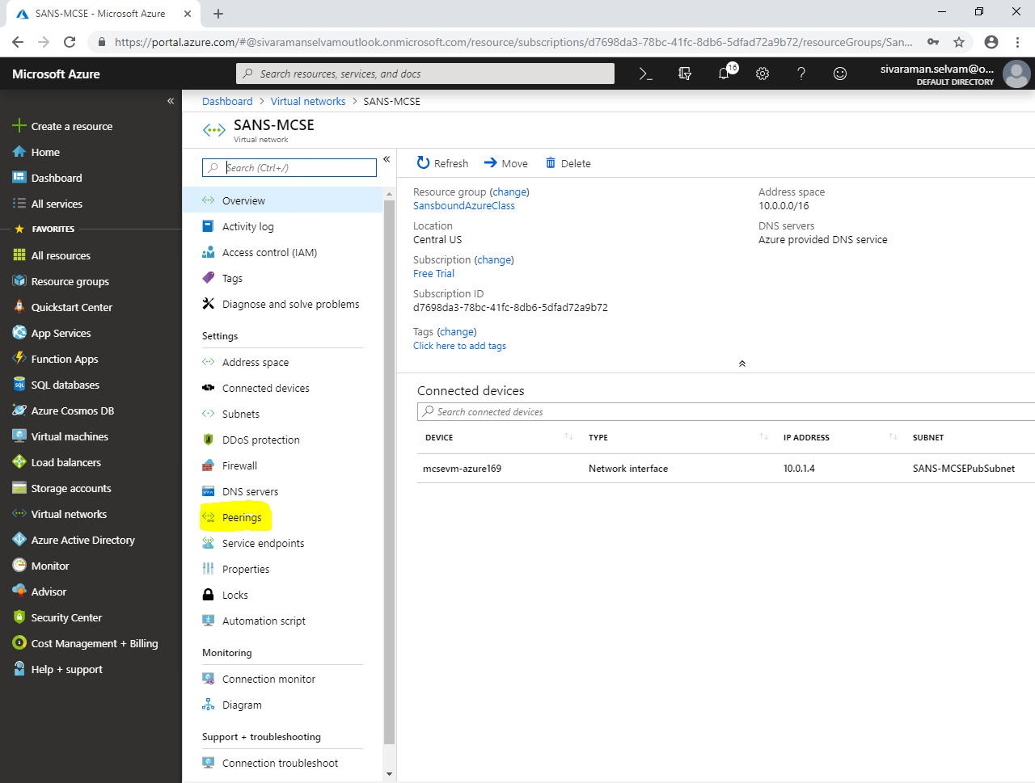

Click **“Add”**.

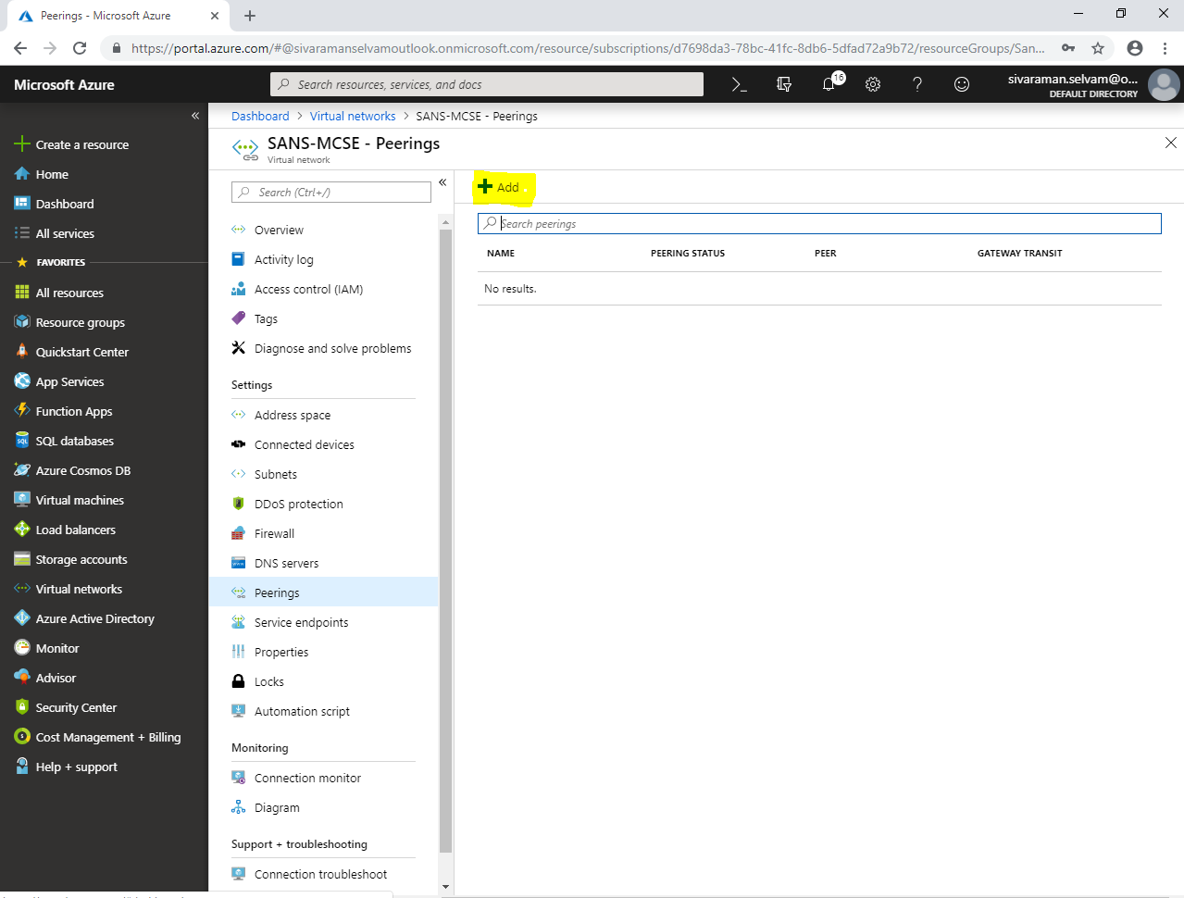

While **“Add peering”**

Type **“Name”** as **“SANSMCSE-CCNA”**.

In **“Peer details”** as **“Resource manager”**.

Select **“Subscription”** as **“Free Trial”**.

Select **“Virtual network”** of Remote Virtual network.

In **“Configuration”** need to check **“Allow forwarded traffic”**.

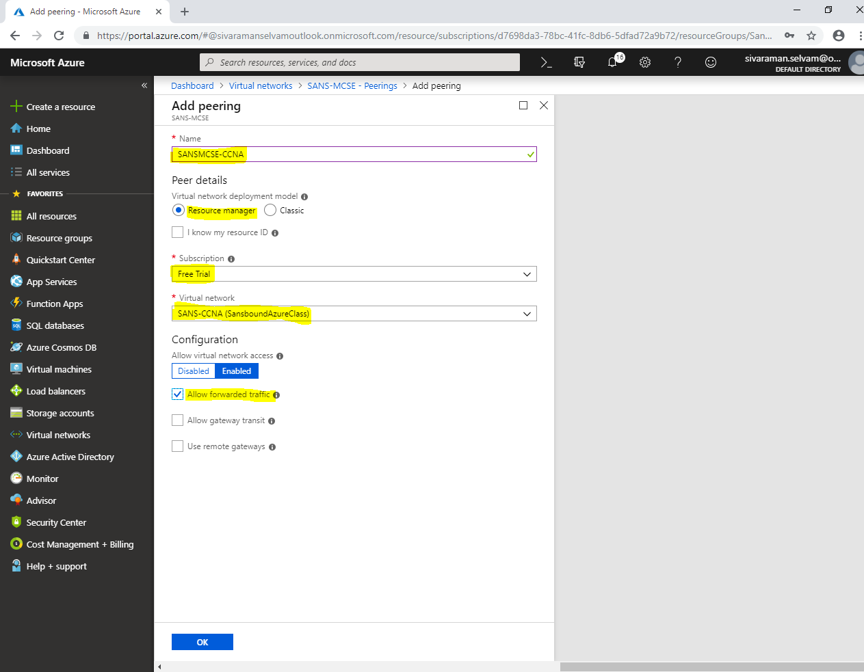

Click **“Ok”**.

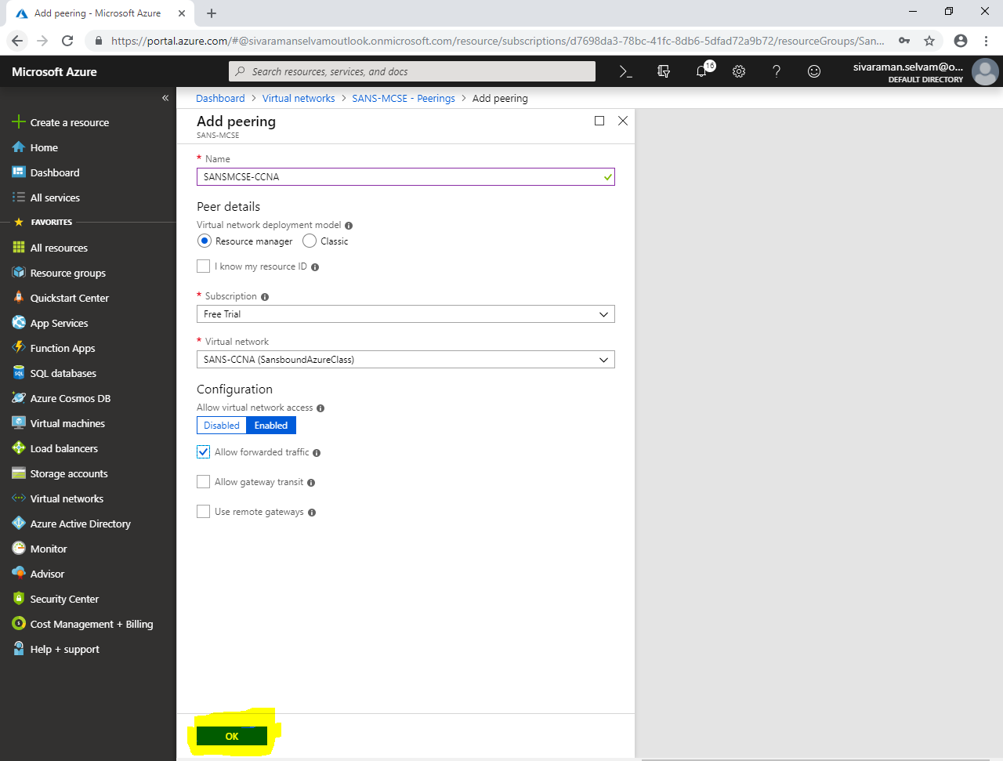

By default you are not able to view **“Peering”** details, click on any other option like **“Options”.**

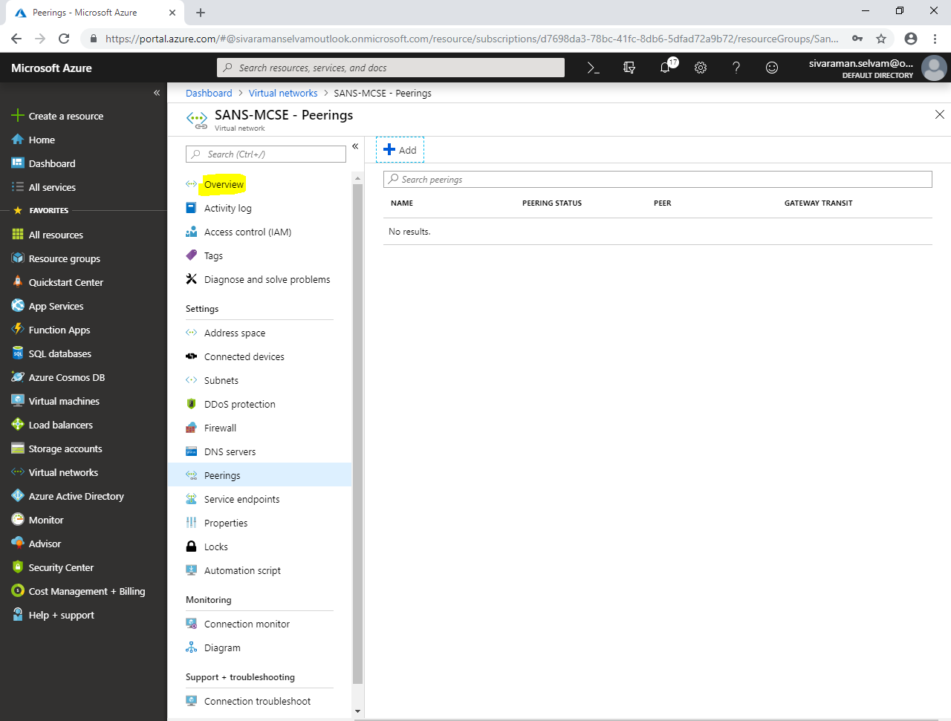

Click **“Peerings”.**

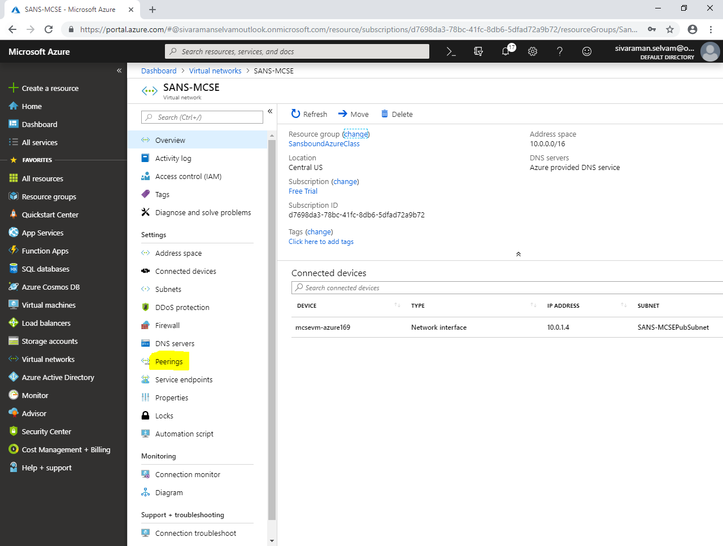

In **“Peerings”**,

You are able to see that you have successfully added peering in **“SANS-MCSE”** virtual network.

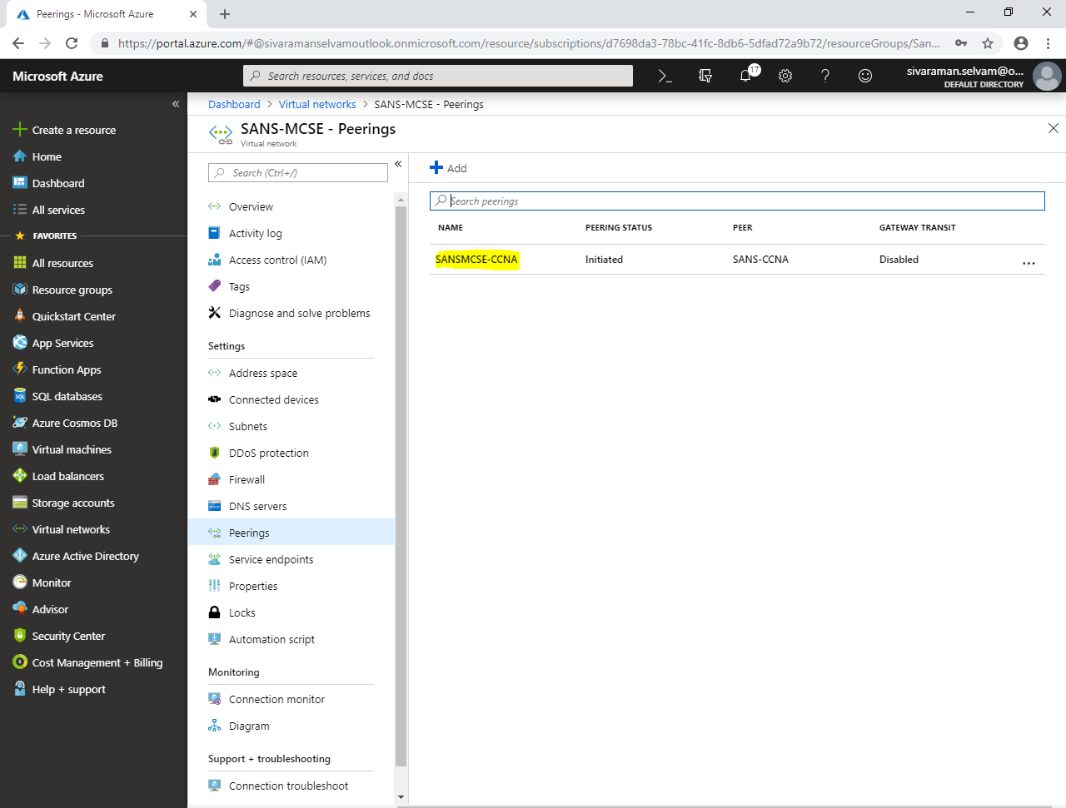

Click **“Virtual networks”** in left side panel.

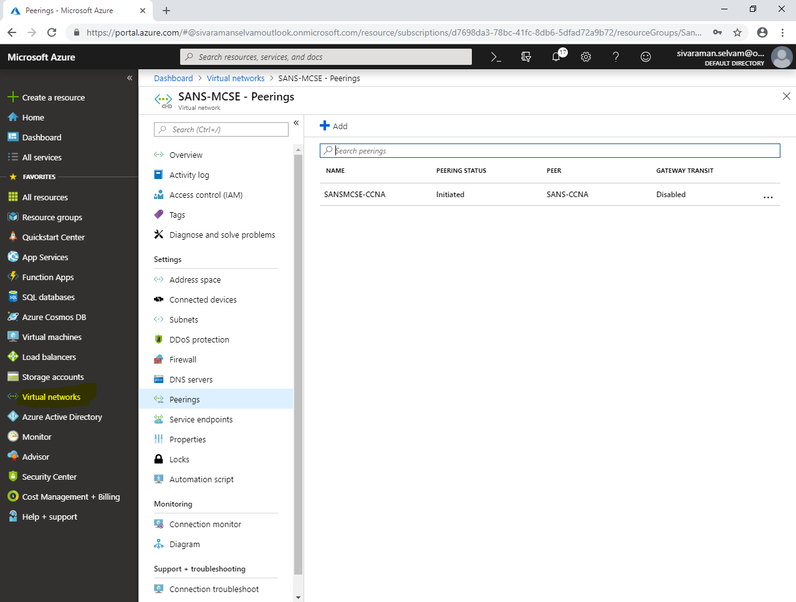

In **“Virtual networks”**,

Click **“SANS-CCNA”** virtual network.

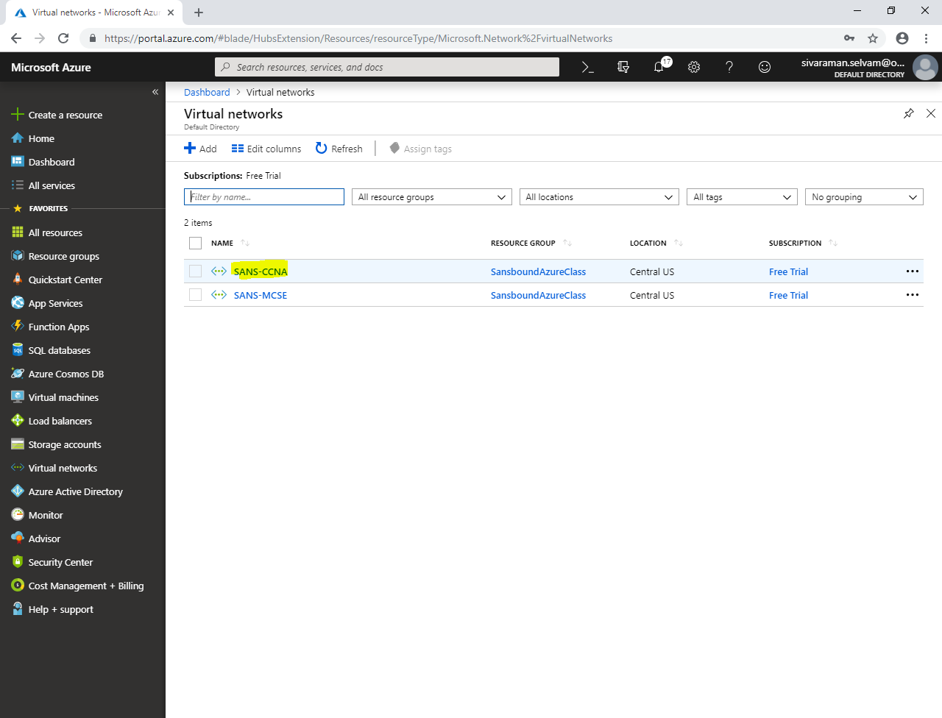

In **“SANS-CCNA”** virtual network,

Click **“Peerings”**.

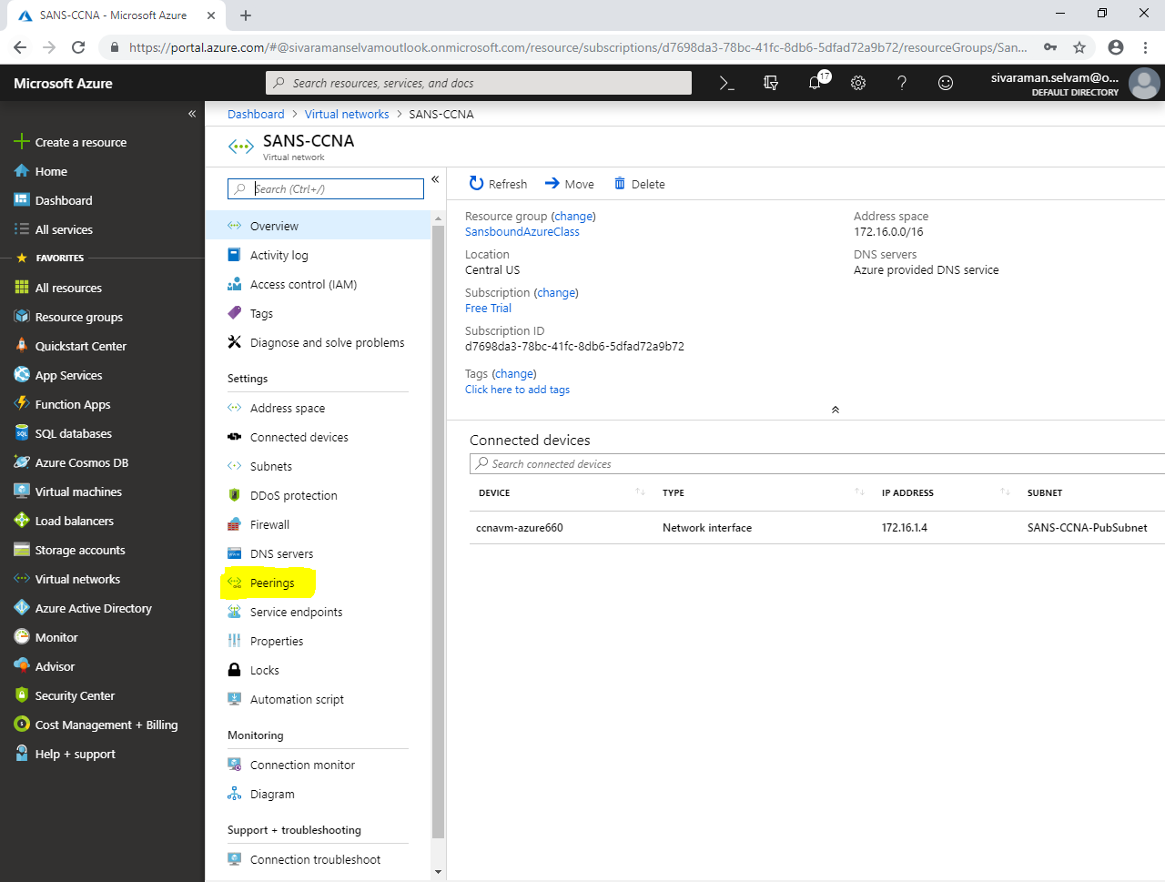

Click **“Add”** to add remote virtual network.

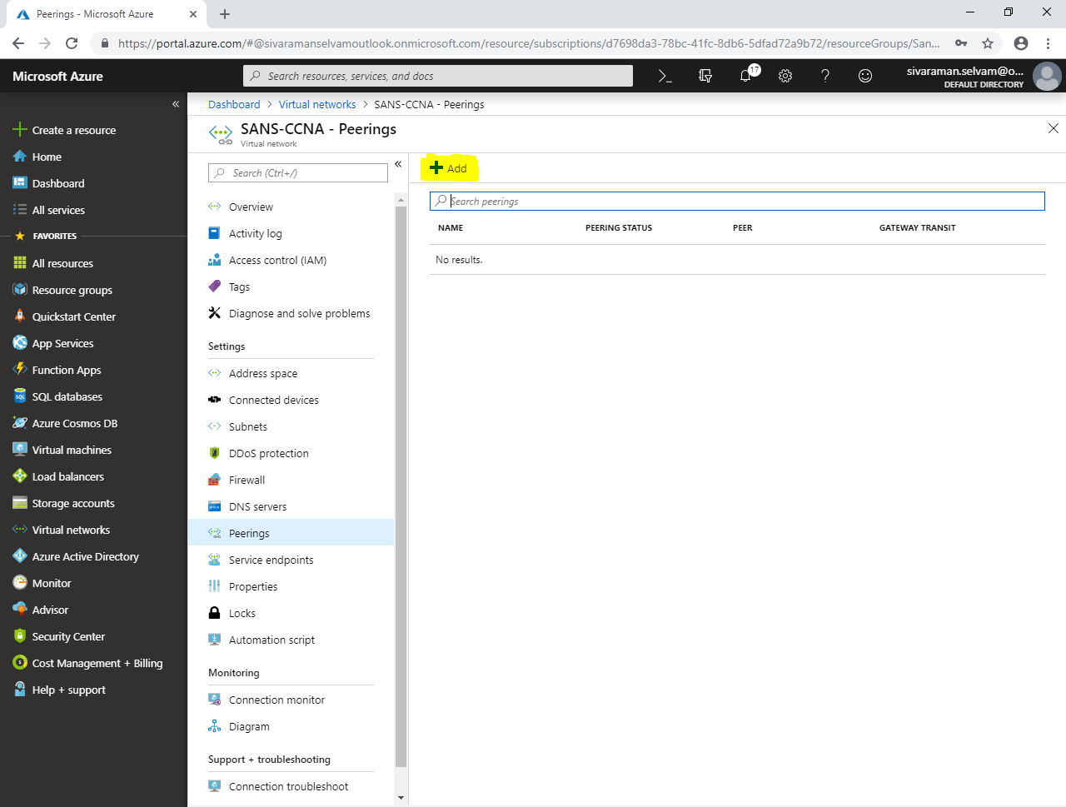

While **“Add peering”**,

Type peering **“Name”** as **“SANS-CCNA-MCSE”**.

In **“Virtual network deployment model”** click on **“Resource manager”**.

Select **“Subscription”** as **“Free Trail”**.

Select **“Virtual network”** as **“SANS-MCSE”** (which you have required to configure VNET peering).

In **“Configuration”**, need to check **“Allow forwarded traffic”**.

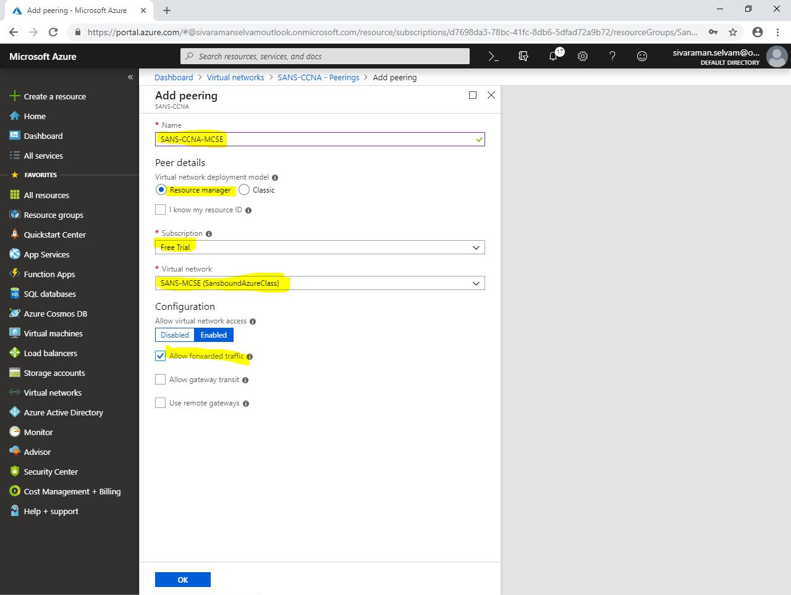

Click **“Ok”**.

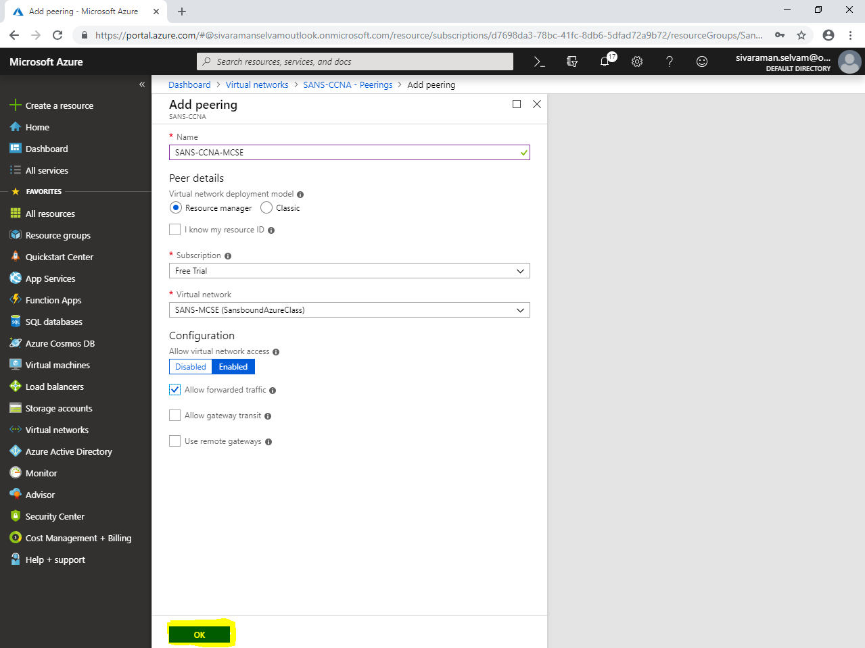

Click **“Overview”**.

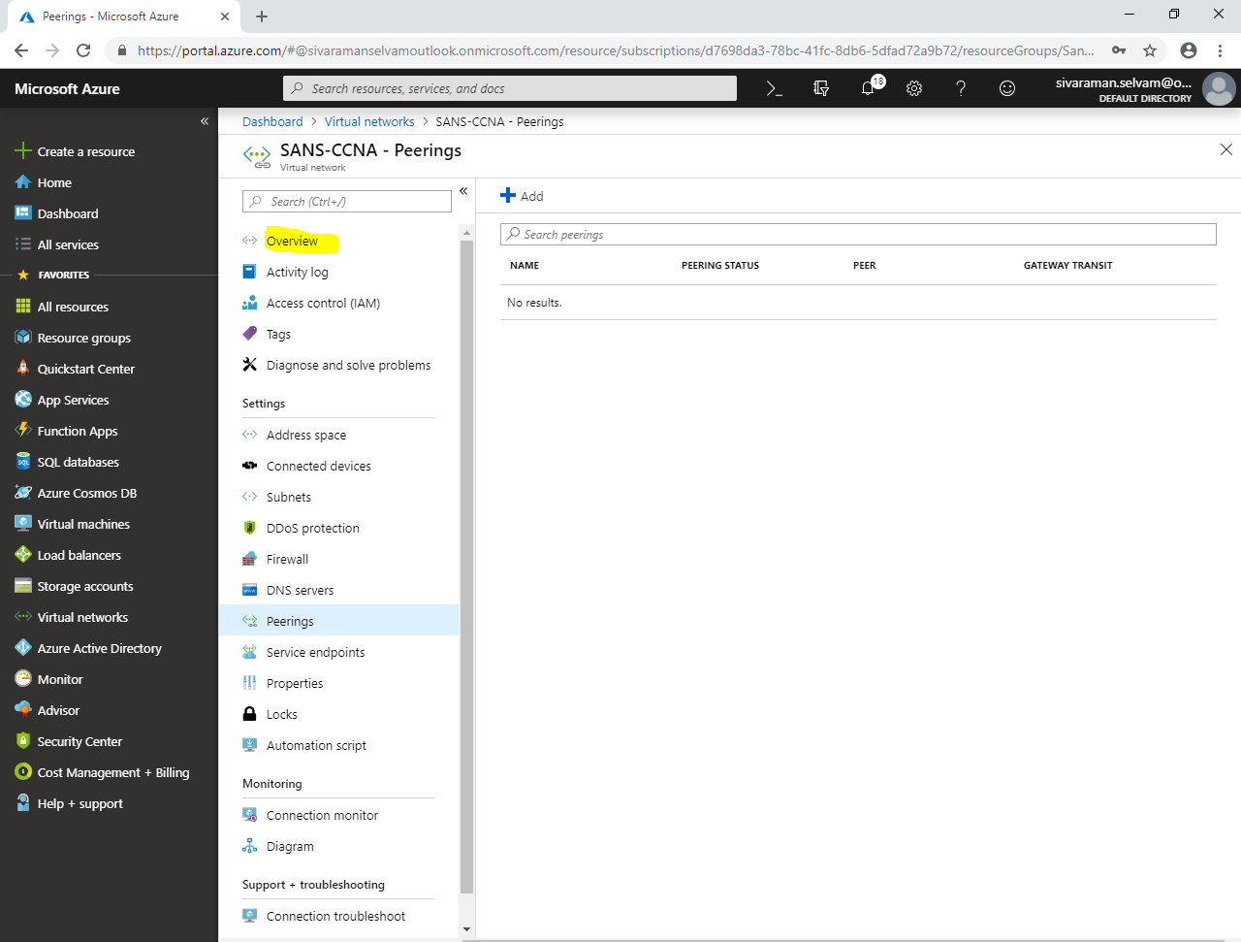

Click **“Peerings”** to view the remote virtual network details.

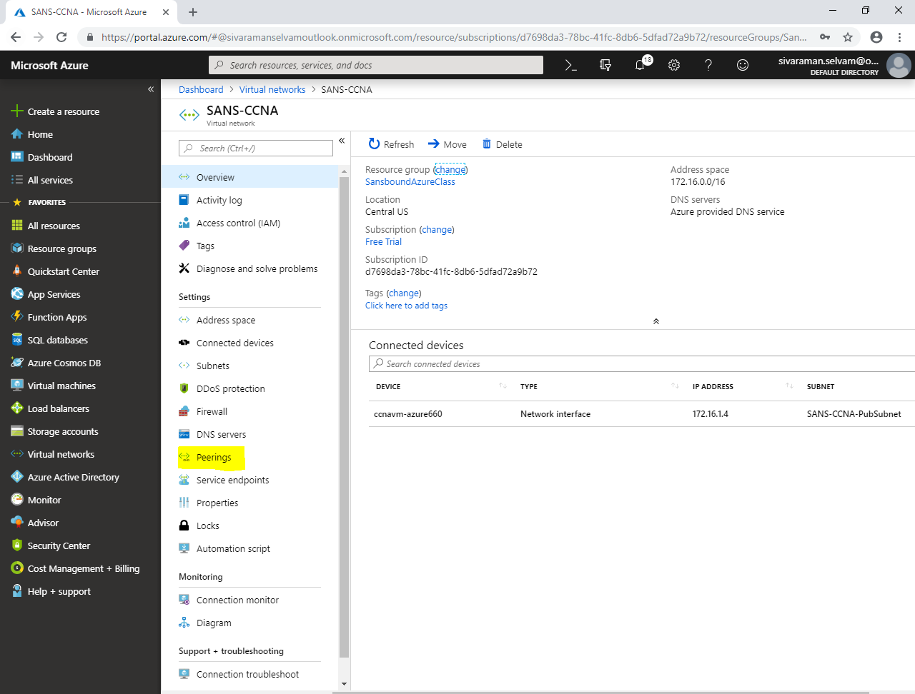

You are able see that **“SANS-CCNA-MCSE”** peering.

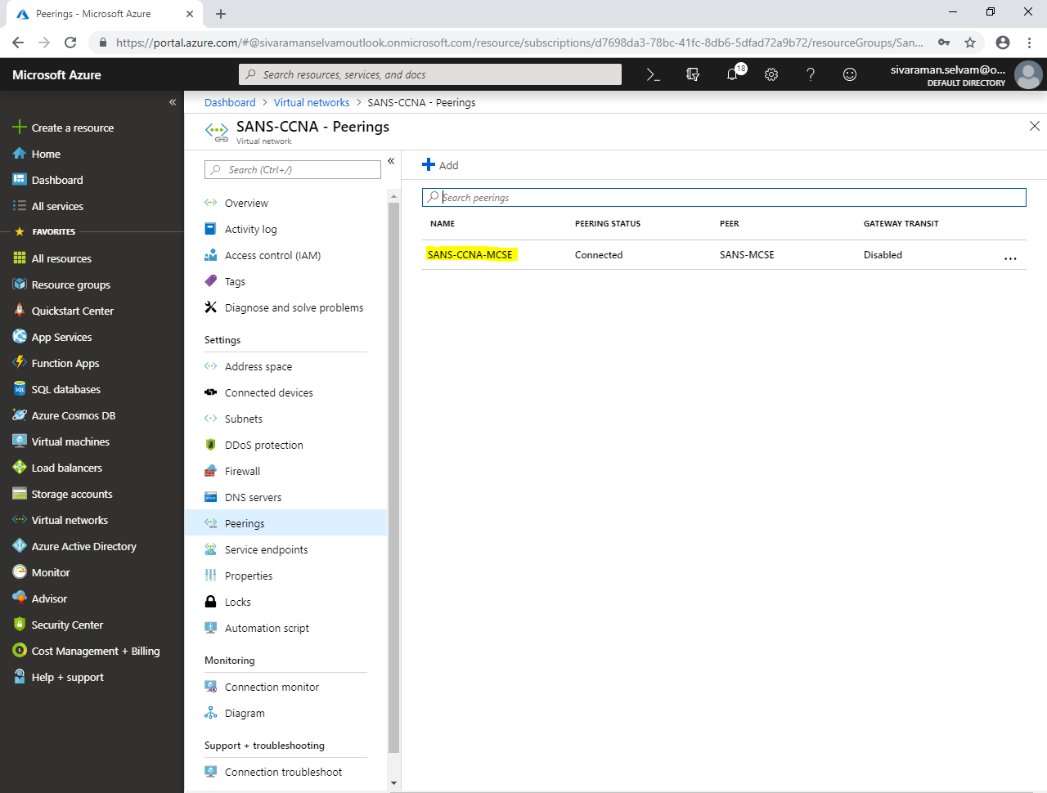

In Windows 2008 R2 server, try to **ping** **172.16.1.4** (Ubuntu IP) of **“SANS-CCNA”** virtual network from **10.0.1.4** of **“SANS-MCSE”** virtual network.

Now we can able to access the resources between **two different Virtual networks (VNET’s)** from same region.

